Preface

This Guide explains how to use the system to process import letters of credit. It assumes that you are familiar with the basic principles of trade finance relating to import letters of credit, and with web browsers.

# About Letters of Credit

A letter of credit is a document issued by a bank to guarantee payments made by their customer(s), who is buying goods. The letter of credit is then forwarded to a correspondent bank in the city where the payment is to be made. The seller or exporter of the goods then draws the specified sum of money under specified terms, through drafts payable by the issuing bank.

Letters of credit, may, therefore be considered either from the perspective of the exporter or seller (referred to as the beneficiary in this Guide) or that of the importer or buyer (referred to as the applicant in this Guide). The system handles this by means of two main products:

* Import letters of credit, covered in this User Guide. These reflect the transaction from the perspective of the applicant's bank, the issuing bank. An import letter of credit can result in the creation of a reimbursement authority, which is sent by the issuing bank to the reimbursing bank to instruct them to settle claims from the claiming bank. For information on how reimbursement authorities are handled, refer Reimbursement Authorities User Guide – Trade Innovation.

As part of entering the Letter of Credit the bank may use provisional functionality to agree the wording of the transaction with the applicant before releasing the final completed wording of the transaction.

* Export letters of credit, covered separately in the Export Letters of Credit User Guide – Trade Innovation. These reflect the transaction from the perspective of other banks involved in the transaction in the beneficiary's country, including the advising bank (which is the bank that notifies the exporter of the letter of credit) and the presenting bank (which is the bank at which the exporter presents the documents upon which payment depends.)

Letters of credit can be categorised into different product types. Your bank can choose the product types, if any, to set up. They might include such types as back-to-back or confirmed credits, for example. If your bank sets up product types, you will be able to specify product type for a letter of credit when you create it, and also will be able to filter product type to view letters of credit you want to see.

## Purchase Orders

An optional module permits you to record details of purchase orders against import letters of credit. This enables you, as issuing bank, to perform reconciliations on your customers' behalf between goods and/or services expected and those received when a drawdown is made.

If a letter of credit has purchase order details entered against it, the system will issue warnings if the total value of those purchase orders differs from the letter of credit amount. During payment events, the system also checks and issues warnings if the total value of items flagged as covered by the drawdown differs from the value of the drawdown itself. This permits you to use the system to perform close reconciliations between amounts, if you so wish.

The functionality used to process purchase order details is implemented by checking the Purchase Orders Required trade finance system parameter, as explained in the System Tailoring User Guide – Trade Innovation.

Purchase order details may be entered when the import letter of credit is created using the Pre Advise and Issue events. They can also be entered at a later date using an Amend or Adjust event.

You can enter details of more than one purchase order against a letter of credit, and each one can be in different currencies. (However, items belonging to the same purchase order must be in the same currency, that of the purchase order itself.)

Where a purchase order is denominated in a currency other than that of the letter of credit, the system calculates and maintains a total amount for the purchase order in the purchase order currency, and an equivalent in the letter of credit currency using an exchange rate identified by you for that purchase order.

You can record items from the same purchase order against more than one letter of credit - to allow, for example, for staggered deliveries. The system uses the unique (within customer) value assigned by the customer to a purchase order to identify those purchase orders that are split across letters of credit. As you are processing a purchase order's details, the system lists the master references of any other letters of credit that have items from that purchase order recorded against them.

Where a purchase order is split across letters of credit, from within one of those letters of credit you can view and process only the items recorded against that letter of credit.

When details of a purchase order are first entered, the purchase order is assigned a status of 'Not Delivered'. This is amended automatically when drawdowns are made to cover items on the purchase order.

Purchase order details are held as part of the import letter of credit's master record. They are expired, booked off and deleted as part of that master record.

Once purchase order details are entered, you can use the Amend and Adjust events to make certain changes.

* Add or delete purchase order items. Where the purchase order is in a different currency from that of the letter of credit, you can amend the exchange rate used.
* Amend any details of the purchase order, except for the purchase order number and the sequence numbers of the items within the purchase order.
* Amend the description and adjustment amount of individual purchase order items during the Claim Received and Outstanding Claim events.

When a drawdown is made using a Claim Received or Outstanding Claim event, you can use invoices presented to identify those items on a purchase order that are covered by the drawdown. The system changes the status of the purchase order from 'Not Delivered' to 'Partially Delivered' or 'Fully Delivered', as appropriate.

The amount outstanding under the purchase order is automatically adjusted to subtract the drawdown amount. If the system option POUpdateDrawdownAmount is set to ‘Yes’, the amount outstanding will also take account of pending drawdowns.

### The Customer Gateway Interface Service

If your bank uses the customer gateway interface service then you may receive details of letters of credit with associated purchase orders electronically. Such messages will be used to create the appropriate event, and the details they contain will be mapped to the appropriate event fields.

The customer gateway interface service is able to handle the extended SWIFT narrative fields supported by the system. For transactions entered through the customer gateway interface service the narrative fields will be split into blocks of 100 lines; each block of 100 lines can then be included on an outward SWIFT message without breaching SWIFT limits.

Refer to customer gateway interface service documentation for further information on how such messages are processed.

## Payment Terms

The system includes facilities for the handling of:

* Sight credits
* Acceptance credits, where payment is made upon a term draft whose maturity date is determined by acceptance of the draft by a bank
* Deferred credits, where the beneficiary does not need to draw a bill of exchange to receive payment - the issuing bank guarantees that payment will be made at a specified future date if terms and conditions are fulfilled
* Mixed credits, which are a combination of sight and acceptance or deferred credits. The system supports part payment to facilitate mixed credits
* By negotiation

The system allows letters of credit to proceed with or without confirmation from the advising bank.

For letters of credit with associated transfer letters of credit, back-to-back letters of credit and assignments, the system has the necessary facilities for combined payment or reconciliation.

When making payments all relevant charges may be paid with the payment and funds to be paid or received in currencies different from that of the letter of credit.

## Transferable Letters of Credit

Transferable letters of credit are created as normal letters of credit. Check the Transferable field to indicate that the letter of credit is transferable.

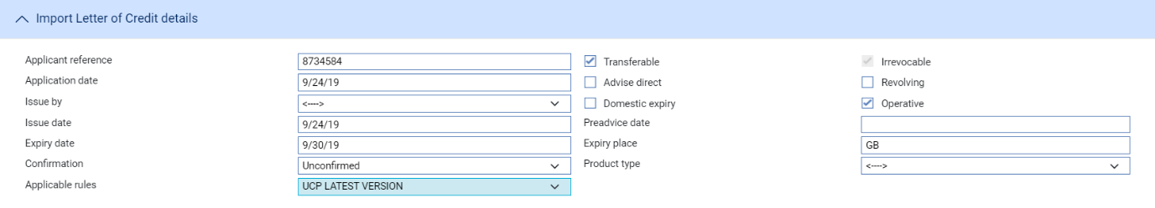

The Partial Shipments field must be any value other than 'Not Allowed' if you wish to create more than one transfer letter of credit against the parent, or if payments to the transferee and the first beneficiary are to be made separately.

Once this parent letter of credit is released, you can create any number of transfer letters of credit against it, which will be settled using the proceeds of the parent letter of credit. Transfer letters of credit must be within the terms of the original letter of credit, and the sum of all transfer letters of credit cannot exceed the value of the parent letter of credit.

The beneficiary of the parent letter of credit is termed the first beneficiary, and the beneficiary of the transfer letter of credit termed the second beneficiary. The principal for the transfer letter of credit is generally the first beneficiary, but may be the issuer of the original letter of credit.

A transfer letter of credit is created on the instructions of the first beneficiary, who can specify that, when documents are presented, the first beneficiary's invoices should be substituted for those presented by the second beneficiary. The default values for 'buyer' and 'seller' in the transfer letter of credit are determined by the way that your bank has set up your system - refer System Tailoring User Guide – Trade Innovation for more information.

Once created, a transfer letter of credit appears in the Master browser window and can be opened independent of the parent letter of credit. However, any processing of the transfer letter of credit, such as amendments, payment and expiry, is initiated from within the parent letter of credit. There is no separate Book Off event for a transfer letter of credit. Book off is processed via the parent letter of credit.

The Master Summary window for the parent letter of credit contains a Splits button, which you can use to list any transfer letters of credit entered against it and view details of them. Conversely, the Master Summary window for the transfer letter of credit includes an extra button - the Import LC button - which you can use to view details of the parent letter of credit.

For more on transfer letters of credit refer Transfer Letters of Credit User Guide – Trade Innovation.

## Financing and Discounting

For import letters of credit, the system permits you to enter details of a loan to the applicant for each part payment. You can subsequently record repayment of the loan in part or in full manually. Alternatively, you can set up a loan so that it is repaid automatically at the maturity date. The system also allows acceptance and deferred payments to be discounted and paid early.

If you have the financing module implemented, you can also enter loans from within payment events. Loans can have interest charged in advance or in arrears, or they can be discounted. The financing module also allows you to create financing transactions independent of any existing trade finance transaction. For example, to provide funds to the applicant from the point at which they receive the goods until they can sell them. The trade finance transaction can then be associated with the financing transaction as it is created.

For a full description of the financing module's functionality refer Financing User Guide – Trade Innovation.

### Assigning Proceeds to a Third Party

The system permits you to identify an unlimited number of additional parties to a letter of credit who are to receive proceeds from the transaction. Assignee details can be entered either at the same time as payment is recorded or as a separate event - the Assignment of Proceeds event - after the release of the Issue or Advise event.

You can identify the amount to be assigned to each additional party. The total amount of assignments, together with any back-to-back and transfer letters of credit, can be up to 100% of the value of the letter of credit.

The Assignment of Proceeds event can be used to set up assignment details and subsequently to make amendments to, or delete, those details. Once entered, assignment details can be amended or deleted any time until the disbursement of funds.

Information entered using the Assignment of Proceeds event is available during payment events. Assignment details entered as part of a payment event, or any changes to them during that event, are reviewed as part of that event’s details.

1. The letter of credit's Master Summary window includes a Splits button, which allows you to display details of any assignments or transfers. Assignments are only shown in this window once the event creating them has been released.

You should ensure that all Assignment of Proceeds events are completed and released before initiating a payment event.

### Licenses

The system includes facilities for the use of licenses with transactions of the type described in this Guide. Your bank can also make returns to the central licensing authority on a regular basis to show the utilisation of the licenses issued to customers.

One or more licenses can be linked to a transaction and a reservation made for the amount of the transaction. When a claim is received, a drawdown can be made against the license. Full validation between the transaction and license is provided to ensure that licenses do not become overdrawn.

If the amount of the transaction is increased or decreased during an amendment event, then additional reservations can be made for an increase or the balance reinstated for a decrease. Any unutilised balance on expiry or cancellation can be (optionally) reinstated on the license.

Refer Licenses User Guide – Trade Innovation for details of licenses.

## Shipping Guarantees

The system includes facilities that allow your bank to issue guarantees against an import letter of credit. Shipping guarantees may be created from within an import letter of credit, or as standalone documents that are subsequently linked to an import letter of credit.

You can issue any number of shipping guarantees against an import letter of credit. Depending on how your system is configured, each shipping guarantee may be issued in respect either of a single document of title or of multiple documents of title. When the document of title is received, the Claim Received event can be used to link a shipping guarantee with the document of title in lieu of which it was issued, and a document requesting the return of the actual shipping guarantee may be issued. Shipping guarantees can also be linked to an inward documentary collection order during Outstanding Claim events.

For full information on shipping guarantees in the system refer Shipping Guarantees User Guide – Trade Innovation.

## Participating a Transaction

If you have the participations module implemented, you can participate a transaction using an existing participation deal, or creating a new participation deal with that transaction.

You can participate a transaction from within the Advise or Issue event, or later from within a Maintain Liability event. At either of these stages, you can either select an existing agreed participation deal, or create a new deal.

If the amount of a transaction is changed by an Amend event, or by the transaction being paid, expired, or cancelled, a Drawdown/Revolve Commit Amt event may be created as a subsidiary event to update the commitment amount available on the participation deal. This will occur under the following circumstances:

* If the amount is increased, a drawdown will take place to reduce the amount available on the participation deal
* If the amount is decreased, including being reduced to zero when the transaction is paid, expired, or cancelled, a revolve will be used to increase the amount available on the participation deal only if the participation deal is defined as revolving.

A Drawdown/Revolve Commit Amt event may be created by the following events:

* Amend
* Cancel
* Expire
* Maintain Liability
* Documents Presented
* Outstanding Presentation
* Claim Received
* Outstanding Claim
* Renew
* Reduction/Increase

If the participation deal itself is amended in such a way as to alter a participant's share, a Maintain Liability subsidiary event is automatically generated for each transaction affected by the amendment. This updates the transaction and the charges associated with it to take account of changes to the participation deal.

## Credit Risk Management

If your bank has implemented a credit risk management application, your system will perform on-line credit limit checking as necessary as part of the life-cycle of a transaction. Depending on how your system has been configured, account manager approval for a credit line utilisation may be required always, or only when overline conditions are detected.

Refer Common Facilities User Guide – Trade Innovation for more information on credit risk management.

## Re-issuance Letters of Credit

The Import Letter of Credit product may also be used by your bank where it is acting as a ‘Re-issuance bank’ in the letter of credit process.

If your bank receives instructions from another financial institution to ‘Re-issue’ a letter of credit on behalf of an initiating or partner financial institution, it is possible to map the incoming SWIFT MT700 – Issue of a documentary credit message, to the import letter of credit issue event. Additionally, any subsequent amendment instructions received via a SWIFT MT707 – Amendment to a documentary credit message, may be mapped to the import letter of credit, amend event.

This functionality enables your partner banks and their corporate clients to benefit from ‘White labelling’ or ‘Private labelling’ solutions, whereby the letter of credit is rebranded by the bank who ‘Re-issues’ it.

The functionality is enabled by way of the following system option:

|  |  |
| --- | --- |
| System Option - Identifier | Description |
| MT700ChooseImportProduct | If set to yes, incoming SWIFT MT700 messages are routed to the ILC or ISB Issue events, depending on the 'Form' of L/C described in Field 40A and the bank defined codeword/identifier quoted in Field 72 |

When this system option is switched on and the message is mapped appropriately in System Tailoring | In SWIFT mapping, any messages received that match the criteria described in the system option will map to the import letter of credit, issue event.

If your bank has established a ‘Private labelling’ programme for your clients, you may wish to transmit SWIFT MT710 – Advice of a third bank’s or non-bank’s documentary credit messages from the import letter of credit, issue event, following receipt of an MT700.

This can also be achieved by mapping the MT710 to the import LC Issue event via System Tailoring | Parameter sets | Product-Event level documents, thereby enabling the SWIFT MT710 message to be generated and transmitted from this event.

Refer System Tailoring Guide – Trade Innovation for information on how to switch on system options and map SWIFT messages.

## Incorporating Legacy System Transactions

Your bank can incorporate import letter of credit transactions into the system from a legacy system using customer gateway interface service messages.

Each transaction is received as a customer gateway interface service message, which is processed in the usual way. Each such message, once successfully processed, is used to create an Issue Take-on event and associated master record in the system. The Issue Take-on event can be automatically released, and the master record given a status of 'LIV' or 'EXP', depending on its expiry date. Processing can then be carried out against the master record in the usual way, using the standard import letter of credit events.

The transaction's original unique reference is recorded against the master record generated within the system.

To allow legacy transactions to be incorporated into the system workflow in this way your bank must set up the following for the Issue Take-on event:

* Postings to allow the calculation of current values of master-level liability and margin amounts at master level within the system
* Charges and default charge schedules
* Tracers and their default schedules
* Note types

The system allows you to enter legacy transactions manually, using the standard Issue event. An additional field is provided to allow you to enter the transaction's unique reference from the legacy system.

## Using Trade Innovation to Process Import Letters of Credit

The table below lists the events covered in this Guide, explaining what each event allows you to do. The table lists the names given to events when the system is delivered. Your bank can change these names once the system is installed. Consequently, the names in your version of the system may be different from the ones listed here.

There are two names for each event:

* The full name, which is displayed when you choose a new event
* The short name, which is displayed in the Work in Progress pane of the Master Summary window

This Guide uses the full name of each event, as delivered with the system.

In addition to the events listed in the table, you can also use the functionality described in Common Facilities User Guide – Trade Innovation when processing transactions in the system.

|  |  |  |
| --- | --- | --- |
| Full Name | Short Name | What it Does |
| Adjust | Adjust | Allows you to make changes to any of the information held for a letter of credit (see page 105). |
| Amend | Amend | Allows you to make amendments to the basic details of a letter of credit (see page 95). |
| Assignment of Proceeds | Assignment | Allows you to assign proceeds to additional parties (see page 50). |
| Beneficiary Response to Amend | Amd Rs | Allows you to enter the beneficiary's response to an amendment (see page 101). |
| Beneficiary Response to Cancel | Can Rspnse | Allows you to enter details of the beneficiary's response to a cancellation (see page 110). |
| Cancel | Cancel | Allows you to cancel a letter of credit (see page 109). |
| Cancel Reimbursement | Cancel | Allows you to cancel a reimbursement authorisation (see page 112). |
| Claim Received | Clm Recv'd | Allows you to log information about claims made by the presenter, to enter details of documents, and to pay the claim, providing the terms of the letter of credit have been met (see page 56). |
| Issue | Issue | Allows you to enter full details of the letter of credit and then issue it. |
| Issue Shipping Guarantee | Iss Shp Gt | Available only if your system has the shipping guarantees functionality implemented. Allows you to create a shipping guarantee.  Refer Shipping Guarantees User Guide – Trade Innovation. |
| Discount Payment | Discount | Allows you to discount accepted and deferred payments (see page 84). |
| Maintain Liability | Maint Liab | Updates a participated letter of credit to take account of changes in the participation deal. Refer *Participated Deals User Guide – Trade Innovation.* |
| Outstanding Claim | Outst Clm | Allows you, as issuing bank, to process the next stage of a claim not completed in a single event, for example due to discrepancies or usance terms (see page 68). |
| Pre Advise | Pre Advise | Allows you to create a pre-advice to be sent to the beneficiary through an advising bank, prior to the issuance of the letter of credit. |
| Receive Acknowledgement | Rec Acknow | Allows you to record the acknowledgement of receipt of a letter of credit by the next advising bank (see page 49). |
| Repay Finance | Pay | Allows you to record the repayment of a loan made to the applicant (see page 81). |
| Revolve | Revolve | Automatically generated event which processes a revolving credit (see page 87). |
| Revolve Notice | Rev Notice | Automatically generated event which produces a notification that a letter of credit is about to revolve (see page 86). |
| Transfer | Transfer | Allows you to create a transfer letter of credit. |
| Transfer LC – Amend | Amend Trf | Allows you to amend a transfer import letter of credit. |
| Transfer - Ben Response Amend | T Amd Rsp | Allows you to enter details of the beneficiary's response to an amendment to a transfer import letter of credit. |
| Transfer - Ben Response Cancel | Cn Trf Rsp | Allows you to enter details of the beneficiary's response to cancellation of a transfer import letter of credit. |
| Transfer - Cancel | Cancel Trf | Allows you to cancel a transfer import letter of credit. |
| Transfer LC – Adjust | Adjust Trf | Allows you to adjust a transfer import letter of credit. |

For the last six menu options refer Transfer Letters of Credit User Guide – Trade Innovation.

## Using Deal Templates to Create an Import Letter of Credit

Trade Innovation permits you to create deals (transactions) from templates and/or, if you have the capability ManageDealTemplates assigned, to add, update and delete deal templates.

You can create a new import letter of credit from a template at one of three points:

* From within the TI Dashboard. In the New Master pane, the Create from Template button allows you to select the template to use. You must specify the Team, the Branch and the Product
* From within the Master Browser window. In the New Master pane, the Create from Template button allows you to select the template to use. You must specify the Team, the Branch and the Product
* From within a transaction, during the Input step of an event that is creating a new master record. The Create from Template link allows you to select the template to use.

See the *Common Facilities Guide* – Trade Innovation for further details.

# Creating an Import Letter of Credit

This chapter explains how to use the system as issuing bank to initiate an import letter of credit on your system. It explains how to use the Pre Advise and Issue events in conjunction or separately to initiate, pre-advise and issue an import letter of credit. It also covers receiving acknowledgements.

For information on how back-to-back letters of credit are handled, refer Export Letters of Credit User Guide – Trade Innovation.

For information on creating transferable letters of credit refer Transfer Letters of Credit User Guide – Trade Innovation.

## Pre-advising and Issuing Import Letters of Credit

The system includes two events that allow you, as issuing bank, to initiate an import letter of credit in response to the receipt of an application from an importer, who is usually a customer of your bank, or the importer's bank. These are:

* The Pre Advise event, which allows you to create a brief notification to be sent to the beneficiary through an advising bank prior to the issuance of the letter of credit. This can be used if, for example, the letter of credit would be issued by mail, the pre-advice can be sent by a quicker means (such as SWIFT), or if full goods descriptions or other details of the transaction are not available initially
* The Issue event, during which full details of the letter of credit are entered and, upon release of which, the letter of credit is issued

If you create a Pre Advise event before the Issue event, then the system automatically uses the information entered in the earlier event when creating the later one.

### Customer Gateway Interface Service Users

Import letters of credit may be received via customer gateway interface service, in which case the master record will be created automatically as the incoming message is integrated into the system work-flow.

### Purchase Orders

You can record purchase orders and details of the items they cover against an import letter of credit (see page 43) either when that letter of credit is created using the Pre Advise or Issue event (or later using an Amend or Adjust event).

You can record an unlimited number of purchase orders against an import letter of credit. Purchase orders do not have to be in the same currency as the import letter of credit, and the purchase orders recorded against a letter of credit can be in different currencies. (However, the individual items covered by a purchase order must be in the same currency - that of the purchase order.)

If you enter a purchase order in a currency different from that of the letter of credit, you can enter an exchange rate code or the actual exchange rate to be used to convert the amount of the purchase order to that of the letter of credit. The system automatically calculates and displays the amount of such a purchase order in the currency of the letter of credit, and also calculates and displays a total amount for all purchase orders, in the currency of the letter of credit.

You may split the items included on a single, underlying purchase order across several import letters of credit. Each such underlying purchase order typically has a unique number assigned to it by the customer (who is the import letter of credit's applicant). When you are processing a purchase order, the system identifies all other letters of credit for the applicant that has the same purchase order number recorded against them, and lists them.

When you save a Pre Advise or Issue event, the system matches the amount of the letter of credit with the total value of purchase orders recorded against it, and warns you of any discrepancy.

If the advice is transmitted to the advising bank via SWIFT, the purchase order details can be mapped to field 45A Description of Goods and/or Services of the MT700 or MT705 message, and then to continuation messages, if necessary.

### Attaching a License

Depending on your system set up and type of letter of credit or guarantee you are using, you have the option to issue a letter of credit or guarantee of attaching one or more licenses. The amount that is attributed to the license must be less than or the goods code will also be validated against the license.

If the credit is revolving then the license amount must be sufficient to cover the maximum amount available across the revolving periods.

Refer Licenses User Guide – Trade Innovation for details of licenses.

## Pre-advising an Import Letter of Credit

You can create a Pre Advise event in one of two ways:

* If the Pre Advise event is the first event within the letter of credit's life-cycle, in the Masters window use the drop-down list in the New Masters pane to select 'Import Letter of Credit - Pre Advise', then click **New**
* If you have created and pended an Issue event for the letter of credit, in the Master Summary window select 'Pre Advice' from the Create New Event drop-down list and click **Create**

In either case the system creates the Pre Advise event either at a Log step (see page 11) or Input step (see page 16), depending on how the Workflow orchestration controlling the event is configured. Refer *Workflow Tailoring User Guide* – Trade Innovation for details.

### Logging a Pre-advice

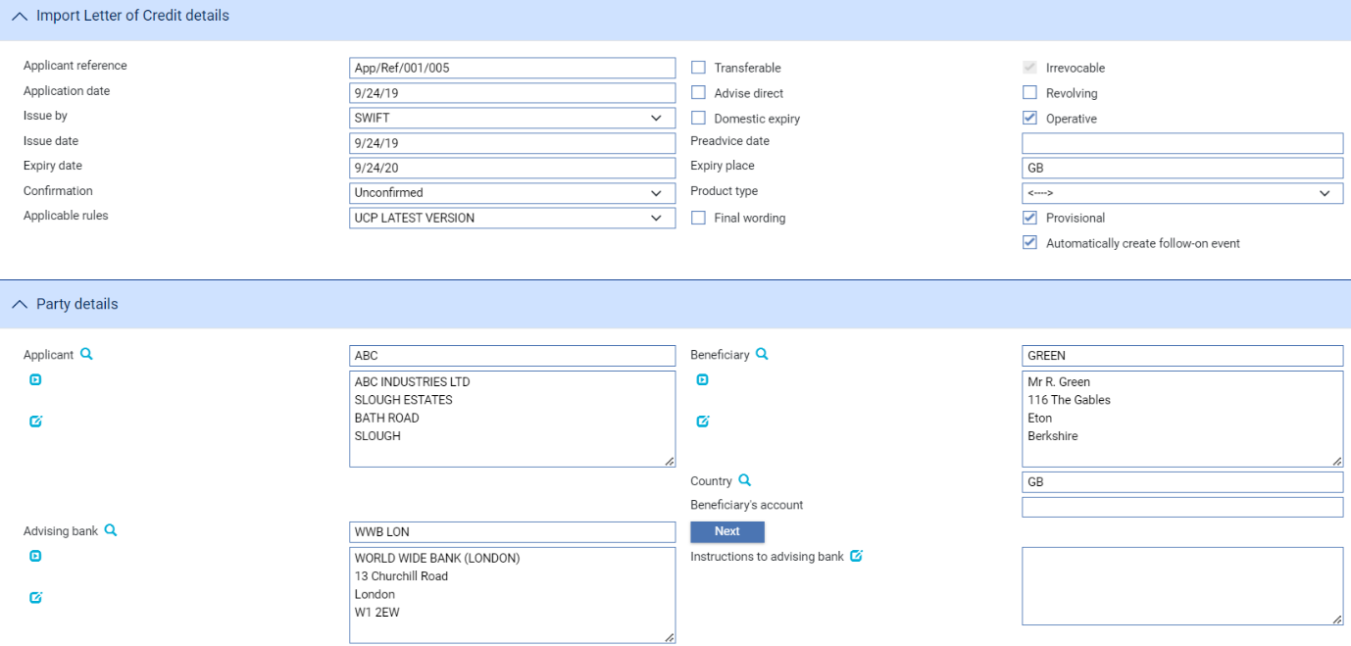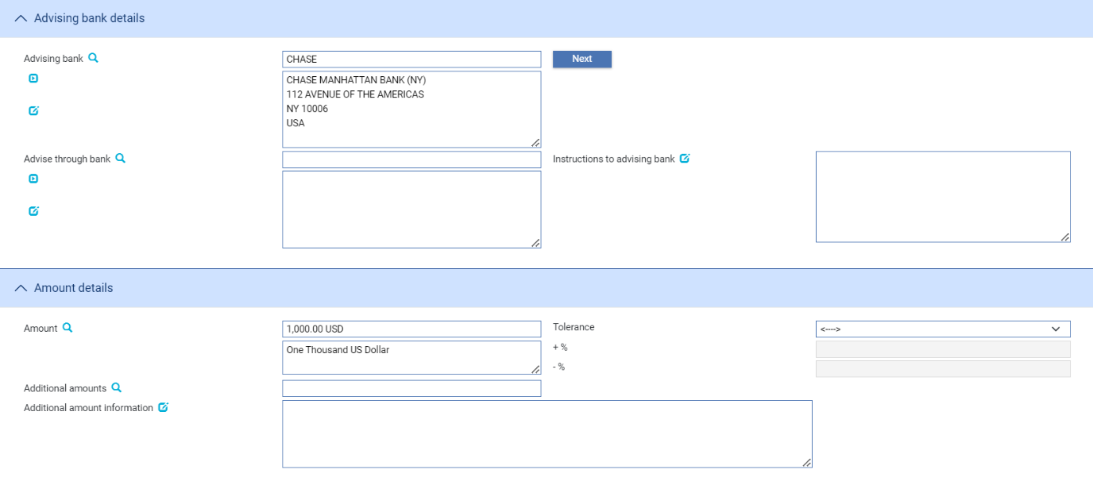

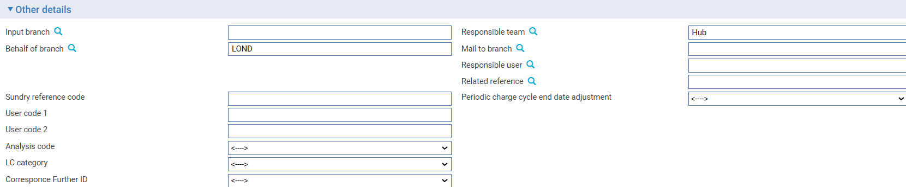

* A Pre-advise log step uses the following default panes. Depending on how your system is configured, panes and fields available in log steps can be tailored for each data capture step. Refer *SDK - Screen Tailoring Guide* – Trade Innovationfor details. The Import LC Details pane (see page 12)
* The Party Details Pane (see page 13)
* The Amount Details Pane (see page 14)
* The Other Details Pane (see page 15)

### The Import LC Details Pane

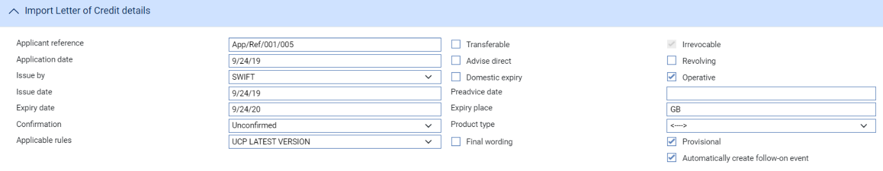

The following table explains what to enter into the fields in the Import LC Details pane:

|  |  |  |
| --- | --- | --- |
| Field | What to Enter | |
| Applicant Reference | The applicant's reference for the letter of credit, taken from their application. | |
| Advise by | The transmission method to be used to notify the Beneficiary bank of the pre-advice. | |
| Preadvice Date | The date on which the pre-advice was created. The system uses today's processing  date by default. | |
| Expiry Date | The letter of credit’s expiry date. | |
| Expiry Place | The location at which the expiry date applies. | |
| Confirmation | Select from one of the of the following values: | |
|  | Confirmed | If you want the requested confirmation party to confirm the letter of credit. |
|  | Unconfirmed | If you do not want the requested confirmation party to confirm the letter of credit. This is the default value. |
|  | May Add | If you have no preference whether the requested confirmation party confirms the letter of credit or not. |
| Applicable Rules | This allows you to select additional information to be included in the relevant SWIFT MT700 (MT710 and MT720) message generated by the event.  Select one of the following to indicate the rules applied to the issue of the documentary credit: | |
|  | UCP LATEST  VERSION | The documentary credit is subject to the version of the ICC Uniform Customs and Practice for Documentary Credits, International Chamber of Commerce, Paris, that is in effect on the date of issue.  This is used as the default. |
|  | EUCP LATEST  VERSION | The documentary credit is subject to the version of the Supplement of the ICC Uniform Customs and Practice for Documentary Credits for Electronic Presentations, International Chamber of Commerce, Paris, that is in effect on the date of issue. |
|  | UCPURR  LATEST  VERSION | The documentary credit is subject to the version of the ICC Uniform Customs and Practice for Documentary Credits and the version of the Uniform Rules for Bank-to-bank Reimbursements  As published by International Chamber of  Commerce, Paris, that is in effect on the date of issue of the Letter of Credit. |
|  | EUCPURR  LATEST  VERSION | The documentary credit is subject to the version of the Supplement of the ICC Uniform Customs and Practice for Documentary Credits for Electronic Presentations and the version of the Uniform Rules for Bank-to-bank Reimbursements under documentary credits, International Chamber of Commerce, Paris, that is in effect on the date of issue. |
|  | ISP LATEST  VERSION | For standby letters of credit only. The documentary credit is subject to the version of the ICC International Standby Practices, International Chamber of Commerce, Paris, that is in effect on the date of issue. |
|  | OTHR | The documentary credit is subject to other rules. Use the Other Applicable Rules field to specify those rules (up to 35  characters) |
| Transferable | Check this field if the letter of credit is transferable. | |
| Advise Direct | Check this box if the pre-advice is being advised directly to the beneficiary. Upon checking of this box, the advising bank details pane shall not be available for input. | |
|  |  | |
| Product Type | If your bank has set up product types for import letters of credit, select the appropriate one from the drop-down list on this field. | |
| Irrevocable | The ‘Irrevocable’ flag appears only when the Zone level system option, ‘AllowRevocableLCs’ is set to ‘No’ and the SWIFT version is 2018 or higher. In this case, the ‘Irrevocable’ flag is protected.    When the Zone level system option, ‘AllowRevocableLCs’ is set to ‘Yes’ and the System option, 'SWIFTversion' is 2018 or higher, the ‘Revocable’ flag appears and is un protected. | |
| Revolving | Check this box if the letter of credit is a revolving credit. | |
| Operative | Indicate whether the letter of credit is operative or not. If you leave this box unchecked, then the letter of credit will remain inoperative until you use a subsequent event to check this flag | |
| Provisional | Check this box if the event is to be treated as ‘Provisional’, in which case a subsequent version of the event is required before the event can be completed. | |
| Automatically create follow-on event | Checking this box enables the system to automatically create a subsequent version of the event at an Input step; otherwise a new version of the event needs to be created manually. | |

### The Party Details Pane

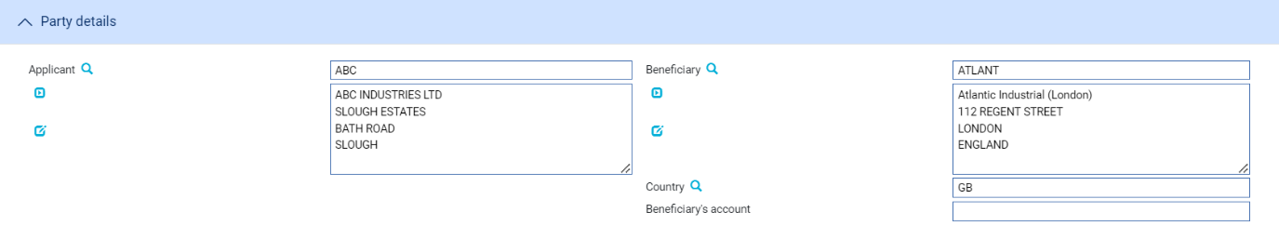

The following table explains what to enter into the fields in the Party Details pane:

|  |  |
| --- | --- |
| Field | What to Enter |
| Applicant | The applicant. |
| Beneficiary | The beneficiary. |
| Country | The beneficiary’s country of residence. |
| Beneficiary’s Account | If known, enter the beneficiary's account number with the advising bank. |

### The Advising Bank Details Pane

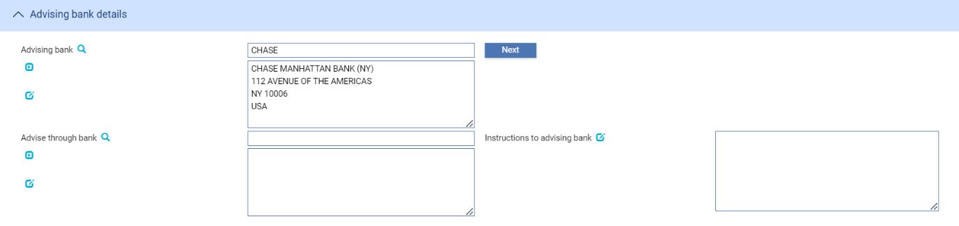

The following table explains what to enter into the fields in the Advising Bank Details pane:

|  |  |  |
| --- | --- | --- |
|  | Field | What to Enter |
|  | Advising Bank | The advising bank. |
|  | Advise Through Bank | The Advise Through bank. |
|  | Instructions to Advising Bank | Any instructions that the issuing bank intends to inform the advising bank |

### The Amount Details Pane

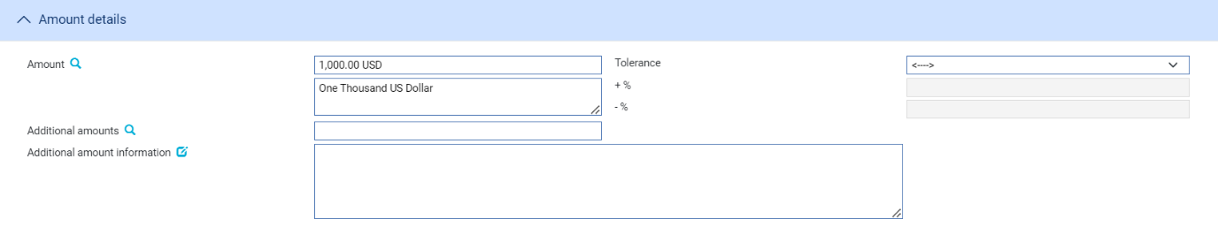

The following table explains what to enter into the fields in the Amount Details pane:

|  |  |  |
| --- | --- | --- |
| Field | What to Enter | |
| Amount | The amount and currency of the transaction. The system displays the amount and currency in the language of your system beneath these fields. You can edit this text, if necessary. | |
| Tolerance | Specify how the amount is being expressed. Select from one of the following: | |
|  | Exact | If the amount is the exact value of the letter of credit. |
|  | About | If the amount given in the Amount field is within 10% either way of the expected value of the letter of credit. |
|  | Other | If you select this option, use the -% and +% fields to specify as a percentage how much more or less than the final value of the letter of credit the amount entered is allowed to be. |
|  | Not Exceeding | If the final value of the letter of credit is expected to be no more than the amount entered, and not less than 95% of the amount entered. |
|  | Min/Max | If you select this option the system displays a + Amount and a - Amount field. Use them to specify as an amount how much more or less than the final value of the transaction the amount entered can be. |
| Additional Amounts | Any amounts payable to the beneficiary in addition to the principal amount of the transaction. These might include, for example, local freight charges.  If you enter an amount, it is added to the amount of liability under the transaction. If you use a different currency for the amount, then the amount is converted to the currency of the transaction using the current spot rate. | |
| Additional Amount Information | Detail related to the additional amount entered. | |

### The Other Details Pane

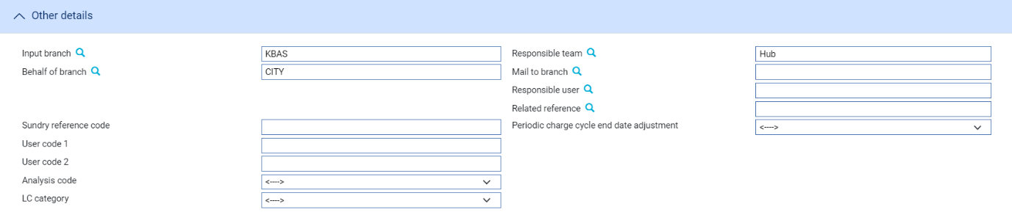

|  |  |
| --- | --- |
| Field | What to Enter |
| Input Branch | The input branch for the transaction. The input branch is set from the either:   * the accounting branch from the user’s team, or * the transaction branch for user if the user has a default transaction branch or is locked to a specific branch, or * a branch associated with the user where the user can enter transactions for several branches for a team |
| Responsible Team | The team that has overall responsibility for the master e.g. as the contact to resolve any queries or issues regarding the master and associated events. The system defaults the responsible team when creating the transaction as follows:   * Manual – set from team creating the transaction * Gateway – set from the team specified on the incoming message (if present and valid) otherwise to the team to which the transaction is assigned through workflow allocation based on the behalf of branch * SWIFT – set to the team to which the transaction is assigned through workflow allocation based on the behalf of branch   It can be changed, if required, to either the team associated with the primary customer, default team for the product or the user’s current team. |
| Behalf of Branch | The behalf of branch for the transaction as entered by the user or set from the incoming SWIFT or gateway message. The behalf of branch determines the parameter sets that are to be used to generate charges, documents, postings, etc. during transaction processing. The branch can be changed to any other branch within the same main banking entity that shares the same parameter sets. |
| Mail to Branch | The mail to branch can be set to any branch within the main banking entity of the  behalf of branch. |
| Responsible User | A user that has responsibility for the master e.g. as the contact to resolve any queries or issues regarding the master and associated events. This can be any user assigned to the responsible team. |
| Related Reference | Refers to the master to which the current master is linked or associated with. |
| Sundry Reference Code/User Code 1/User Code 2 | You may use these fields to enter values for analysis purposes. Your bank will have devised its own system for using these fields. User defined fields that the bank can use for holding data. |
| Periodic Charge Cycle End Date Adjustment | Select what happens when a periodic charge cycle end date falls on a non-business/working day. See the *System Tailoring User Guide – Trade Innovation* for more information. |
| Analysis Code/LC Category | User definable fields. These can be configured in System Tailoring | List Values/Field Mapping. |

## Entering Full Details of the Pre-advice

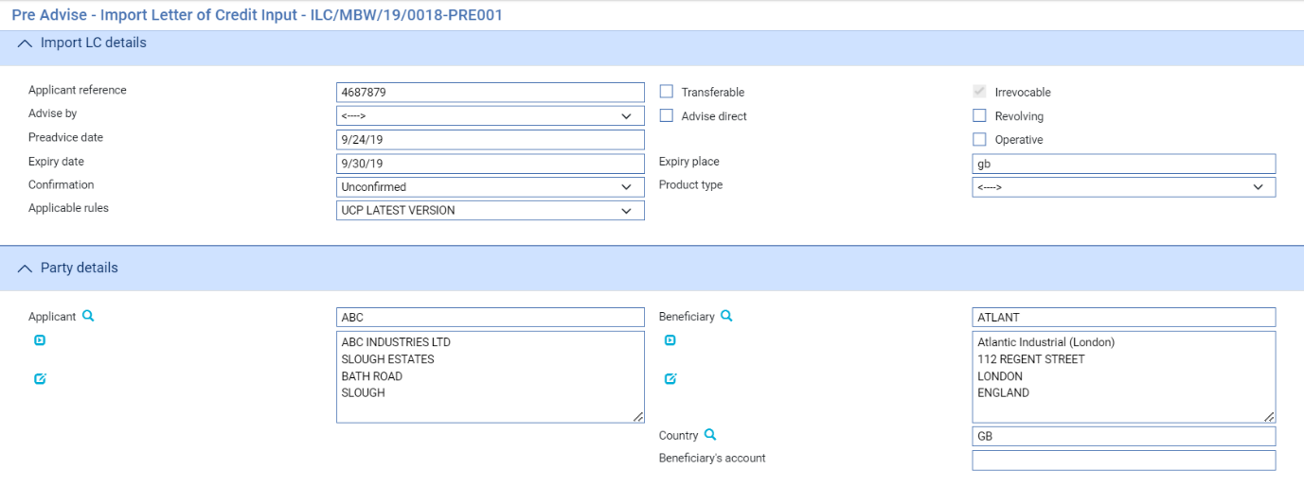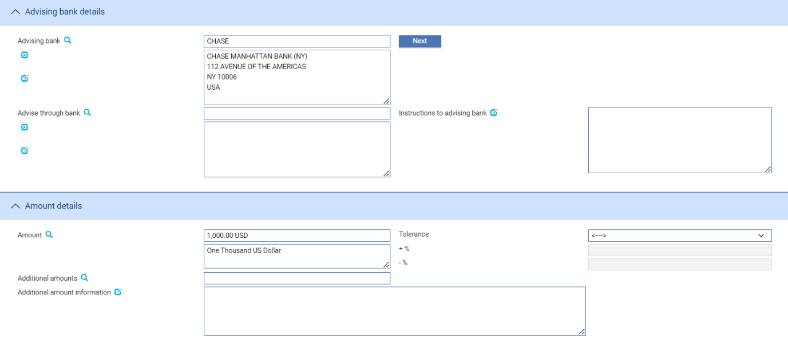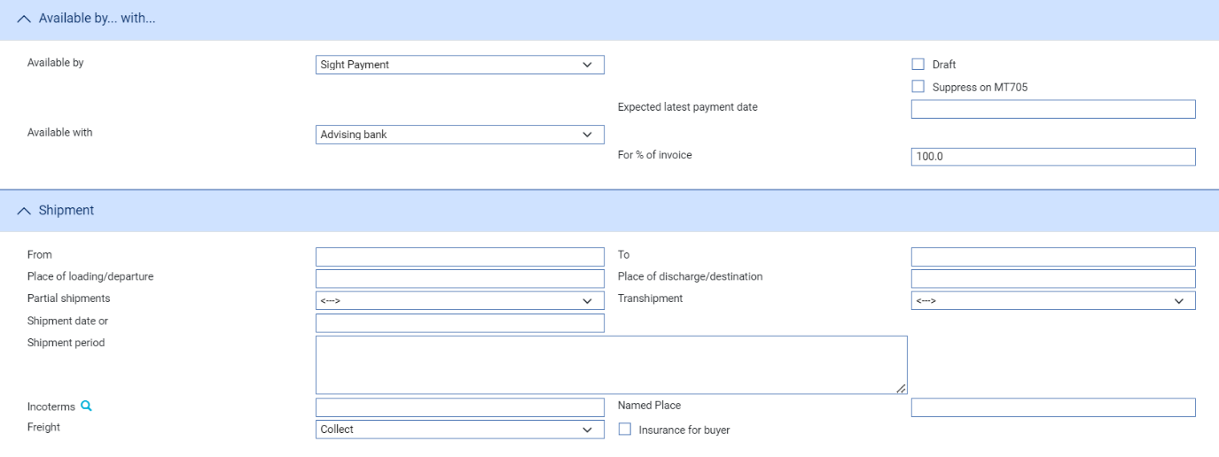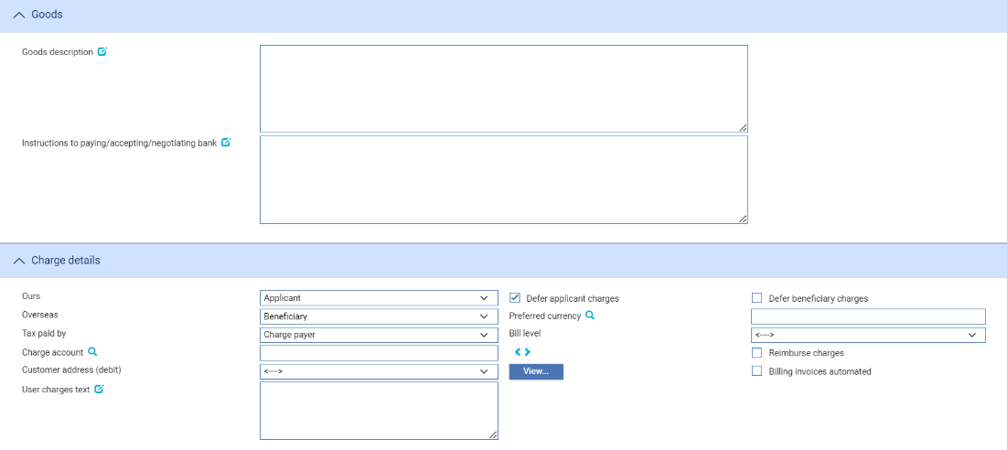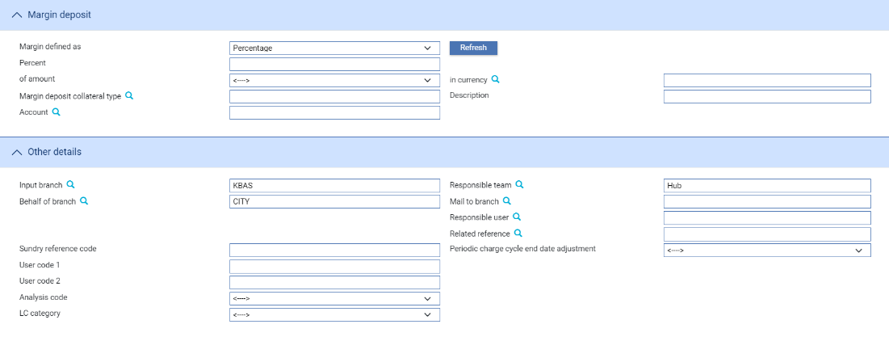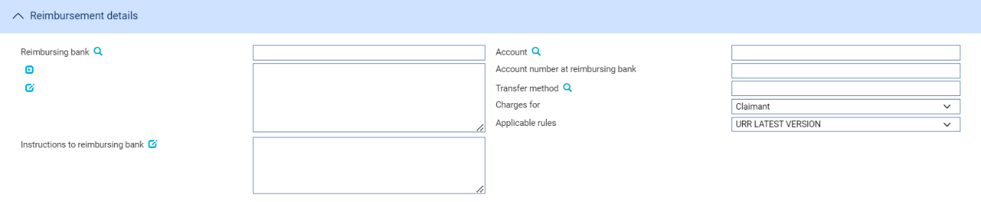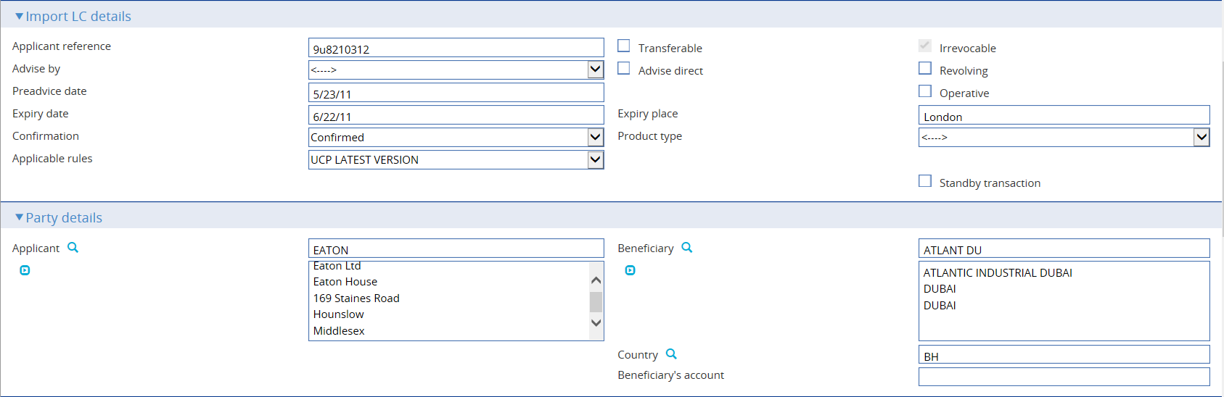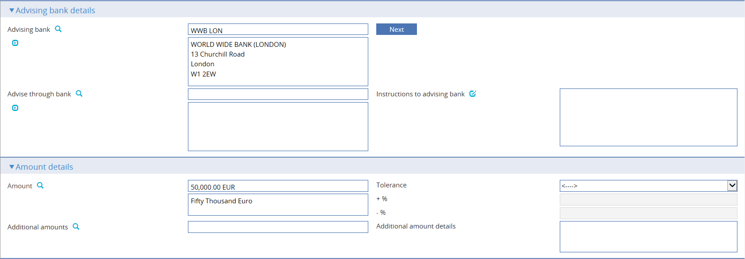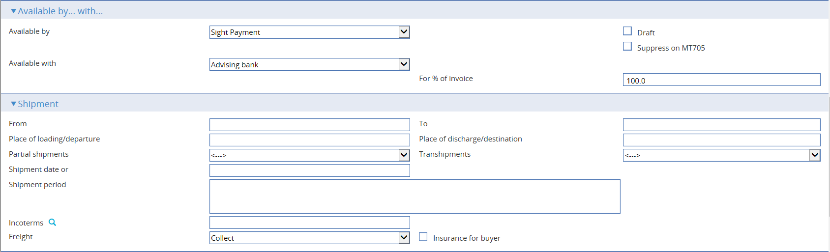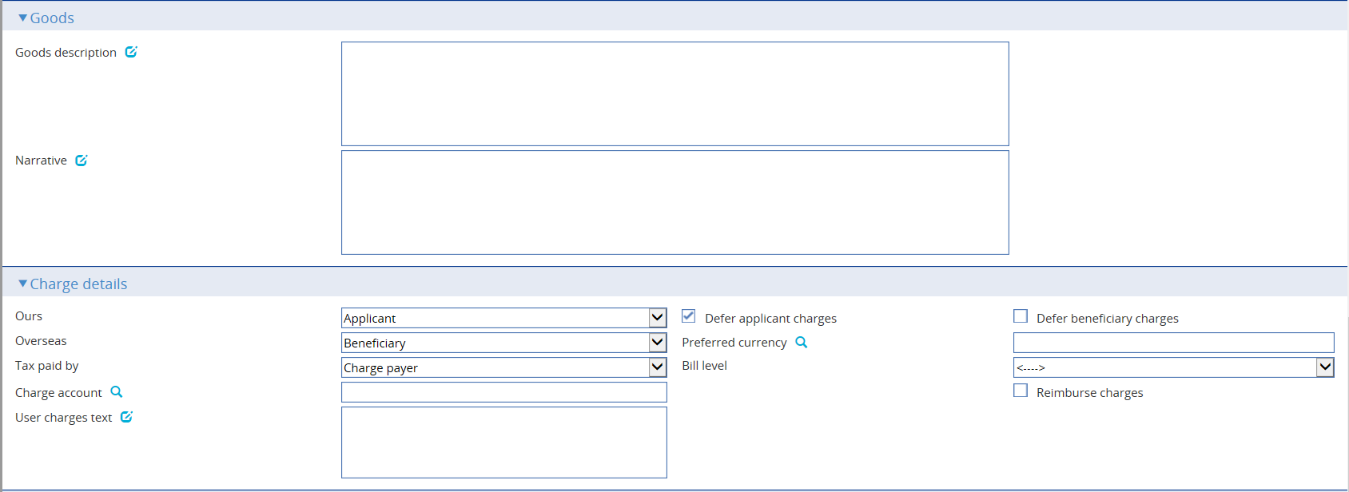

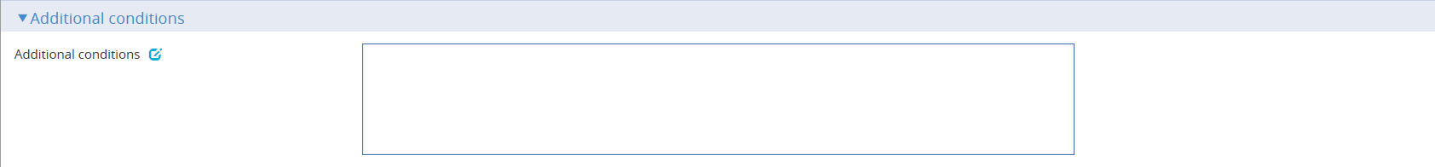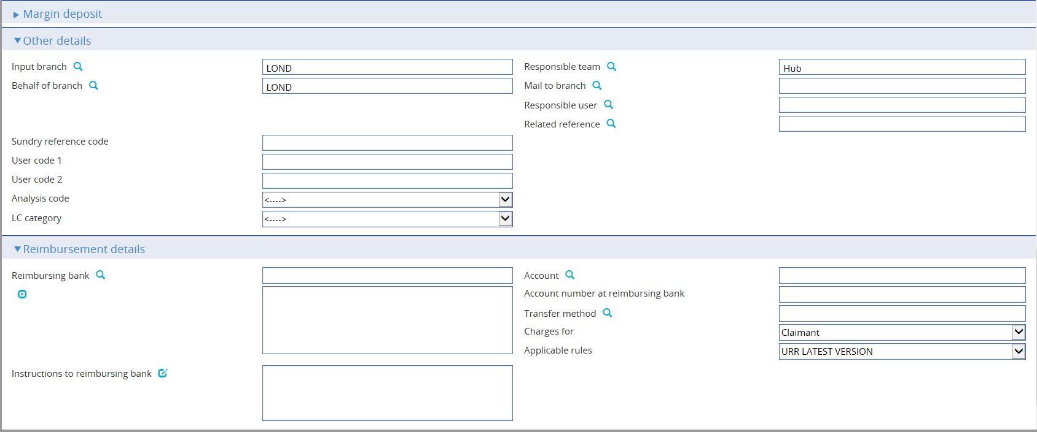

The window used during an Input step has the following panes:

* The Import LC Details Pane (see page 19)
* The Party Details Pane (see page 21)
* The Advising Bank Details Pane (see page 21)
* The Amount Details Pane (see page 21)
* The Available By/With Pane (see page 23)
* The Shipment Pane (see page 23)
* The Goods Pane (see page 24)
* The Charge Details Pane (see page 25)
* The Other Details Pane (see page 26)
* The Margin Deposits Pane (refer Common Facilities User Guide – Trade Innovation)
* The Reimbursement Details Pane (see page 27)

If your system is configured to support purchase orders, a Purchase Order button is displayed which accesses a window used to enter purchase order details (see page 43).

### The Import LC Details Pane

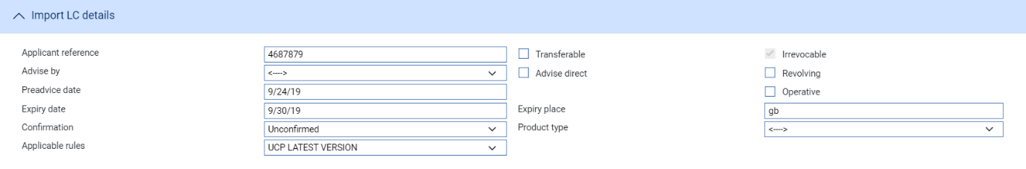

The following table explains what to enter into the fields in the Import LC Details pane:

|  |  |  |  |
| --- | --- | --- | --- |
|  | Field | What to Enter | |
|  | Applicant Reference | The applicant's reference for the letter of credit. | |
|  | Advise By | The transmission method to be used to notify the pre-advice. | |
|  |  |  | |
|  | Preadvice Date | The date on which the pre-advice is created. The system uses the current system date by default. | |
|  | Expiry Date | The letter of credit's expiry date. | |
|  | Confirmation | Select from one of the following values: | |
|  |  | Confirmed | If you want the requested confirmation party to confirm the letter of credit. |
|  |  | Unconfirmed | If you do not want the requested confirmation party to confirm the letter of credit. This is the default value. |
|  |  | May Add | If you have no preference whether the requested confirmation party confirms the letter of credit or not. |
|  | Applicable Rules | This allows you to select additional information to be included in the relevant SWIFT MT700 (MT710 and MT720) message generated by the event.  Select one of the following to indicate the rules applied to the issue of the documentary credit: | |
|  |  | UCP LATEST VERSION | The documentary credit is subject to the version of the ICC Uniform Customs and Practice for Documentary Credits, International Chamber of Commerce, Paris, that is in effect on the date of issue.  This is used as the default. |
|  |  | EUCP LATEST VERSION | The documentary credit is subject to the version of the Supplement of the ICC Uniform Customs and Practice for Documentary Credits for Electronic Presentations, International Chamber of Commerce, Paris, that is in effect on the date of issue. |
|  |  | UCPURR LATEST VERSION | The documentary credit is subject to the version of the ICC Uniform Customs and Practice for Documentary Credits and the version of the Uniform Rules for Bank-to-bank Reimbursements under documentary credits, International Chamber of Commerce, Paris, that is in effect on the date of issue. |
|  |  | EUCPURR LATEST VERSION | The documentary credit is subject to the version of the Supplement of the ICC Uniform Customs and Practice for Documentary Credits for Electronic Presentations and the version of the Uniform Rules for Bank-to-bank Reimbursements under documentary credits, International Chamber of Commerce, Paris, that is in effect on the date of issue. |
|  |  | ISP LATEST VERSION | For standby letters of credit only. The documentary credit is subject to the version of the ICC International Standby Practices, International Chamber of Commerce, Paris, that is in effect on the date of issue. |
|  |  | OTHR | The documentary credit is subject to other rules. Use the Other Applicable Rules field to specify those rules (up to 35 characters). |
|  | Transferable | Check this field if the letter of credit is transferable. | |
|  | Advise Direct | Check this box if the pre-advice is being advised directly to the beneficiary. If this is the case you cannot enter details of an advising bank. | |
|  | Expiry Place | The location at which the expiry date applies. | |
|  | Product Type | If your bank has set up product types for import letters of credit, select the appropriate one from the drop-down list on this field. Depending on how your system has been configured this field may be mandatory. | |
|  | Irrevocable | The ‘Irrevocable’ flag appears only when the Zone level system option, ‘AllowRevocableLCs’ is set to ‘No’ and the SWIFT version is 2018 or higher. In this case, the ‘Irrevocable’ flag is protected.  When the Zone level system option, ‘AllowRevocableLCs’ is set to ‘Yes’ and the System option, 'SWIFTversion' is 2018 or higher, the ‘Revocable’ flag appears and is unprotected. | |
|  | Revolving | Check this box if the letter of credit is a revolving credit. | |
|  | Operative | Indicate whether the letter of credit is operative or not. If you leave this box unchecked, then the letter of credit will remain inoperative until you use a subsequent event to change this box's setting. | |
|  | Gateway transaction refused | Displayed if the instruction to issue the letter of credit has been received via the gateway. Check this box if your bank wishes to reject the request to issue the letter of credit. | |

### The Advising Bank Details Pane

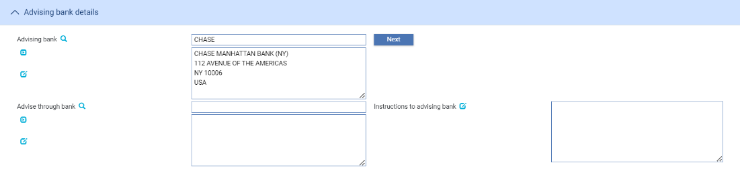

The following table explains what to enter into the fields in the Advising Bank Details pane:

|  |  |  |
| --- | --- | --- |
|  | Field | What to Enter |
|  | Advising Bank | The advising bank. |
|  | Advise Through Bank | The Advise Through bank. |
|  | Instructions to Advising Bank | Any instructions for the advising bank. |

### The Party Details Pane

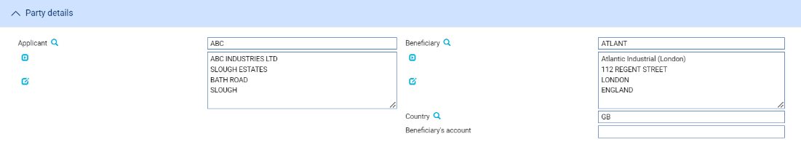

The following table explains what to enter into the fields in the Party Details pane:

|  |  |  |
| --- | --- | --- |
|  | Field | What to Enter |
|  | Applicant | The applicant.. |
|  | Beneficiary | The beneficiary.. |
|  | Country | The beneficiary's country of residence. |
|  | Beneficiary's Account | If known, enter the number of the beneficiary's account with the advising bank. |

### The Amount Details Pane

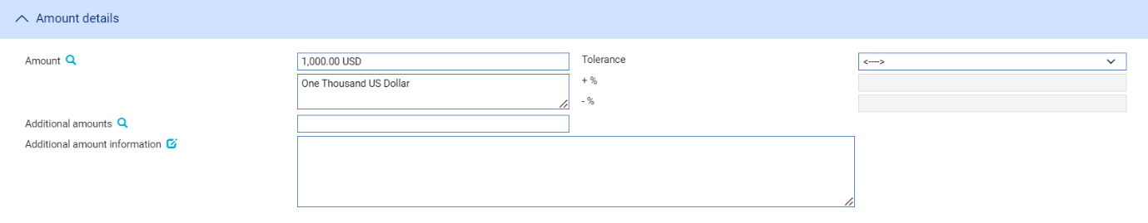

The following table explains what to enter into the fields in the Amount Details pane:

|  |  |  |
| --- | --- | --- |
| Field | What to Enter | |
| Amount | The amount and currency of the transaction. The system displays the amount and currency in the language of your system beneath these fields. You can edit this text, if necessary. | |
| Tolerance | Specify how the amount is being expressed. Select from one of the following: | |
|  | Exact | If the amount is the exact value of the letter of credit. |
|  | About | If the amount given in the Amount field is within 10% either way of the expected value of the letter of credit. |
|  | Other | If you select this option, use the -% and +% fields to specify as a percentage how much more or less than the final value of the letter of credit the amount entered is allowed to be. |
|  | Not Exceeding | If the final value of the letter of credit is expected to be no more than the amount entered, and not less than 95% of the amount entered. |
|  | Min/Max | If you select this option the system displays a + Amount and a - Amount field. Use them to specify as an amount how much more or less than the final value of the transaction the amount entered is allowed to be. |
| Additional Amounts | Any amounts payable to the beneficiary in addition to the principal amount of the transaction. These might include, for example, local freight charges.  If you enter an amount, it is added to the amount of liability under the transaction. If you use a different currency for the amount, then the amount is converted to the currency of the transaction using the current spot rate. | |
| Additional Amount Information | A text description of what any additional amounts are for. | |

### The Available By/With Pane

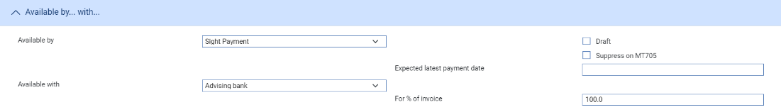

The First field is used to set the tenor of the payment. Refer *Common Facilities User Guide* – Trade Innovationfor instructions.

The following table explains what to enter into the remaining fields not covered by the Common Facilities User Guide – Trade Innovation:

|  |  |  |
| --- | --- | --- |
| Field | What to Enter | |
| Available With | Select from one of the following to indicate which party the beneficiary should present documents for payment to:   * Ourselves * Issuing Bank * Advising Bank * Any Bank * Any Bank in (city) - the system displays a field, into which you can enter the name of the city * Any Bank in (country) - the system displays a browser which you can use to select the country * (named bank) - the system displays fields which you can use to specify the bank   When you have made your selection additional fields may be displayed, depending on what you have selected: | |
|  | Country | If Available With is set to 'Any Bank in Country' identify the country. |
|  | City | If Available With is set to 'Any Bank in City' identify the city. |
|  | Named Bank | If Available With is set to 'Named Bank' identify the bank. |
| For % of Invoice | The percentage of the invoice value of the goods that the transaction covers. The system uses 100% as the default value. | |
| Suppress on MT705 | Whether to omit the Available With details from the MT705 Pre Advice. | |

### The Shipment Pane

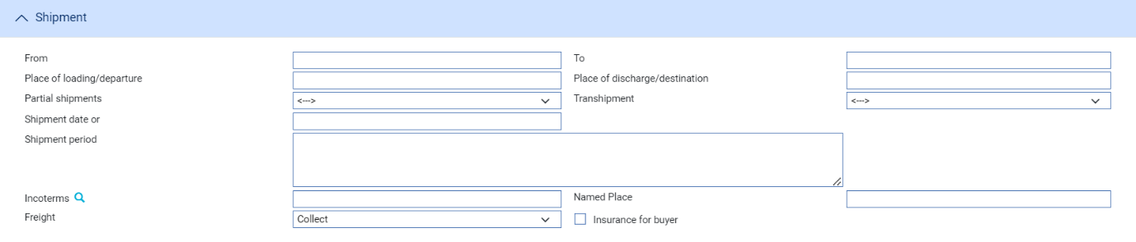

The following table explains what to enter into the fields in the Shipment pane. The Purchase Orders button is displayed only if your system is configured to use purchase orders with import letters of credit. It allows you to enter details of purchase orders against the letter of credit (see page 43):

|  |  |  |
| --- | --- | --- |
| Field | What to Enter | |
| From | The place of taking in charge of the goods. | |
| To | The final destination of the goods. | |
| Place of Loading/ Departure | The port or airport where the goods were loaded. | |
| Place of Discharge/Destination | The port or airport for which the goods are destined. | |
| Partial Shipments/ Transhipments | Select from the following values: | |
|  | Blank | to leave the field blank in the associated SWIFT message |
|  | Allowed | If partial shipments/transhipments are permitted for this letter of credit. |
|  | Not Allowed | If partial shipments/transhipments are not permitted for this letter of credit. |
|  | Conditional | If selected then the user should specify conditions in the Additional conditions narrative. |
| Shipment Date | The latest shipment date allowed. | |
| Shipment Period | Specify the period of time during which goods are to be loaded or despatched. | |
| Incoterms | Select incoterms. | |
| Named Place | The Place where the Seller will make the goods available for the buyer. | |
| Freight | When you select a value in the Incoterms field, the system automatically selects the appropriate value in this field using information set up for the selected incoterms to indicate whether freight is to be pre-paid or paid on collection. You can override this value. | |
| Insurance for Buyer | When you select a value in the Incoterms field, the system automatically selects the appropriate value in this field using information set up for the selected incoterms to indicate whether the buyer is to provide insurance cover or not. The field is checked if insurance cover is to be provided by the buyer. You can override the value displayed here. | |

### The Goods Pane

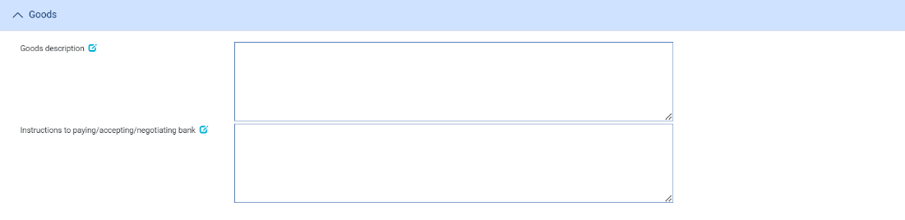

The following table explains what to enter into the fields in the Goods pane:

|  |  |
| --- | --- |
| Field | What to Enter |
| Goods Description | A narrative description of the goods. |
| Instructions to Paying/Accepting/Negotiating Bank | Any instructions for the paying or accepting or negotiating bank |
| Purchase Orders | An optional module permits you to record details of purchase orders against import letters of credit. If the system option- ‘PurchaseOrdersImplemented’ is enabled. |

### The Charge Details Pane

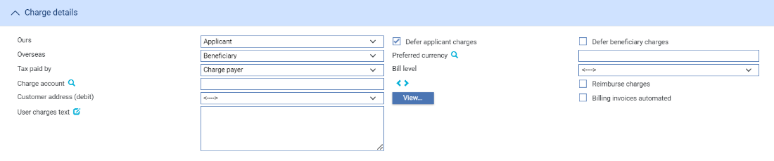

The following table explains what to enter into the fields in the Charge Details pane:

|  |  |
| --- | --- |
| Field | What to Enter |
| Ours | Specify which party - the beneficiary or the applicant - will pay your bank's charges. |
| Defer Applicant Charges | Indicate whether your own charges are to be collected now or deferred until payment. Check this box if the charges are to be deferred, otherwise leave it blank. |
| Defer Beneficiary Charges | Indicate whether your own charges to the beneficiary are to be collected now or  deferred until payment. Check this box if the charges are to be deferred, otherwise  leave it blank. |
| Overseas | Specify which party - the beneficiary or the applicant - will pay overseas charges. |
| Preferred Currency | The currency in which your bank's own charges will be collected. Typically, you would set this to your local currency. If you leave this field blank, the system uses the currency of the letter of credit.  Where the charges are for the applicant, the setting here is overridden by the applicant's preferred currency. |
| Charge Account | The number of the account used for any charges debited to the customer. Charge accounting is normally controlled by the standing settlement instructions for charges. Entering an account number here overrides the account specified in the standing settlement instructions. |
| Tax Paid By | Specify which party - your customer or the party liable for charges - will pay any tax due on the letter of credit or its charges. |
| Bill Level | Select whether charges for this license should be billed at customer level, transaction level or product level. |
| Customer Address (Debit) | The charge payer customer’s address defaults to their prime address. The customer’s  alternative address can be selected using the list field.  Note: This list excludes the customer’s prime and SWIFT address types. Use the adjacent View button to display the chosen address in full. |
| Reimburse Charges | Check this box if all the charges associated with the transaction is for the beneficiary, and you wish to debit these to the applicant's account as the letter of credit is issued. If this is the case, the applicant is reimbursed once the beneficiary settles. |
| Billing Invoice Automated | This check box can be used to indicate whether the invoices for charges generated by the transaction (e.g. Billing settlement event) are automatically generated or not. |
| User Charges Text | Any additional information concerning the charges. |

### The Other Details Pane

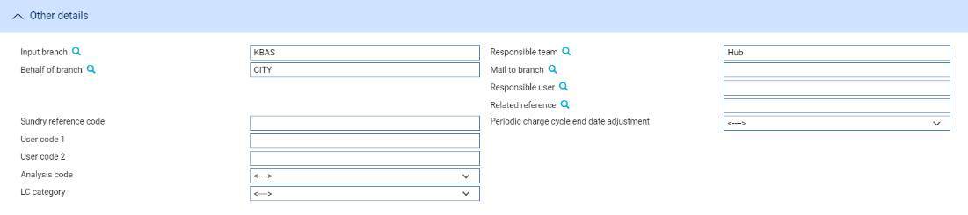

The following table explains what to enter into the fields in the Other Details pane. This pane may also include input fields defined by your bank:

|  |  |  |
| --- | --- | --- |
|  | Field | What to Enter |
|  | Input Branch | The input branch for the transaction. The input branch is set from either:   * the accounting branch from the user’s team, or * the transaction branch for user if the user has a default transaction branch or is locked to a specific branch, or * a branch associated with the user where the user can enter transactions for several branches for a team |
|  | Behalf Of Branch | The behalf of branch for the transaction as entered by the user or set from the incoming SWIFT or gateway message. The behalf of branch determines the parameter sets that are to be used to generate charges, documents, postings, etc. during transaction processing. The branch can be changed to any other branch within the same main banking entity that shares the same parameter sets. |
|  | Sundry Ref Code /User Code 1/ User Code 2 | You may use these fields to enter values for analysis purposes. Your bank will have devised its own system for using these fields. |
|  | Analysis Code/LC Category | User definable fields. These can be configured in System Tailoring | List Values/Field Mapping. |
|  | Responsible Team | The team that has overall responsibility for the master e.g. as the contact to resolve any queries or issues regarding the master and associated events. The system defaults the responsible team when creating the transaction as follows:   * Manual – set from team creating the transactionshi * Gateway – set from the team specified on the incoming message (if present and valid) otherwise to the team to which the transaction is assigned through workflow allocation based on the behalf of branch * SWIFT – set to the team to which the transaction is assigned through workflow allocation based on the behalf of branch   It can be changed, if required, to either the team associated with the primary customer, default team for the product or the user’s current team. |
|  | Mail To Branch | The mail to branch can be set to any branch within the main banking entity of the behalf of branch. |
|  | Responsible User | A user that has responsibility for the master e.g. as the contact to resolve any queries or issues regarding the master and associated events. This can be any user assigned to the responsible team. |
|  | Related Reference | You can specify any other transaction to which this letter of credit is related. This may already have been done when the master record was created. You can use the browser to select from possible references to include. |
|  | Periodic Charge Cycle End Date Adjustment | Select what happens when a periodic charge cycle end date falls on a non-business/working day. See the *System Tailoring User Guide – Trade Innovation* for more information. |

### The Reimbursement Details Pane

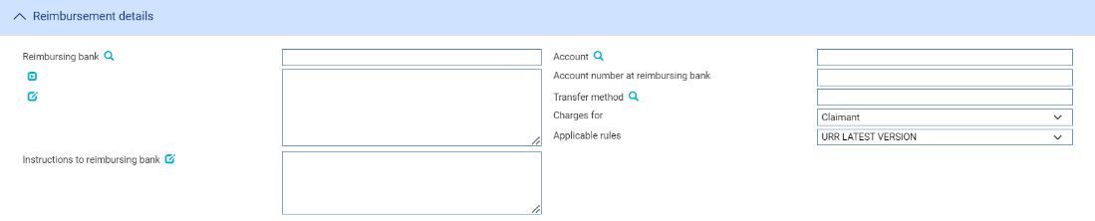

The following table explains what to enter into the fields in the Reimbursement Details pane:

|  |  |  |
| --- | --- | --- |
| Field | What to Enter | |
| Reimbursing Bank | If the transaction involves a reimbursing bank, use this field to identify it.. | |
| Account | The number of the reimbursing bank’s account in your bank’s books to be credited. | |
| Account Number at Reimbursing Bank | The number of your bank’s account with the reimbursing bank. | |
| Transfer Method | The method to be used when paying funds via the reimbursing bank. | |
| Charges For | Select whether the reimbursing bank’s charges are paid by the claimant or the issuing bank. | |
| Instructions to Reimbursing Bank | Any instructions for the reimbursing bank. | |
| Applicable Rules | This allows you to select additional information regarding the terms of the reimbursement.  Select one of the following to indicate the rules applied to the issue of the documentary credit under reimbursement instructions: | |
|  | URR VERSION | The documentary credit is subject to the version of the ICC Uniform Rules for Bank to Bank Reimbursement, International Chamber of Commerce, Paris that is in effect on the date of issue.  This is used as the default |
|  | NOTURR | The documentary credit is not subject to the version of the ICC Uniform Rules for Bank to Bank Reimbursement, International Chamber of Commerce, Paris, that is in effect on the date of issue. |

## Issuing an Import Letter of Credit

You can create an Issue event in one of two ways:

If you have not already created the letter of credit using a Pre Advise event, in the Masters window, select the Team and Behalf of branch and use the drop-down list in the New Masters pane to select ‘Import Letter of Credit – Issue’, then click **New**.

If your system has been configured to allow the incorporation of legacy transactions into the system, an Original Reference field is present in the New Masters pane. This is for use when entering transactions from the legacy system manually. It allows you to enter the legacy system’s unique reference for the transaction. If you enter a value here, it must be unique within the system for import letters of credit.

If you have already created a Pre Advise event for the letter of credit, in the Master Summary window select ‘Issue’ from the Create New Event drop-down list and click **Create**.

In either case the system creates an Issue event at either at a log or an input step depending on how the Workflow orchestration controlling the event is configured. Refer *Workflow Tailoring User Guide* – Trade Innovation for details.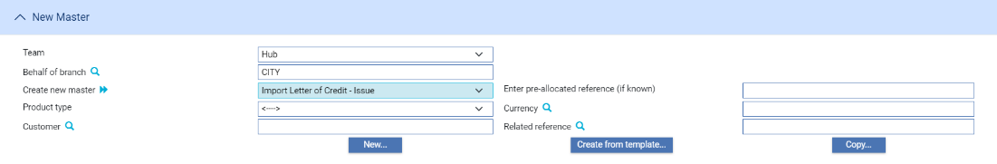

### Entering Full Details of the Issuance

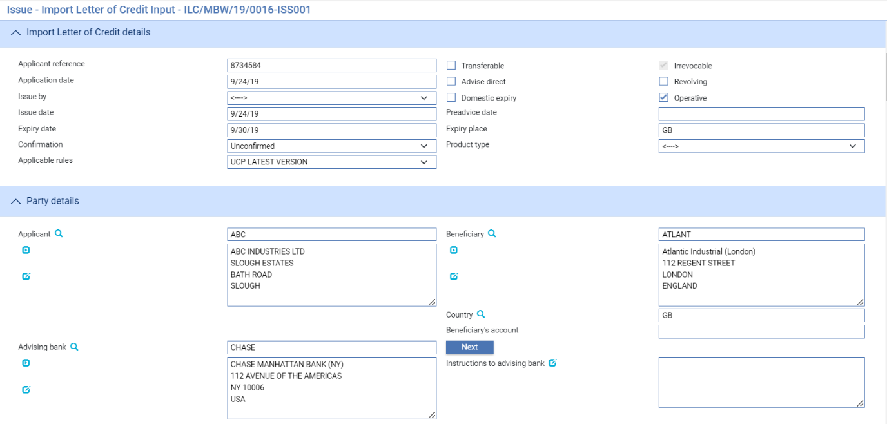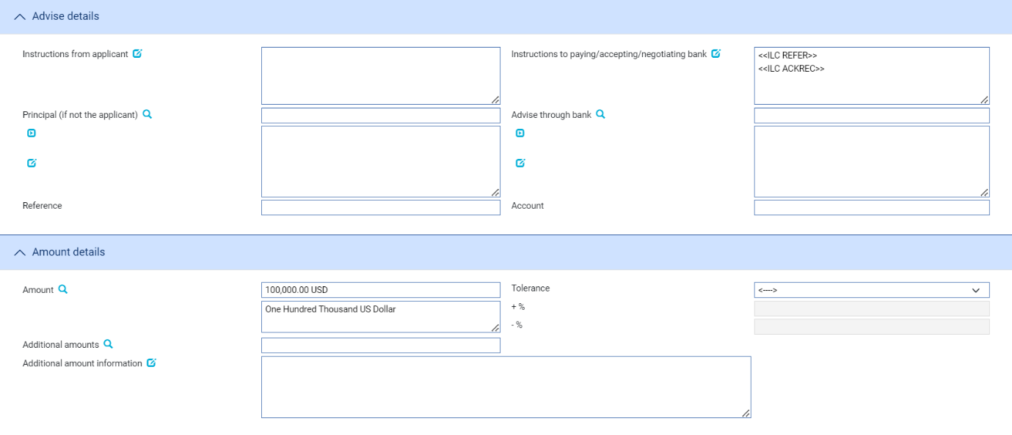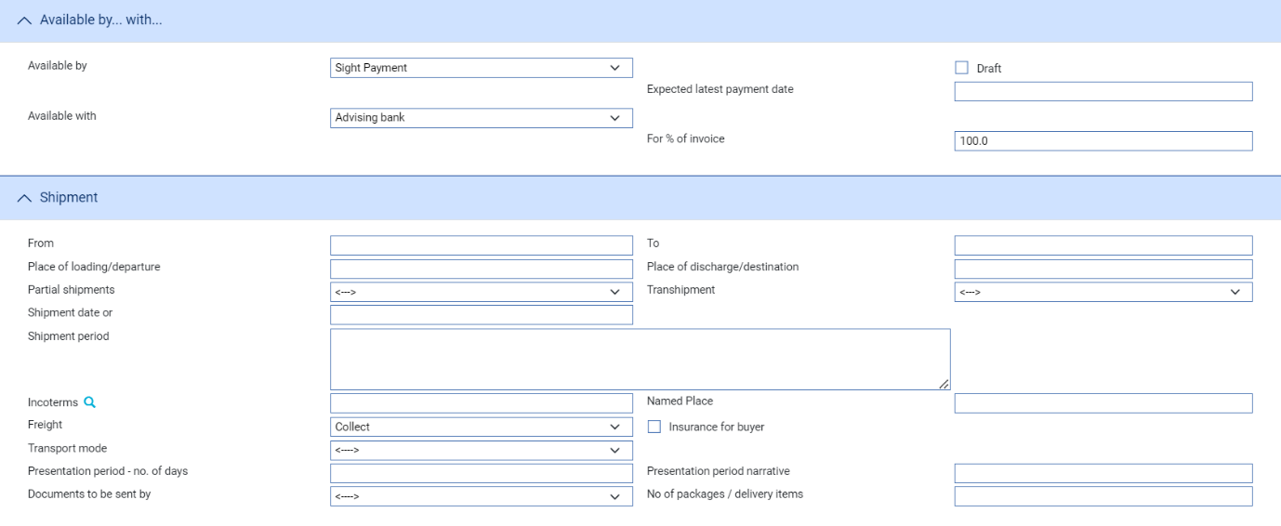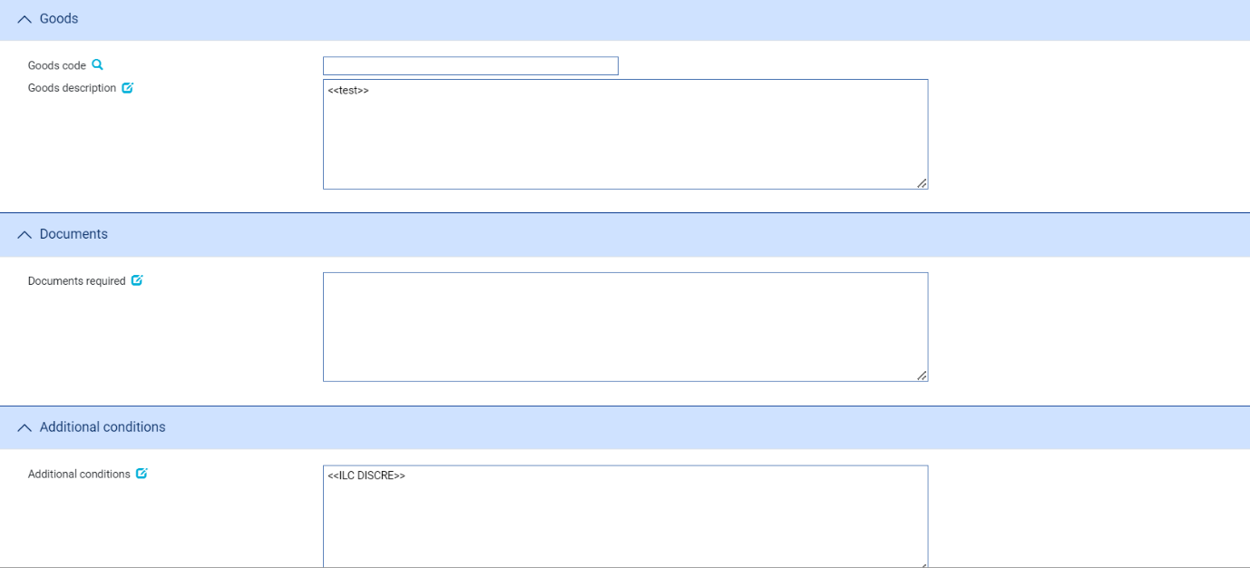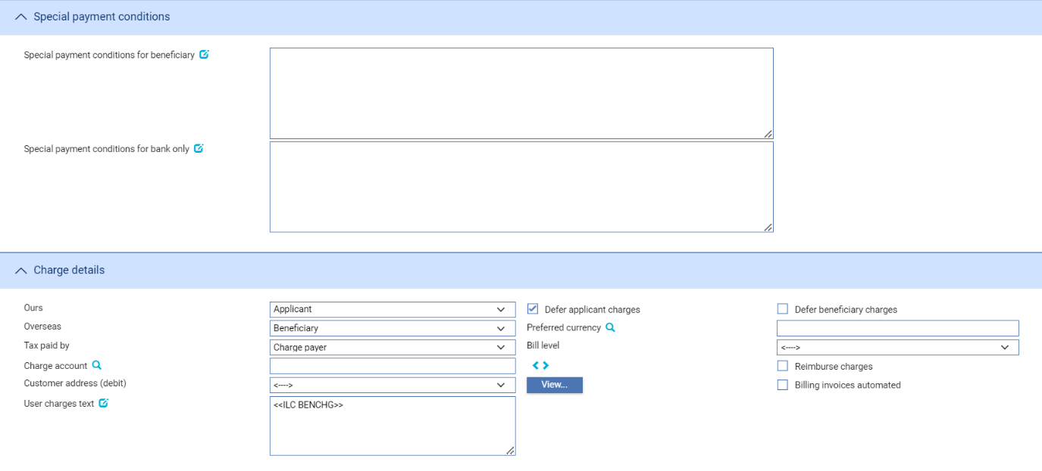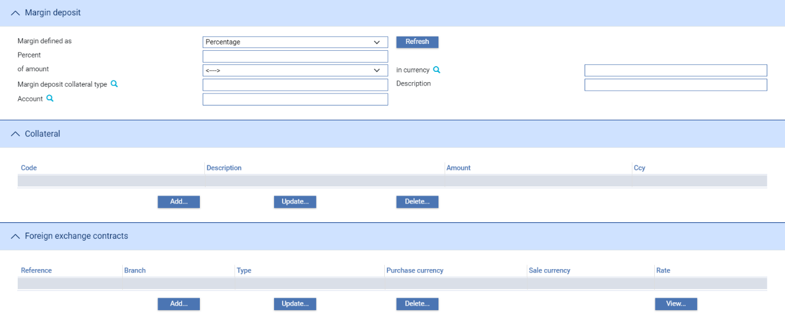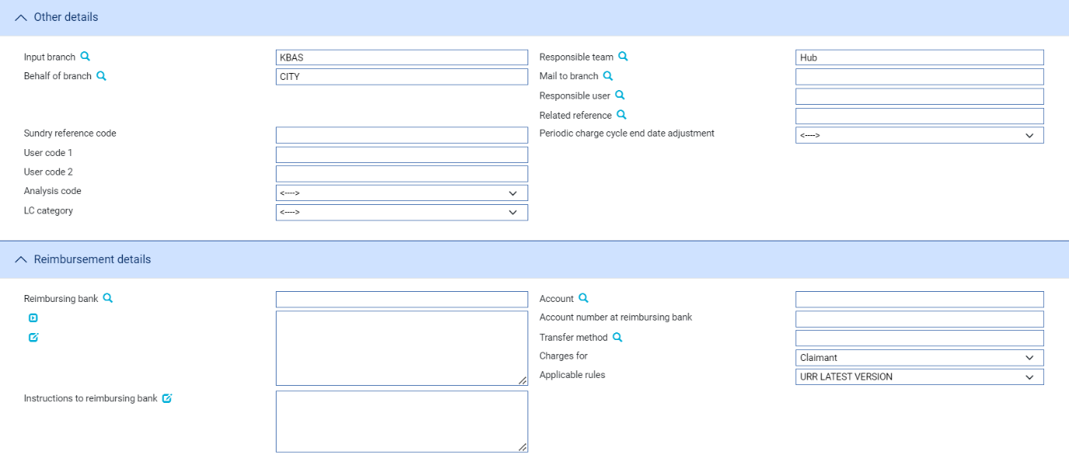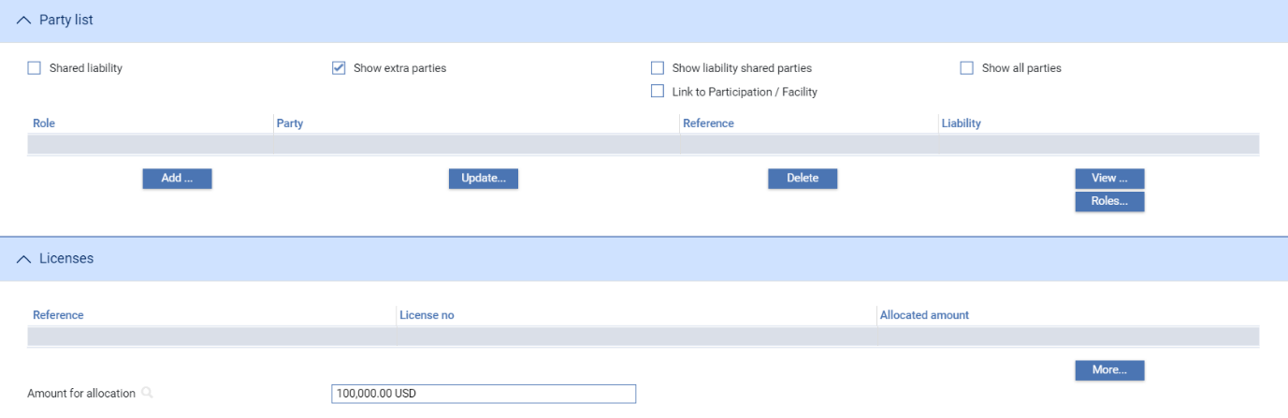

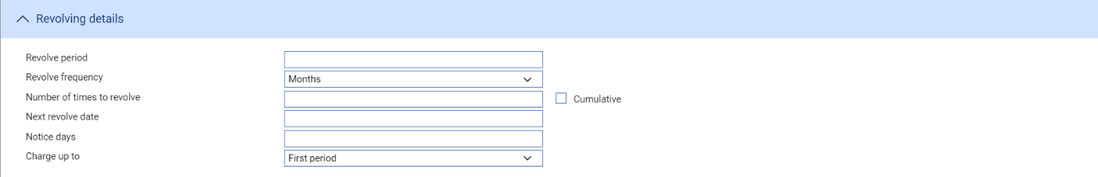

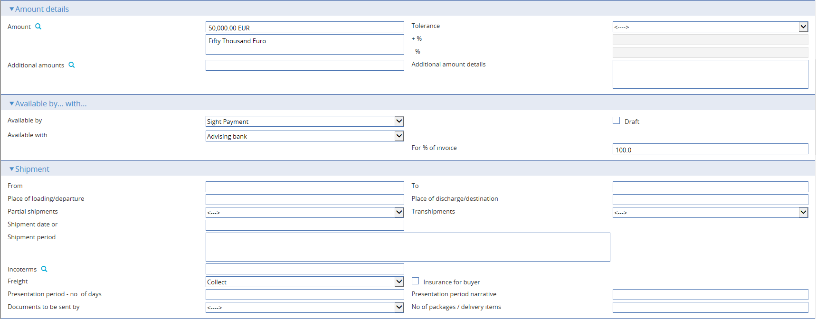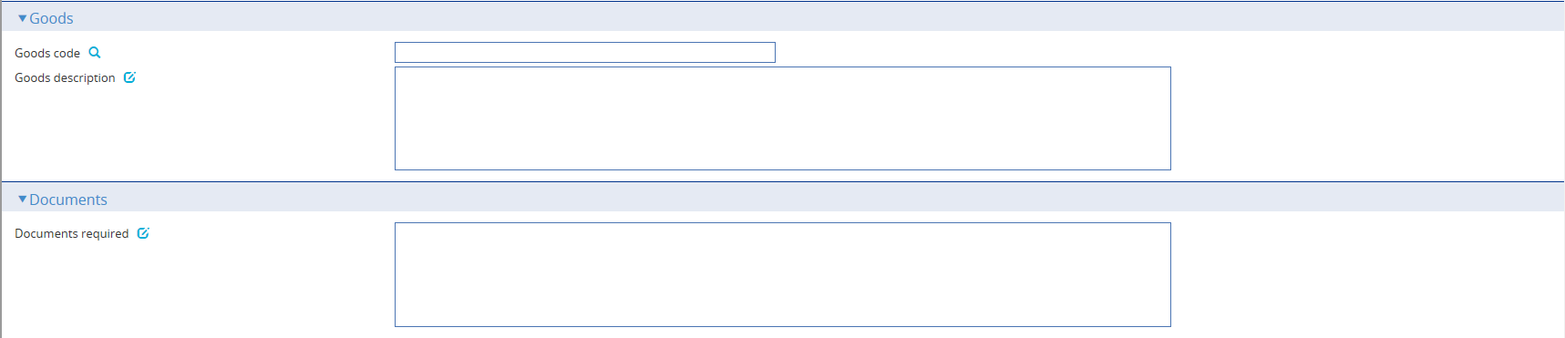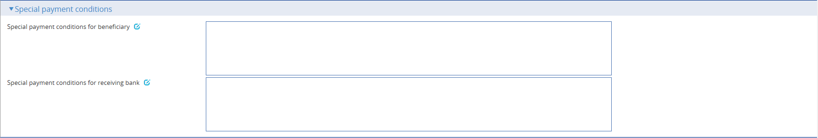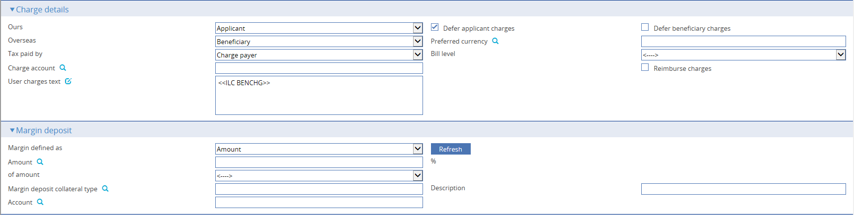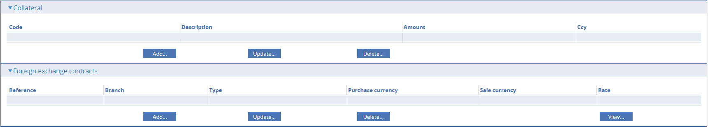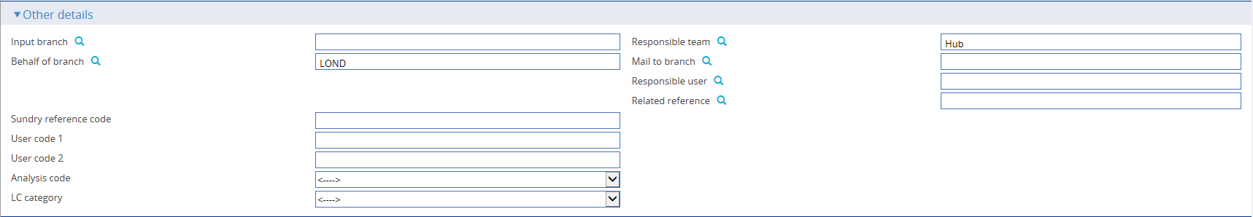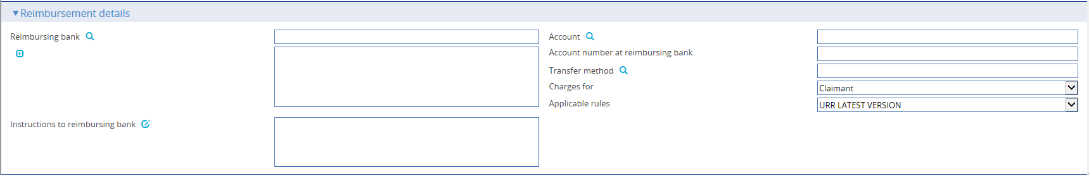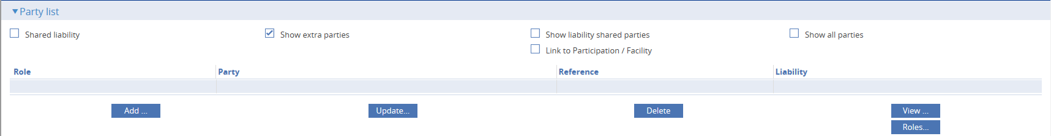

The window used during an Input step has the following panes:

* The Import LC Details Pane (see page 32)
* The Party Details Pane (see page 35)
* The Advise Details Pane (see page 35)
* The Amount Details Pane (see page 36)
* The Available By/With Pane (see page 37)
* The Shipment Pane (see page 38)
* The Goods Pane (see page 39)
* The Documents Pane (see page 39)
* The Additional Conditions Pane (see page 39)
* The Special Payment Conditions Pane (see page 39)
* The Charge Details Pane (see page 40)
* The Margin Deposit Pane
* The Collateral Pane
* The Foreign Exchange Contracts Pane
* The Other Details Pane (see page 41)
* The Reimbursement Details Pane (see page 42)
* The Party List Pane
* The Licenses Pane
* The Revolving Details Pane (see page 43)

If your system is configured to support purchase orders, the Purchase Orders button is displayed, and accesses a window used to enter purchase order details (see page 43).

Instructions on using the Margin Deposit pane, the Collateral pane, the FX Contracts pane and the Party List pane are given in the Common Facilities User Guide – Trade Innovation.

### The Import LC Details Pane

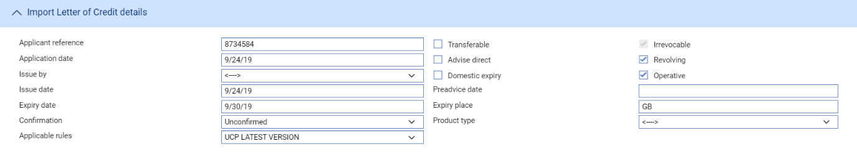

The following table explains what to enter into the fields in the Import LC Details pane:

|  |  |  |  |
| --- | --- | --- | --- |
|  | Field | What to Enter | |
|  | Applicant Reference | The applicant’s reference number for the letter of credit, taken from their application. | |
|  | Application Date | The date of the application. The system uses today’s date as the default. | |
|  | Issue By | The method of transmission to be used to send the letter of credit. If you leave this field blank the system will use the method specified in the address details for the recipient of the letter of credit. | |
|  | Issue Date | The letter of credit’s issuance date. This defaults to today’s processing date. | |
|  | Preadvice Date | This is displayed automatically if a pre-advice was sent before issuance. If the letter of credit has not been pre-advised, leave this field blank. | |
|  | Advise Direct | Check this box if the letter of credit is being advised directly to the beneficiary. If this is the case you cannot enter details of an advising bank. | |
|  | Domestic Expiry | Check this box if the letter of credit expires in the bank’s operating country. By default, the letter of credit expires overseas. Depending on whether the letter of credit expires locally or overseas, the system will display a different date for the expiry of the master. This date depends on product options set up by your bank. | |
|  | Expiry Date | The expiry date of the letter of credit. | |
|  | Expiry Place | The location at which the expiry date applies. | |
|  | Transferable | Check this field if the letter of credit is transferable. You must check this field to be able to create transfer letters of credit using this letter of credit as the parent.  This field is disabled if you check the Standby Transaction field. | |
|  | Irrevocable | The ‘Irrevocable’ flag appears only when the Zone level system option, ‘AllowRevocableLCs’ is set to ‘No’ and the SWIFT version is 2018 or higher. In this case, the ‘Irrevocable’ flag is protected.  When the Zone level system option, ‘AllowRevocableLCs’ is set to ‘Yes’ and the System option, 'SWIFTversion' is 2018 or higher, the ‘Revocable’ flag appears and is unprotected. | |
|  | Revolving | Check this field if the letter of credit is revolving. | |
|  | Operative | Indicate whether the letter of credit is operative. By default, the letter of credit is operative and the box is checked. Click on the box so that it is unchecked to change to No. If you do this, the letter of credit will remain inoperative until it is amended to make it operative.  If you try to create any other event while the letter of credit is not operative, a warning will be displayed. | |
|  | Confirmation | Select from one of the following values: | |
|  |  | Confirmed | If you want the requested confirmation party to confirm the letter of credit. |
|  |  | Unconfirmed | If you do not want the requested confirmation party to confirm the letter of credit. This is the default value. |
|  |  | May Add | If you have no preference whether the requested confirmation party confirm the letter of credit or not. |
|  |  | This field is mandatory unless you have checked the Advise Direct field to indicate that there is no advising bank. | |
|  | Product Type | If your bank has set up product types for import letters of credit, select the appropriate one from the drop-down list on this field. Depending on how your system has been configured, this field may be mandatory. | |
|  | Applicable Rules | Allows you to select additional information to be included in the relevant SWIFT MT700 (MT710 and MT720) message generated by the event.  Select one of the following to indicate the rules applied to the issue of the documentary credit: | |
|  |  | UCP LATEST VERSION | The documentary credit is subject to the version of the ICC Uniform Customs and Practice for Documentary Credits, International Chamber of Commerce, Paris, that is in effect on the date of issue.  This is used as the default. |
|  |  | EUCP LATEST VERSION | The documentary credit is subject to the version of the Supplement of the ICC Uniform Customs and Practice for Documentary Credits for Electronic Presentations, International Chamber of Commerce, Paris, that is in effect on the date of issue. |
|  |  | UCPURR LATEST VERSION | The documentary credit is subject to the version of the ICC Uniform Customs and Practice for Documentary Credits and the version of the Uniform Rules for Bank-to-bank Reimbursements under documentary credits, International Chamber of Commerce, Paris, that is in effect on the date of issue. |
|  |  | EUCPURR LATEST VERSION | The documentary credit is subject to the version of the Supplement of the ICC Uniform Customs and Practice for Documentary Credits for Electronic Presentations and the version of the Uniform Rules for Bank-to-bank Reimbursements under documentary credits, International Chamber of Commerce, Paris, that is in effect on the date of issue. |
|  |  | ISP LATEST VERSION | For standby letters of credit only. The documentary credit is subject to the version of the ICC International Standby Practices, International Chamber of Commerce, Paris, that is in effect on the date of issue. |
|  |  | OTHR | The documentary credit is subject to other rules. Use the Other Applicable Rules field to specify those rules (up to 35 characters). |
|  | Other Applicable Rules | Displayed only if you select OTHR in the previous field. | |
|  | Final Wording | Check this box to indicate the final version of the contract or detail related to the Letter of credit that is agreed with the Applicant. | |
|  | Applicant | The applicant. | |
|  | Beneficiary | The beneficiary. | |
|  | Country | The beneficiary’s country of residence. | |
|  | Beneficiary’s Account | If known, enter the number of the beneficiary’s account with the advising bank. | |
|  | Advising Bank | The advising bank. If the applicant has not specified an advising bank to be used, then once you have identified the country of residence of the beneficiary, the system will display your default correspondent bank in that country, if you have one.  If it is your bank’s policy to use correspondent banks in sequence, the system will display details of the next bank to be used. You will be able to use the Next button to display details of each correspondent bank in the sequence in turn. | |
|  | Instructions to Advising Bank | Any instructions for the advising bank. | |
|  | Provisional | Check this box if the event is to be treated as ‘Provisional’, in which case a subsequent version of the event is required before the event can be completed. | |
|  | Automatically create follow-on event | Checking this box enables the system to automatically create a subsequent version of the event at an Input step; otherwise a new version of the event needs to be created manually. | |

### The Party Details Pane

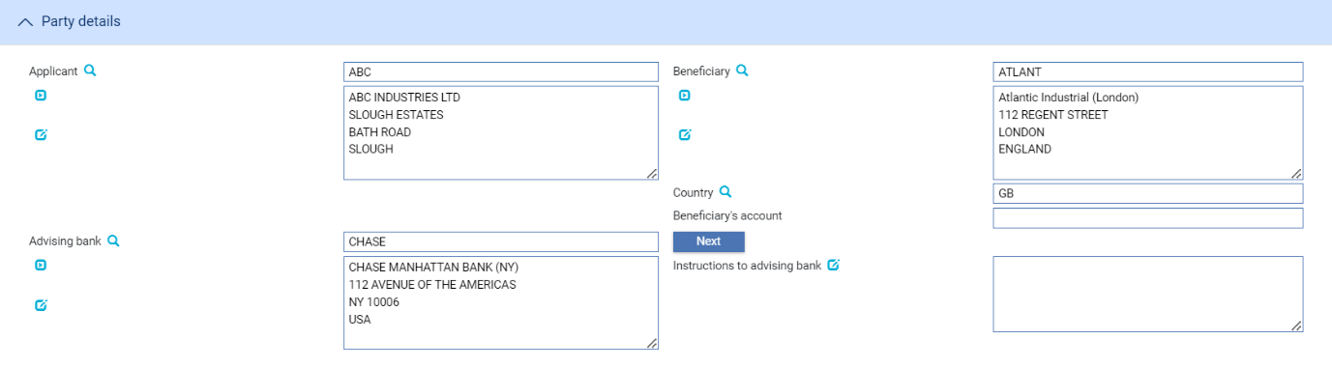

The following table explains what to enter into the fields in the Party Details pane:

### The Advise Details Pane

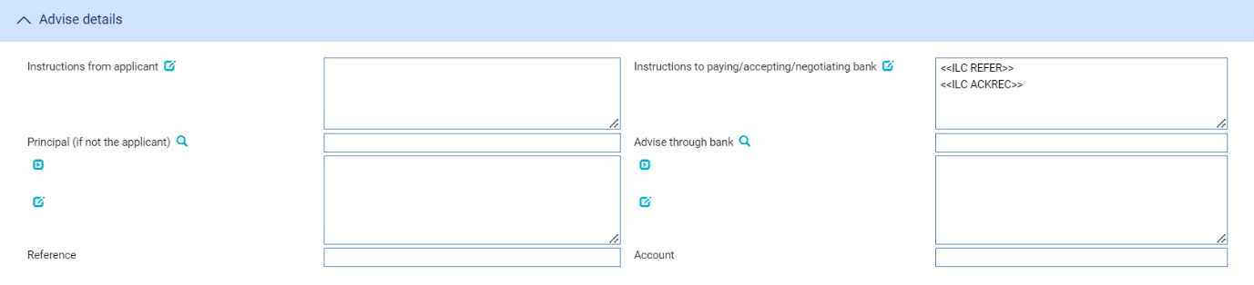

The following table explains what to enter into the fields in the Advise Details pane:

|  |  |  |
| --- | --- | --- |
| Field | What to Enter | |
| Instructions from Applicant | Any instructions received from the applicant. | |
| Instructions to Paying/Accepting/Negotiating Bank | Any instructions for the paying or accepting or negotiating bank. | |
| Principal (If Not the Applicant) | The principal party, if the principal party is not the applicant. The field is displayed when Issuer is set to Bank. | |
| Reference | If the principal party is not the applicant, enter the principal party’s reference for the letter of credit here. | |
| Advise Through Bank | The Advise Through bank. | |
| Account | The number of the beneficiary’s account at the advise through bank. | |
| Requested Confirmation Party | Select one of the following options: | |
|  | Blank | The default value for this field. |
|  | Advising Bank | If you want the advising bank to add its confirmation or may add its confirmation. |
|  | Advise Through Bank | If you want the advise through bank to add its confirmation or may add its confirmation. |
|  | OTHER | If you want other bank to add its confirmation or may add its confirmation. |
|  | This field is displayed and mandatory when confirmation is set to CONFIRMED or MAYADD. | |
| Requested Confirmation Party – Other | The name and address of the bank which is requested to add its confirmation or may add its confirmation.  This field is displayed and mandatory when Requested Confirmation Party is set to Other. | |
| Confirmation charges payable by | Select from one of the following options: | |
|  | Blank | The default value for this field. |
|  | Applicant | If you want the applicant to be responsible for payment of confirmation charges |
|  | Beneficiary | If you want the beneficiary to be responsible for payment of confirmation charges |
|  | This field is displayed and mandatory when confirmation is set to CONFIRMED or MAYADD. | |

### The Amount Details Pane

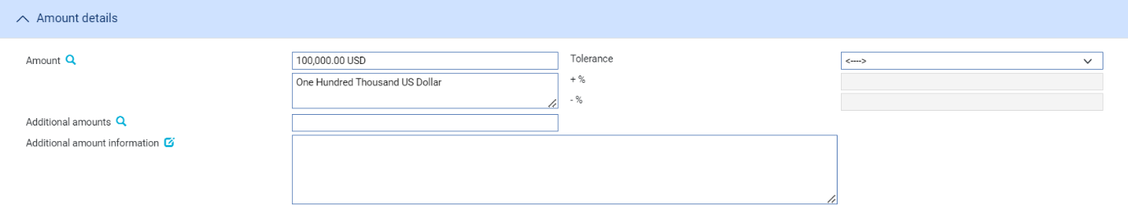

The following table explains what to enter into the fields in the Amount Details pane:

|  |  |  |
| --- | --- | --- |
| Field | What to Enter | |
| Amount | The amount and currency of the transaction. The system displays the amount and currency in the language of your system beneath these fields. You can edit this text, if necessary. | |
| Tolerance | Specify how the amount is being expressed. Select from one of the following: | |
|  | Exact | If the amount is the exact value of the letter of credit. |
|  | About | If the amount given in the Amount field is within 10% either way of the expected value of the letter of credit. |
|  | Other | If you select this option, use the -% and +% fields to specify as a percentage how much more or less than the final value of the letter of credit the amount entered is allowed to be. |
|  | Not Exceeding | If the final value of the letter of credit is expected to be no more than the amount entered, and not less than 95% of the amount entered. |
|  | Min/Max | If you select this option the system displays a + Amount and a – Amount field. Use them to specify as an amount how much more or less than the final value of the transaction the amount entered is allowed to be. |
| Additional Amounts | Any amounts payable to the beneficiary in addition to the principal amount of the transaction. These might include, for example, local freight charges.  If you enter an amount, it is added to the amount of liability under the transaction. If you use a different currency for the amount, then the amount is converted to the currency of the transaction using the current spot rate. | |
| Additional Amount Information | A text description of what any additional amounts are for. | |

### The Available By/With Pane

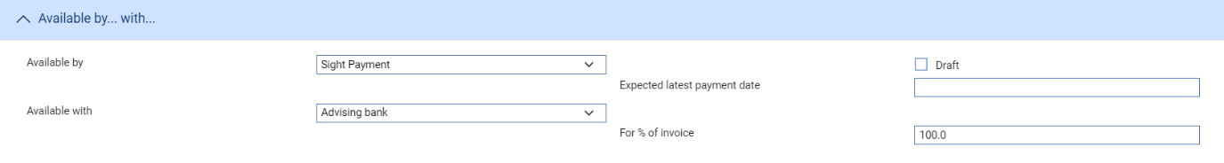  
The First field is used to set the tenor of the payment. Refer *Common Facilities User Guide* – Trade Innovation for instructions. The default value is Sight Payment.

The following table explains what to enter into the remaining fields not covered by the Common Facilities User Guide – Trade Innovation:

|  |  |  |
| --- | --- | --- |
| Field | What to Enter | |
| Available With | Select from one of the following to indicate which party the beneficiary should present documents for payment to:   * Ourselves * Issuing Bank * Advising Bank * Any Bank * Any Bank in (city) – the system displays a field, into which you can enter the name of the city * Any Bank in (country) – the system displays a browser which you can use to select the country * (named bank) – the system displays fields which you can use to specify the bank   When you have made your selection additional fields may be displayed, depending on what you have selected: | |
|  | Country | If Available With is set to ‘Any Bank in Country’ identify the country. |
|  | City | If Available With is set to ‘Any Bank in City’ identify the city. |
|  | Named Bank | If Available With is set to ‘Named Bank’ identify the bank. |
| For % of Invoice | The percentage of the invoice value of the goods that the transaction covers. The system uses 100% as the default value. | |
| Draft | Indicates whether the drafts are being held by your bank or not. | |

### The Shipment Pane

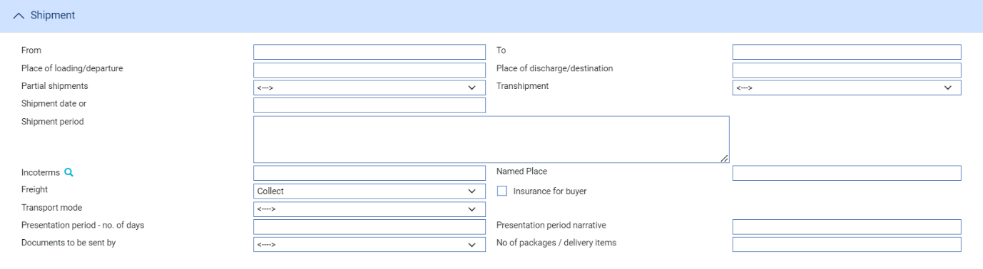

The following table explains what to enter into the fields in the Shipment pane. A Purchase Orders button is displayed if your system is configured to use purchase orders with import letters of credit. It allows you to enter details of purchase orders against the letter of credit (see page 43):

|  |  |  |
| --- | --- | --- |
| Field | What to Enter | |
| From | The place of taking in charge of the goods. | |
| To | The final destination of the goods. | |
| Place of Loading/ Departure | The port or airport where the goods were loaded. | |
| Place of Discharge/Destination | The port or airport for which the goods are destined. | |
| Partial Shipments/ Transhipments | Select one from the following values: | |
|  | Blank | To leave the field blank in the associated SWIFT message. |
|  | Allowed | If partial shipments/ransshipments are permitted for this letter of credit. |
|  | Not Allowed | If partial shipments/ransshipments are not permitted for this letter of credit. |
|  | Conditional | If selected then the user should specify conditions in the Additional conditions narrative. |
| Shipment Date | The latest shipment date allowed. | |
| Shipment Period | Specify the period of time during which goods are to be loaded or despatched. | |
| Incoterms | Select incoterms. | |
| Named Place | The Place where the Seller will make the goods available for the buyer. | |
| Freight | When you select a value in the Incoterms field, the system automatically selects the appropriate value in this field using information set up for the selected incoterms to indicate whether freight is to be pre-paid or paid on collection. You can override this value. | |
| Insurance for Buyer | When you select a value in the Incoterms field the system automatically selects the appropriate value in this field using information set up for the selected incoterms to indicate whether the buyer is to provide insurance cover or not. The field is checked if insurance cover is to be provided by the buyer. You can override the value displayed here. | |
| Transport Mode | Specify the mode of transport used for shipping goods. | |
| Presentation Period/Presentation Period Narrative | Specify the number of calendar days after the date of shipment within which the documents must be presented for payment, acceptance or negotiation. Narrative must only be used to specify another type of date than a shipment date, for example invoice date, from which the period for presentation begins.  A default value is set automatically; calculated using the latest shipping date and the expiry date, but this default can be overridden. | |
| Documents to be Sent By | The method to be used to send documents. | |
| No of Packages/Delivery Items | Specify how many mailings are to be made. | |

### The Goods Pane

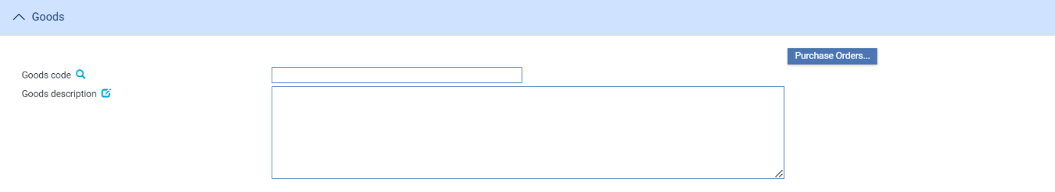

|  |  |
| --- | --- |
| Field | What to Enter |
| Goods code | Select a goods code. |
| Goods description | Enter a narrative description of the goods being delivered under the terms of the letter of credit. |
| Purchase Orders | An optional module permits you to record details of purchase orders against import letters of credit. If the system option- ‘PurchaseOrdersImplemented’ is enabled. |

### The Documents Pane

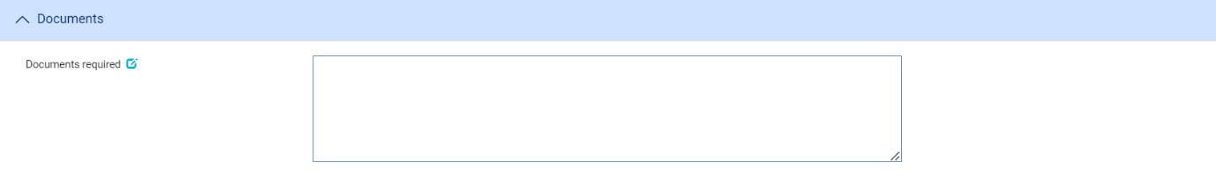

|  |  |
| --- | --- |
| Field | What to Enter |
| Documents required | Enter a narrative description of any documents required to support the transaction. |

### The Additional Conditions Pane

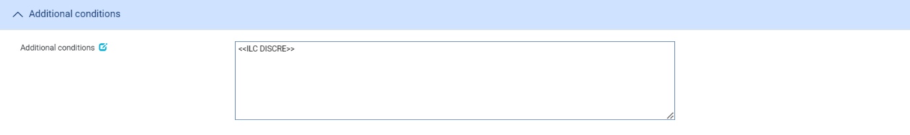

|  |  |
| --- | --- |
| Field | What to Enter |
| Additional conditions | Enter a narrative description of any additional conditions. |

### The Special Payment Conditions Pane

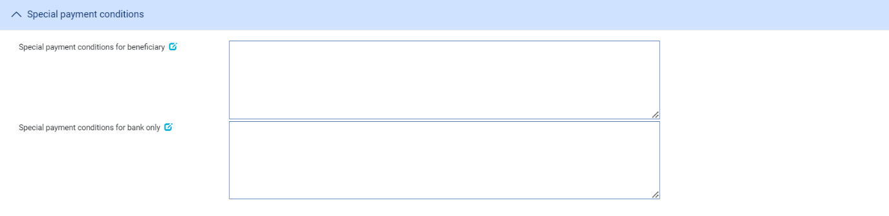

The following table explains what to enter into the fields in the Special Payment Conditions pane:

|  |  |
| --- | --- |
| Field | What to Enter |
| Special payment conditions for beneficiary | Specify special payment conditions applicable to the beneficiary of the credit. |
| Special payment conditions for bank only | Specify special payment conditions applicable to the receiving bank of the credit without disclosure to the beneficiary. |

### The Charges Details Pane

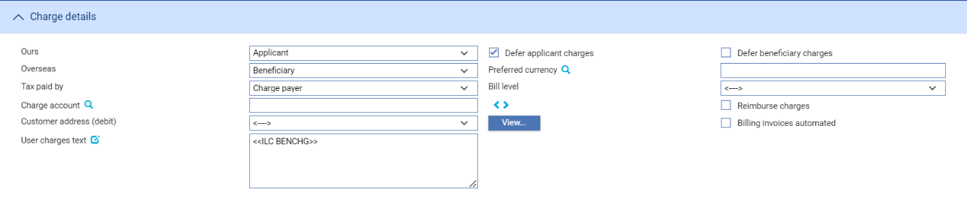

The following table explains what to enter into the fields in the Charge Details pane:

|  |  |
| --- | --- |
| Field | What to Enter |
| Ours | Specify which party – the beneficiary or the applicant – will pay your bank’s charges. |
| Defer Applicant Charges | Indicate whether your own charges to the applicant are to be collected now or deferred until payment. Check this box if the charges are to be deferred, otherwise leave it blank. |
| Defer Beneficiary Charges | Indicate whether your own charges to the beneficiary are to be collected now or deferred until payment. Check this box if the charges are to be deferred, otherwise leave it blank. |
| Reimburse Charges | Check this box if all the charges associated with the transaction is for the beneficiary, and you wish to debit these to the applicant’s account as the letter of credit is issued. If this is the case, the applicant is reimbursed once the beneficiary settles. |
| Overseas | Specify which party – the beneficiary or the applicant – will pay overseas charges. |
| Preferred Currency | The currency in which your bank’s own charges will be collected. Typically, you would set this to your local currency. If you leave this field blank, the system uses the currency of the letter of credit.  Where the charges are for the applicant, the setting here is overridden by the applicant’s preferred currency. |
| Tax Paid By | Specify which party – your customer or the party liable for charges – will pay any tax due on the letter of credit or its charges. |
| Bill Level | Select whether charges for this letter of credit should be billed at customer level, transaction level or product level. The Bill level list field excludes user defined level. |
| Charge Account | The number of the account used for any charges debited to the customer. Charge accounting is normally controlled by the standing settlement instructions for charges. Entering an account number here overrides the account specified in the standing settlement instructions. |
| Customer address (debt) | The charge payer customer’s address defaults to their prime address. The customer’s alternative address can be selected using the list field.   1. This list excludes the customer’s prime and SWIFT address types. Use the adjacent View button to display the chosen address in full. |
| Billing invoices automated | This check box can be used to indicate whether the invoices for charges generated by the transaction (e.g. Billing settlement event) are automatically generated or not. |
| User Charges Text | Any additional information concerning the charges. |

### The Other Details Pane

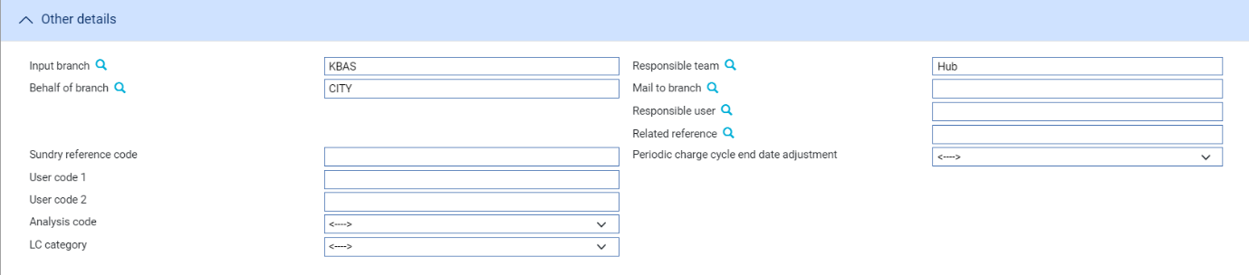

The following table explains what to enter into the fields in the Other Details pane. This pane may also include input fields defined by your bank:

|  |  |  |
| --- | --- | --- |
|  | Field | What to Enter |
|  | Input Branch | The input branch for the transaction. The input branch is set from either:   * the accounting branch from the user’s team, or * the transaction branch for user if the user has a default transaction branch or is locked to a specific branch, or * a branch associated with the user where the user can enter transactions for several branches for a team |
|  | Behalf Of Branch | The behalf of branch for the transaction as entered by the user or set from the incoming SWIFT or gateway message. The behalf of branch determines the parameter sets that are to be used to generate charges, documents, postings, etc. during transaction processing. The branch can be changed to any other branch within the same main banking entity that shares the same parameter sets. |
|  | Sundry Ref Code /User Code 1/ User Code 2 | You may use these fields to enter values for analysis purposes. Your bank will have devised its own system for using these fields. |
|  | Analysis Code/LC Category | User definable fields. These can be configured in System Tailoring | List Values/Field Mapping. |
|  | Responsible Team | The team that has overall responsibility for the master e.g. as the contact to resolve any queries or issues regarding the master and associated events. The system defaults the responsible team when creating the transaction as follows:   * Manual – set from team creating the transaction * Gateway – set from the team specified on the incoming message (if present and valid) otherwise to the team to which the transaction is assigned through workflow allocation based on the behalf of branch * SWIFT – set to the team to which the transaction is assigned through workflow allocation based on the behalf of branch   It can be changed, if required, to either the team associated with the primary customer, default team for the product or the user’s current team. |
|  | Mail To Branch | The mail to branch can be set to any branch within the main banking entity of the behalf of branch. |
|  | Responsible User | A user that has responsibility for the master e.g. as the contact to resolve any queries or issues regarding the master and associated events. This can be any user assigned to the responsible team. |
|  | Related Reference | You can specify any other transaction to which this letter of credit is related. This may already have been done when the master record was created. You can use the browser to select from possible references to include. |
|  | Periodic Charge Cycle End Date Adjustment | Select what happens when a periodic charge cycle end date falls on a non-business/working day. See the *System Tailoring User Guide – Trade Innovation* for more information. |

### The Reimbursement Details Pane

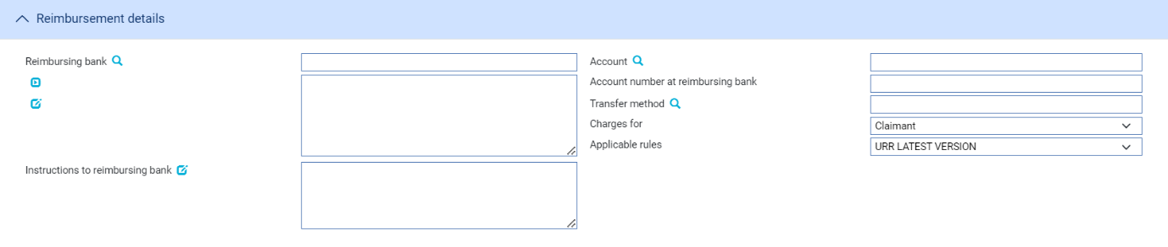

The following table explains what to enter into the fields in the Reimbursement Details pane:

|  |  |  |
| --- | --- | --- |
| Field | What to Enter | |
| Reimbursing Bank | If the transaction involves a reimbursing bank, use this field to identify it.. | |
| Account | The number of the reimbursing bank's account in your bank's books to be credited. | |
| Account Number at Reimbursing Bank | The number of your bank's account with the reimbursing bank. | |
| Transfer Method | The method to be used when paying funds via the reimbursing bank. | |
| Charges For | Select whether the reimbursing bank's charges are paid by the claimant or the issuing bank. | |
| Applicable Rules | This allows you to select additional information regarding the terms of the reimbursement.  Select one of the following to indicate the rules applied to the issue of the documentary credit under reimbursement instructions: | |
| URR VERSION | The documentary credit is subject to the version of the ICC Uniform Rules for Bank to Bank Reimbursement, International Chamber of Commerce, Paris that is in effect on the date of issue.  This is used as the default. |
| NOTURR | The documentary credit is not subject to the version of the ICC Uniform Rules for Bank to Bank Reimbursement, International Chamber of Commerce, Paris, that is in effect on the date of issue. |
| Instructions to Reimbursing Bank | Any instructions for the reimbursing bank. | |

### The Revolving Details Pane

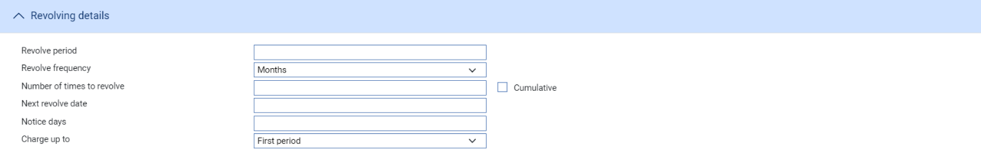

The Revolving Details pane is displayed if you check the Revolving field to indicate that the letter of credit is revolving. The following table explains what to enter into the fields in the Revolving Details pane:

|  |  |
| --- | --- |
| Field | What to Enter |
| Revolve Period/Revolve Frequency | Use these two fields to define the frequency at which the credit is to revolve.  For example, enter 3 into the first field, and select 'Months' in the second field if the credit is to revolve every 3 months. |
| Number of Times to Revolve | The number of times the letter of credit is to revolve.  When entering information into the above fields ensure that the last revolution will occur before the expiry date of the letter of credit. |
| Cumulative | Check this field if the revolution is to be cumulative; otherwise leave it blank. |
| Next Revolve Date | The date on which the first revolution is to take place. |
| Notice Days | If notification is required before the revolution takes place, enter the number of days before each revolution that the Revolve Notice event should be created. |
| Charge Up To | Indicate whether the charge period for calculating charges is to be set to be up to the expiry date, or the date of the next Revolve event. |

## Entering Purchase Order Details

Purchase order information can be accessed (if already present) or entered (if not) using the Purchase Orders button in the Goods pane.

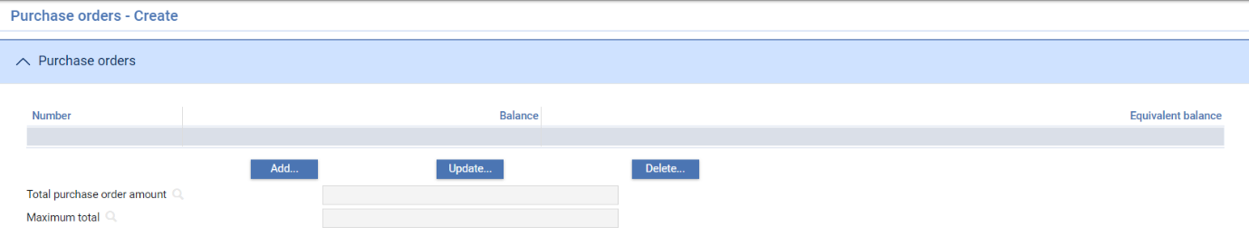

The window that is displayed lists all the purchase orders already recorded against the letter of credit. For each purchase order it shows:

* The number assigned to the purchase order by the applicant
* The amount outstanding on the purchase order, in the currency of the purchase order
* The amount outstanding equivalent in the currency of the letter of credit
* The Total field shows the total amount outstanding of all purchase orders recorded against the letter of credit, in the currency of the letter of credit. The Maximum Total field shows the maximum possible total amount taking into account variances entered for quantity and price

You can view and delete purchase order details using the View and Delete buttons in the usual way.

To add a new purchase order, click **Add**.

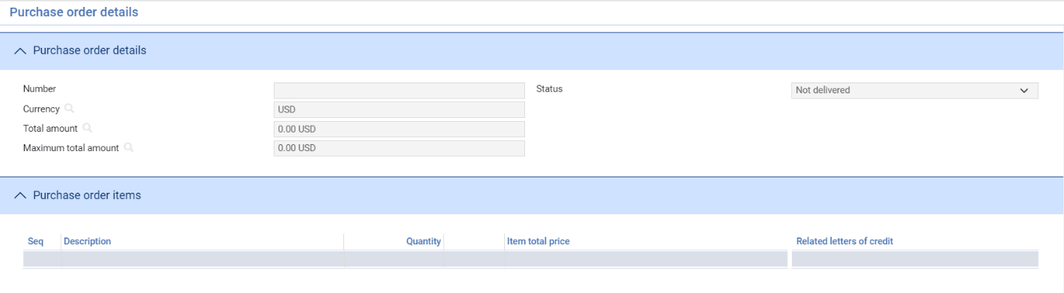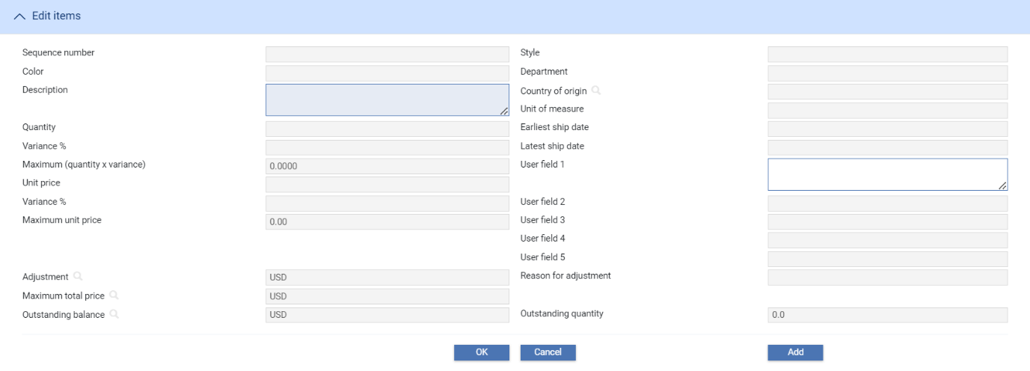

In the window that appears enter the purchase order number (which is alphanumeric) provided by the applicant into the Number field. The system checks whether this purchase order number has been recorded against any other letters of credit for that applicant. If so, it lists the master references for those letters of credit in the Related Letters of Credit pane.

By default, the purchase order is recorded in the currency of the letter of credit. If you change this currency the system displays some additional fields which you can use to identify the exchange rate to be used to convert the purchase order amount into the currency of the letter of credit.

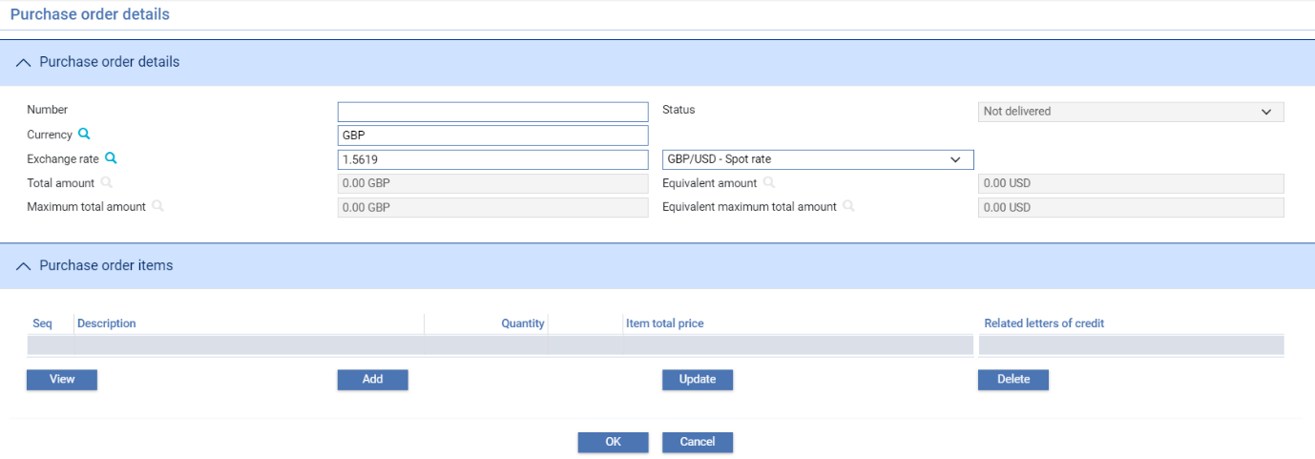

You can either enter an exchange rate code (in which case the system retrieves and displays the exchange rate) or you can enter the exchange rate itself.

As you enter purchase order items, the system calculates the total value of the purchase order in the purchase order currency, and the equivalent amount in the letter of credit currency, using the exchange rate entered here. It displays these two figures using the Total Amount and Equivalent Amount fields.

The Status field shows the status of the purchase order as 'Not Delivered'. This status changes automatically when a drawdown is made which covers one or more items on the purchase order.

Once you have entered information for the purchase order itself, the fields in the Purchase Order Items pane are enabled, allowing you to enter details of those items on the purchase order to be recorded against the letter of credit you have open.

The table at the end of this section explains what to enter into the fields in this window. For each item in turn, enter its details in the fields in the Edit Items pane. Once you complete, press **Add**. This saves the details and clears the Edit Items fields for you to enter the next item.

For each item, the pane lists the item's unique (within purchase order) sequence number, its description, the quantity and unit of measurement, and the total cost of the item.

To amend an item's details, select it in the pane and click the **Update** button. The existing values for the item are displayed, and you can overtype them. You can also delete an item: to delete, select the item and press the **Delete** button. The system displays the existing information for the item and prompts you to confirm the deletion.

|  |  |  |
| --- | --- | --- |
|  | Field | What to Enter |
|  | Sequence Number | A three-character alphanumeric value provided by the applicant which uniquely identifies this item within the purchase order details recorded against this letter of credit. The value you enter here is used to order items when displayed within the system. |
|  | Style | A description of the item's style. |
|  | Color | A description of the item's colour. |
|  | Dept. | The department from which the items is ordered. |
|  | Description | A description of the item. |
|  | Country of Origin | A standard country code for the origin of the item. You can select this from a browser. |
|  | Quantity | The number of units of the goods or services being ordered. |
|  | Var. | Specify what variance from the specified quantity is acceptable, as a percentage. |
|  | Max. Quantity | The maximum possible quantity, taking into account the permitted variance. |
|  | Unit of Measure | The unit of measurement used for the goods or services being ordered (for example, crate). |
|  | Unit Price | The price of each unit. |
|  | Var. | Specify what variance from the specified unit price is acceptable, as a percentage. |
|  | Max. Unit Price | The maximum possible unit price, taking into account the permitted variance. |
|  | Earliest Ship Date | The earliest allowable shipping date for the item. A warning is displayed if this is not compatible with the shipping dates on the letter of credit. |
|  | Latest Ship Date | The latest allowable shipping date for the item. A warning is displayed if this is not compatible with the shipping dates on the letter of credit. |
|  | Adjustment | If the amount to be paid is different from the amount calculated by multiplying the item's Quantity by its Unit Price (for example, if a discount is being given) enter the difference between the calculated cost and the cost to be paid here. Enter a positive amount (for example '5.0') for a reduction in the total cost, or a negative amount (for example '-5.0') for an increase. |
|  | Reason for Adjustment | If you enter an adjustment amount, you can enter the reason for the adjustment here. |
|  | Max. Total Price | The total price for the item. If the POEnterItemTotalAmount system option is set to ‘Yes’ on your system, you can directly enter a price in this field. If it is set to ‘No’, the system calculates the maximum possible total price for this item, taking into account the permitted variance in both price and quantity. For example, 100 items at 3 USD with a price variance of 5% would give a Total Price of 300 USD and a Maximum Total Price of 315.  If you change any of the values in the Quantity, Unit Price, Var or Adjustment fields the system updates this field to reflect the new values. |
|  | Outstanding Quantity | The system displays here the number of units of the goods or services being ordered still outstanding. If you change the value in the Item Quantity field, the system updates this field to reflect the new value. |
|  | Outstanding Bal. | The system calculates and displays here the total value of the outstanding balance of this item by multiplying the maximum possible quantity by the maximum possible Unit Price and then applying any adjustment amount.  If you change any of the values in the Quantity, Unit Price, Var or Adjustment fields the system updates this field to reflect the new values. |

Each purchase order is saved with a status of 'Not Delivered'. When you complete entry, the Purchase Order Items’ pane lists the new purchase order item.

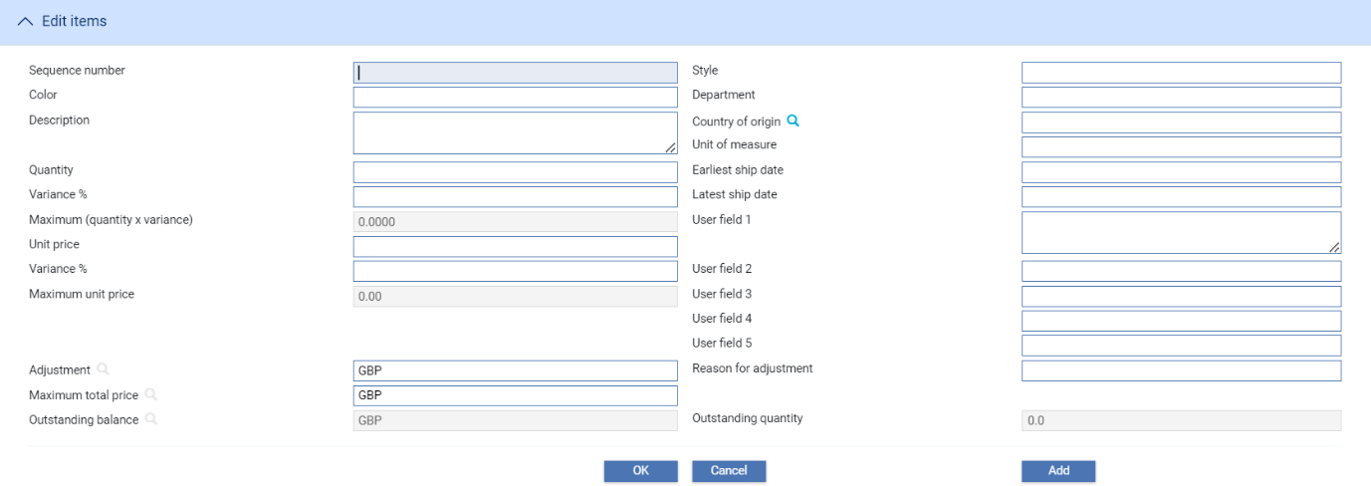

When you click **OK** to save the import letter of credit during Pre Advise or Issue event, the system checks whether the total amount of the purchase orders entered matches the available amount of the import letter of credit (including any tolerance specifications and additional amounts) and produces:

* An error message, if the maximum total purchase order amount is greater than the letter of credit amount
* A warning, if the maximum total purchase order amount is less than the letter of credit amount
* A warning, if the currency of any purchase order differs from the currency of the letter of credit

## The Import Letter of Credit Master Summary Window

Once you create an import letter of credit, the system will display the basic details of that letter of credit using the Master Summary window.

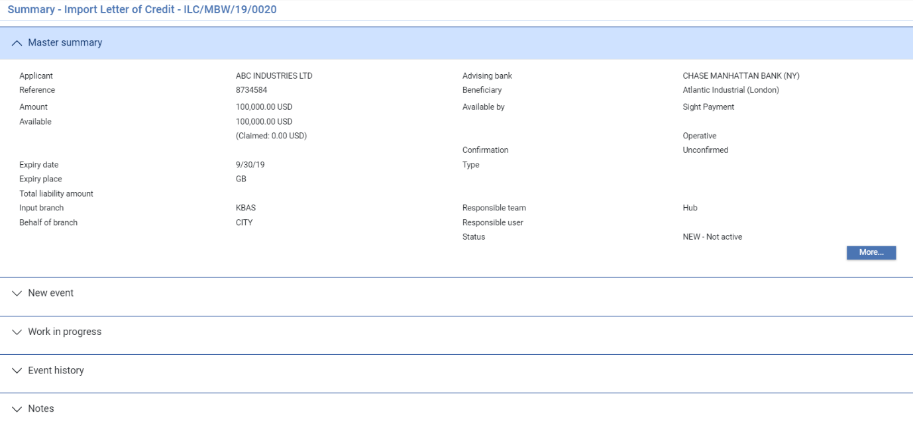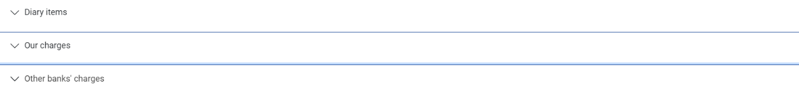

For more information on how the various panes and buttons in this window work, refer Common Facilities User Guide – Trade Innovation.

If a transaction has associated transfer letters of credit or assignments of proceeds, the Master Summary window displays a Split button which you can use to list the associated transactions and view details of them.

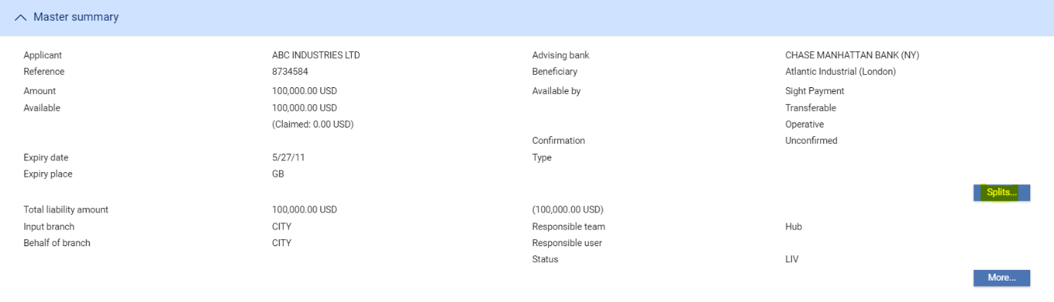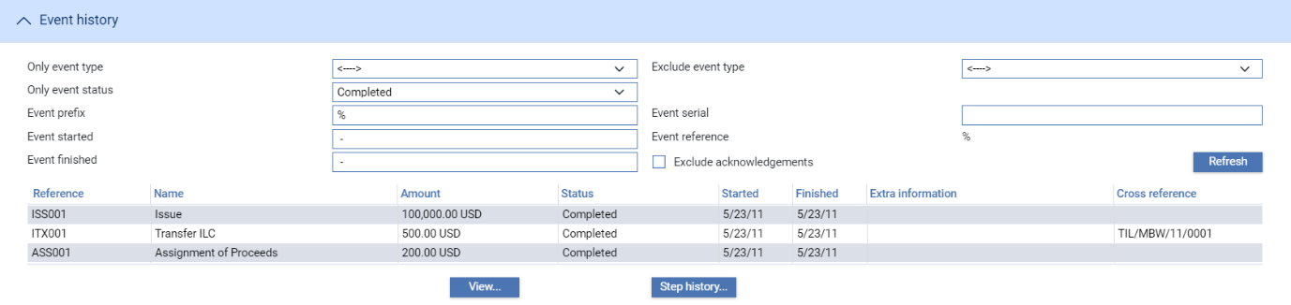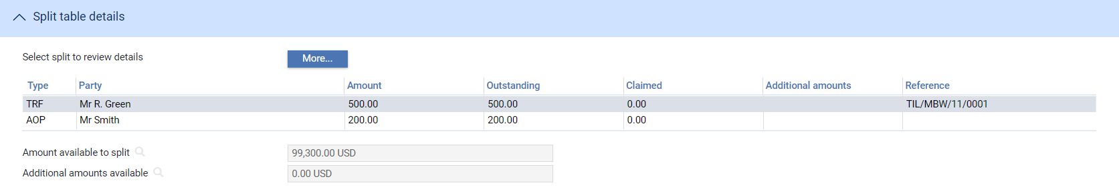

The following table explains the information shown for each item. Select an item and click the More button to display additional information about the item:

|  |  |
| --- | --- |
| Heading | What it Shows |
| Type | One of the following values:   * TRF for a transfer export letter of credit * AOP for an assignment of proceeds |
| Party | The name of the beneficiary or assignee. |
| Amount | The original amount due to the beneficiary. |
| Outstanding | The amount outstanding for the party. |
| Claimed | The amount in the process of being claimed. For a back-to-back letter of credit, this is the amount allocated to the back-to-back letter of credit from the parent letter of credit. |
| Additional Amounts | Any additional amount associated with the item. |
| Reference | For transfer and back-to-back letters of credit, the letter of credit's reference. For assignments of proceeds this column is blank. |
| Amount Available to Split | The amount available for additional assignments of proceeds and back-to-back and transfer letters of credit. |
| Additional Amts Available | Any additional amounts available that can be split between back-to-back and transfer letters of credit. |

## Entering Details of an Acknowledgement

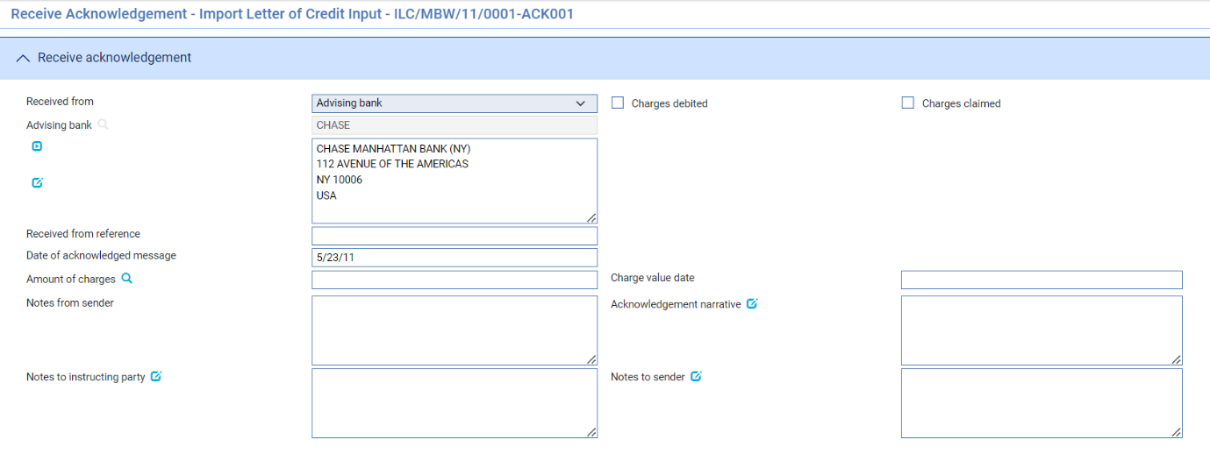

Details of an acknowledgement you have received are entered using a Receive Acknowledgement event. By default the log steps includes the same panes and fields as the input steps. Depending on your system’s configuration, panes and fields available in log steps can be tailored for each data capture step. Refer *SDK - Screen Tailoring* Guide – Trade Innovation for details.

Use the Received From field to enter the role of the party from whom you have received the acknowledgement, and the Received From Reference field to enter that party's reference for the transaction. In the Sender to Receiver field, enter additional information for the receiver. Use Acknowledgement Narrative field to specify additional information about the acknowledgement.

If appropriate, check either the Charges Claimed box or the Charges Debited box to indicate whether the advising bank is claiming its charges or has debited its charges. You cannot check both of these boxes, but you can leave them both blank.

Use the Narrative field to enter any details advised by the acknowledgment received from party.

# Assigning Proceeds to Additional Parties

The system permits you to identify an unlimited number of additional parties to a letter of credit to receive proceeds from the transaction. Assignee details can be entered either when payment is recorded or as a separate event - the Assignment of Proceeds event - after the release of the Issue or Advise event.

You can identify the amount to be assigned to each additional party. The total amount of assignments, together with any back-to-back and transfer letters of credit, can be up to 100% of the value of the letter of credit.

The Assignment of Proceeds event can be used to set up assignment details and subsequently to make amendments to, or delete, those details. Once entered, assignment details can be amended or deleted any time up to the disbursement of funds.

Information entered using the Assignment of Proceeds event is available during payment events (see page 77). Assignment details entered as part of a payment event, or any changes to them during that event, are reviewed as part of that event's details.

1. The letter of credit's Master Summary window includes a Splits button, which allows you to display details of any assignments or transfers. Assignments are only shown in this window once the event creating them has been released.

You should ensure that all Assignment of Proceeds events are completed and released before initiating a payment event.

## Setting Up Assignee Details

To enter assignee details, in the Master Summary window select 'Assignment of Proceeds' from the Create New Event drop-down list. The system opens the event at either at a log or input step depending on how the Workflow orchestration controlling the event is configured. Refer *Workflow Tailoring User Guide* – Trade Innovation for details. By default the log steps includes the same panes and fields as the input steps. Depending on your system’s configuration, panes and fields available in log steps can be tailored for each data capture step. Refer *SDK - Screen Tailoring* Guide – Trade Innovation for details.

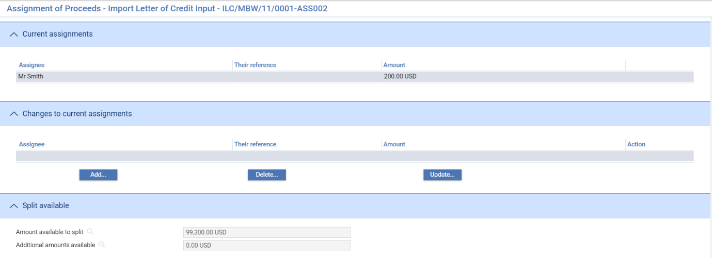

The Amount Available to Split field shows the available amount that can be assigned to other parties. The figure is updated as you add assignments. The Additional Amounts Available field shows any additional amounts available for the transaction, but these are not used for assignments.

You can use the Master Details|Settlement Instructions link to set up master-level standing settlement instructions to receive the assignment proceeds. Refer Common Facilities User Guide – Trade Innovation for instructions. However, note that this button is not displayed if this window is called from within a payment event.

Click **Add** to access a window that allows you to identify parties and assign proceeds to them.

### Entering Assignment Details

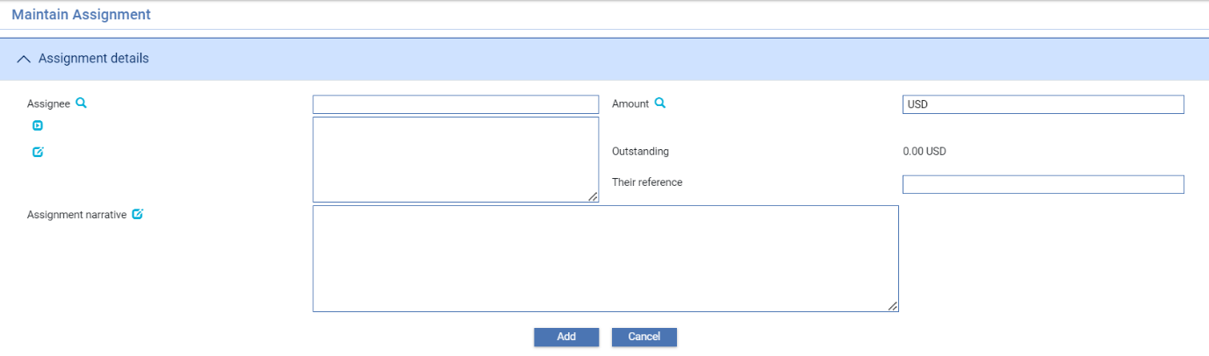

The following table explains what to enter into the fields in this window:

|  |  |  |
| --- | --- | --- |
|  | Field | What to Enter |
|  | Assignee | The assignee. |
|  | Amount | The amount to be assigned to this party, in the currency of the letter of credit. |
|  | Outstanding | Initially this field is blank. Thereafter, the system displays the amount still to be paid to this assignee. |
|  | Their Ref | The first beneficiary's reference for the assignment of proceeds. |
|  | Assignment Narrative | Any narrative text relevant to this party to be included on the notification of the assignment of proceeds. |

When you click Add to save assignee details, the system closes the window and displays the new details in the Assignment of Proceeds window.

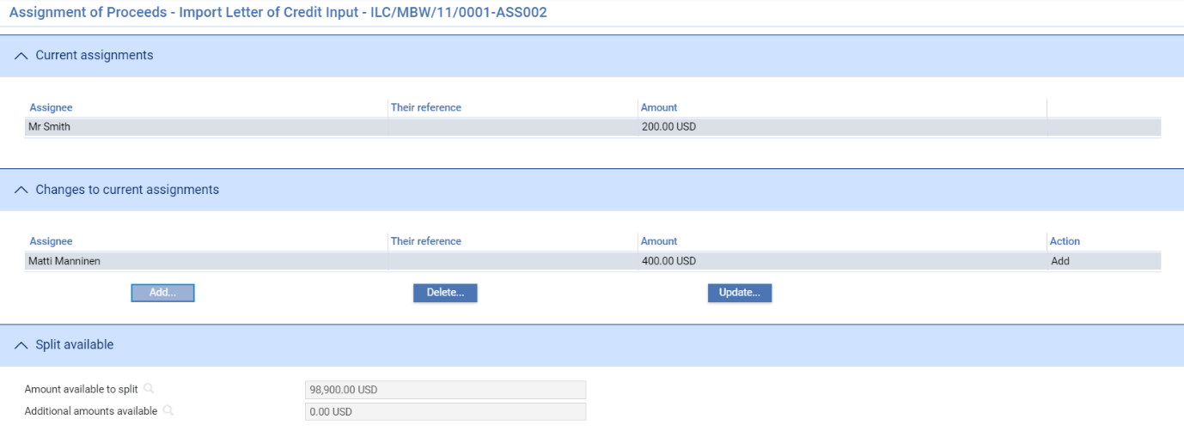

As you add assignees, they are added to the list in the Changes to Current Assignments pane. You can amend and delete assignees using the Update and Delete buttons in the usual way.

Once the initial Assignment of Proceeds event is released, you can use further Assignment of Proceeds events to amend or delete assignee details.

When you open a subsequent Assignment of Proceeds event, the system displays details of current assignments.

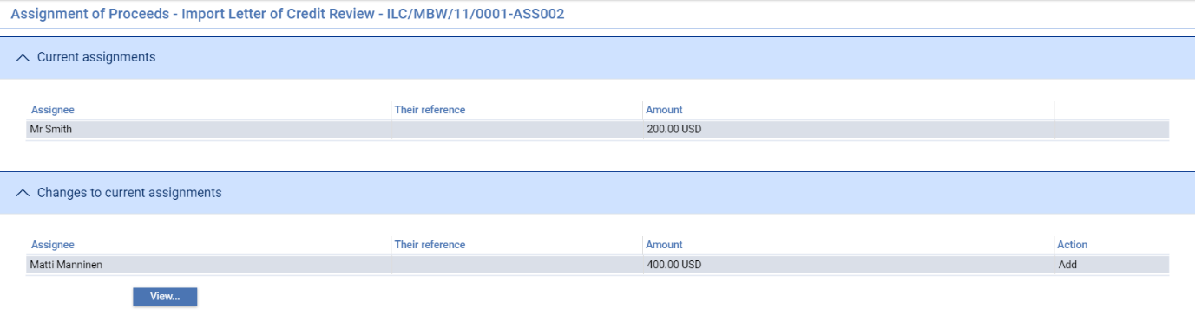

# Claims Received for an Import Letter of Credit

This chapter explains how to use the system as the issuing bank to log the receipt of documents from the presenting bank to select the required payment action and to process notifications of claims received, including continuing claims that are left unpaid pending enquiries. It also explains how to enter details of loans, additional amounts, margin deposits and discounts against payments. (Discounts can also be entered against payments at a later date.)

For instructions on repaying an import letter of credit with associated transfer letters of credit refer Transfer Letters of Credit User Guide – Trade Innovation.

For information on payment actions, including additional bank defined actions and their effect on charges see the Appendix.

For information on using payment events to link shipping guarantees to an import letter of credit and request the return of a shipping guarantee refer Shipping Guarantees User Guide – Trade Innovation.

## Claims and Requests for Authorisation to Pay

When the beneficiary presents documents to the paying or negotiating bank and requests payment, the paying or negotiating bank will have dealt with the claim in one of the following ways:

* For a sight payment they may have paid the beneficiary and be requesting payment
* They may request payment from you, and pay the beneficiary when payment is advised
* If the documents have discrepancies, they may request authorisation from you as issuing bank before they pay the claim

They may or may not send the documents presented for consideration with the claim advice, and so the documents may arrive under separate cover.

As issuing bank, you will use two different events within the system in response to claims advices received from the presenting bank:

* The Claim Received event allows you to log information about an initial claim made by the presenter and to record the receipt of documents. You can use a Claim Received event to pay the claim, or you can complete the event without making payment whilst awaiting, for example, documents or responses to enquiries
* The Outstanding Claim event, which allows you to continue processing a claim, initiated by a Claim Received event in order to enter details of documents subsequently received or of a response from the applicant. In case of protracted correspondence with the applicant or the presenter, any number of Outstanding Claim events can be created, with the final event actually making the payment or rejecting the claim

A letter of credit may have more than one Claim Received event, and each Claim Received event may have several Outstanding Claim events associated with it. However, only one Outstanding Claim event can be in progress for each claim at any one time.

### Participated Deals

If the transaction is participated, payment may result in a Drawdown/Revolve Commit Amt event being created as a subsidiary event to increase the commitment amount available on the participation deal, if the deal is revolving.

### Assignments of Proceeds

During payment events the system permits you to set up new assignments for the transaction, and to access details of assignments already set up and allocate proceeds to them.

Each payment amount allocated to an assignment can be discounted as part of the payment event, if required. However, it cannot be discounted once the payment event is complete.

### Licenses

If there is a license attached to a revolving transaction, the license amount must be sufficient to cover the maximum amount available under the transaction - that is, the transaction amount plus the maximum tolerance - multiplied by the number of revolving cycles.

Refer Licenses User Guide – Trade Innovation for details of licenses.

### Financing Transactions

If your system has the financing module implemented, then while processing a payment the Finance pane will be available.

This allows you to record a financing transaction against the payment, as described in the Financing User Guide – Trade Innovation.

You can also repay a financing transaction from within the payment event.

#### Import Letters of Credit and Riba-free Financing

The system supports Riba-free financing for import letters of credit. It uses the Finance Import LC product along with the facility to allow events to be flagged as provisional. This allows your bank to advise its customers of the costs incurred as a result of Murabahah financing calculations and to record the customer's acceptance or rejection of those costs.

1. Your bank will need to configure the postings, charges and other release items produced on completion of a Finance Import LC Create event so that they are generated only if the Create event is not flagged as provisional; and so that, if the event is provisional, it results in the creation of an offer document for the customer. Refer System Tailoring Guide – Trade Innovation for information on using the rules facility to achieve this.

To process an import letter of credit payment with Murabahah financing, initiate a Claim Received event and enter details of the requested payment in the usual way.

Set the Payment Option field to 'Finance Offer'. This creates a subsidiary Finance Import LC Create event (Refer Financing User Guide – Trade Innovation for full details). In this event select a product type from those flagged as supporting Islamic banking principles. Check the Provisional flag, then specify the amount of the advance in the usual way (Refer Financing User Guide – Trade Innovation for detailed instructions). The system will calculate and display the Murabahah selling price using the Finance Amount Plus Interest/Profit field.

When you complete the Claim Received event, the subsidiary Finance Import LC Create event will also be released and will generate an offer document for the customer.

#### If the Customer Accepts the Offer

If the customer accepts the offer, initiate an Outstanding Claim event and set the payment action to 'Pay with Financing'. This creates a second Finance Import LC Create event, with details inherited from the first. Attach the acceptance document from the customer to the event following the procedure used by your bank, then uncheck the Provisional flag.

Complete the Outstanding Claim event to settle the payment.

#### If the Customer Wishes to Negotiate a Revised Offer

If the customer does not accept the initial offer and wishes to negotiate a revised offer, initiate an Outstanding Claim event and set the payment action to 'Finance Offer'. This creates a second Finance Import LC Create event, with details inherited from the first.

Amend the details as required, keeping the Provisional flag checked.

Complete the Outstanding Claim event. The subsidiary Finance Import LC Create event will also be released and will generate an offer document for the customer showing the amended offer.

This process can be repeated as many times as necessary.

#### If the Customer Rejects the Offer

If the customer rejects the offer, initiate an Outstanding Claim event and set the payment action to 'Pay'. Manually abort the Finance Import LC Create event.

### Purchase Orders

When a drawdown is made against an import letter of credit using a Claim Received or Outstanding Claim event, the system permits you to identify any purchase order items covered by the drawdown as part of the payment event.

You can identify each purchase order item as being partially or fully covered by the drawdown. Once you identify the items covered by the drawdown, the system reduces the outstanding balance and outstanding quantity recorded for the purchase order by the amounts covered and changes the purchase order's status to 'Partially Delivered' or 'Fully Delivered', as appropriate.

You can also amend the description and adjustment amount of individual purchase order items during payment events.

1. If you set the payment action as 'Pay at Maturity' or 'Accept' during a payment event, you can either enter drawdown details against purchase orders in that payment event; or else you can configure your system so that the Outstanding Claim event, generated automatically by the system to handle the payment at time of maturity, completes manually, thus allowing you to enter drawdown details then.

The Appendix identifies which payment actions result in payment, which in refusal, and which leave a claim outstanding.

### Shipping Guarantees

If your system has the shipping guarantees functionality implemented, then you will be able to link the import letter of credit to one or more shipping guarantees and record the receipt of a document of title from within Claim Received and the Outstanding Claim events event. Refer Shipping Guarantees User Guide – Trade Innovation for instructions.

As the payment event is released, a Link Document of Title event is created against each of the relevant shipping guarantees. If a shipping guarantee is removed from a transaction in a subsequent event, an Unlink Document of Title event is created against that shipping guarantee. These events allow your bank to maintain an audit history of the use of shipping guarantees.

## Payment at Maturity

For claims whose payment action was 'Pay at Maturity' or 'Accept', the system creates an outstanding payment event in the diary to handle the payment at the time of maturity. When the maturity date is reached the system processes the event during overnight processing. The event may require input or review, in which case the system places the event in the Work in Progress pane for you to complete.

When you open an outstanding payment event for a maturity payment the system displays the relevant ‘Maturity’ response type.

## Cancelling a Reimbursement Authority

You can cancel a reimbursement authority from within a Claim Received or Outstanding Claim event, even if there is an available balance, by checking the Cancel Reimbursement Authority flag. This issues an MT747 Amendment to Authorisation to Reimburse message for the reimbursing bank instructing them to cancel the remaining balance of the reimbursement authority.

## Claims Received

To enter details of a claim advice you have received, in the Master Summary window select 'Claim Received' from the Create New Event drop-down list and click **Create**. The system opens the event at either at a Log step (see page 56) or Input (see page 57), depending on how the Workflow orchestration controlling the event is configured. Refer *Workflow Tailoring User Guide* – Trade Innovation for details.

### Logging a Claim

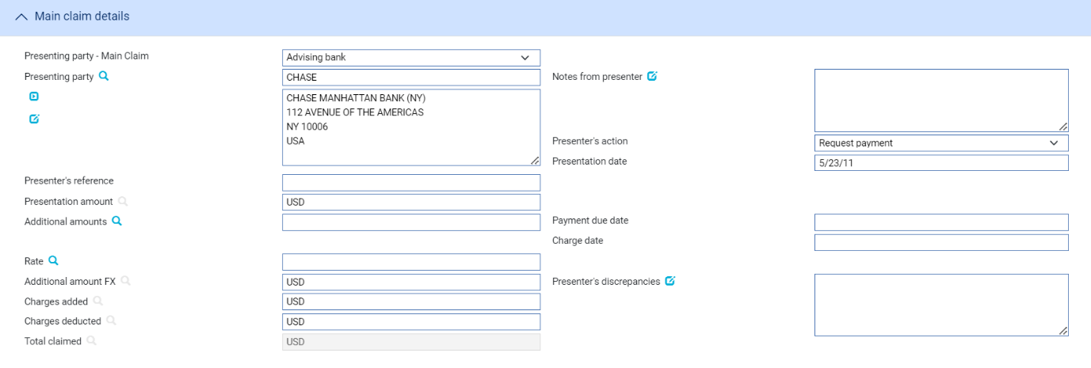

The following table explains what to enter into the fields in this window. For instructions on using the fields in the Document Details pane to identify any documents being presented refer Common Facilities User Guide – Trade Innovation:

|  |  |
| --- | --- |
| Field | What to Enter |
| Select Required Claim Type | Displayed for transferable letters of credit only. Unless you wish to pay a transfer letter of credit set this to 'Standard'. For instructions on using the Claim Received event to pay a transfer letter of credit see the Transfer Letters of Credit User Guide – Trade Innovation. |
| Presenting Party | The presenting party. You can use the first field to select a party already identified for the transaction using their party role, in which case their details are retrieved and displayed in the remaining fields in this pane.  Alternatively, if the presenting party has not been assigned a party role within the transaction, select ‘Other presenting party’ in the first field, then use the fields provided to enter their details in the usual way.  The system uses the advising bank as the default, or the beneficiary, if the letter of credit was advised direct. |
| Presenter’s Reference | The presenting party’s reference for the claim. |
| Notes from Presenter | Any notes received from the presenting party. |
| Presentation Amount | By default, the system displays the available amount of the letter of credit (less outstanding claims) and currency here. |
| Presentation Date | The date the documents were presented at the bank from whom you received the claim. |
| Presenter’s Action | Choose one of the following values from the drop-down list to indicate what action the paying bank has taken with regard to the claim:   * Request Authorisation to Pay * Pay and Claim Reimbursement * Request Payment * Request Acceptance * Sender has Debited our Account * Documents Sent On Approval * Other |
| Additional Amounts | Any additional amounts being claimed. |
| Payment Due Date | The date payment is due, or the value date used to debit your account with the presenting bank. |
| Charge Date | The value date for any charges taken separately. |
| Rate | If the amount in the Additional Amount field is in a currency different from that of the transaction, enter the exchange rate to be used to convert the additional amount to the currency of the letter of credit. |
| Additional Amount FX | The additional amounts expressed in the currency of the transaction. |
| Presenter’s Discrepancies | If the action involves a request for authorisation to pay, use this field to enter details of any discrepancies advised by the presenting bank. |
| Charges added | Any charges that the sender has informed you have been added to the payment amount. For complete reconciliation check that this amount is equal to the charges due to the presenting party. |
| Charges Deducted | Any charges that the sender has informed you have been deducted from the payment amount. For complete reconciliation check that this amount is equal to the charges due from the presenting party. |
| Total Claimed | The system calculates the total amount being claimed and then displays it in this field. |

### Entering Full Details of a Claim Received

For instructions on using the Claim Received event to pay a transfer letter of credit refer Transfer Letters of Credit User Guide – Trade Innovation.

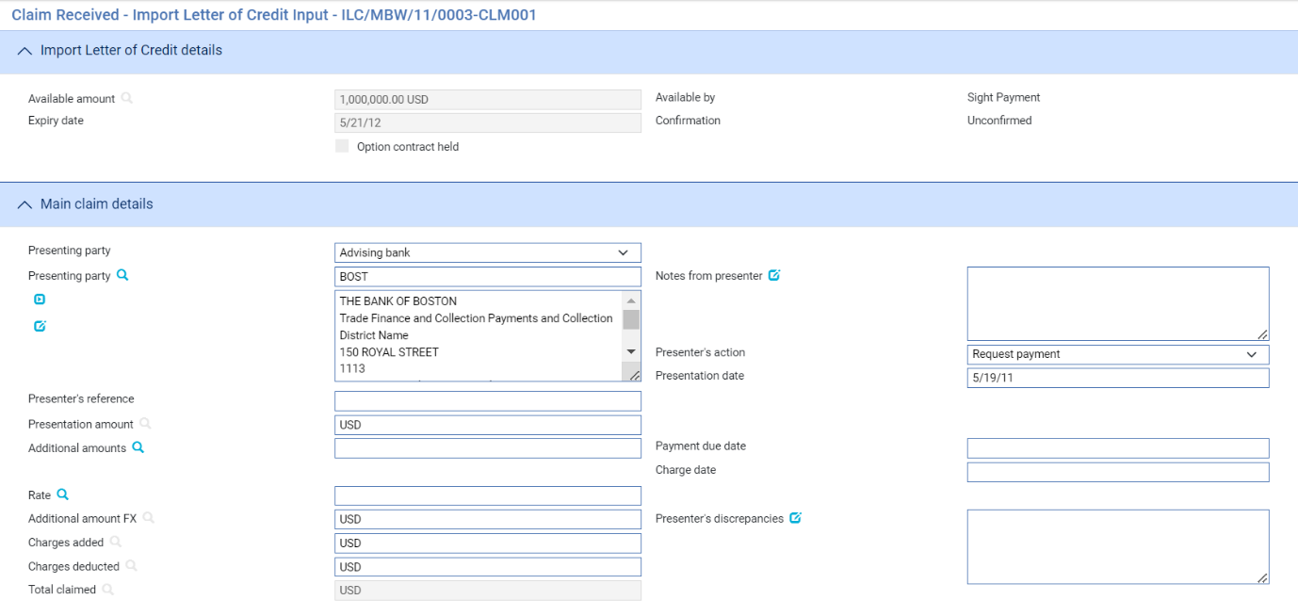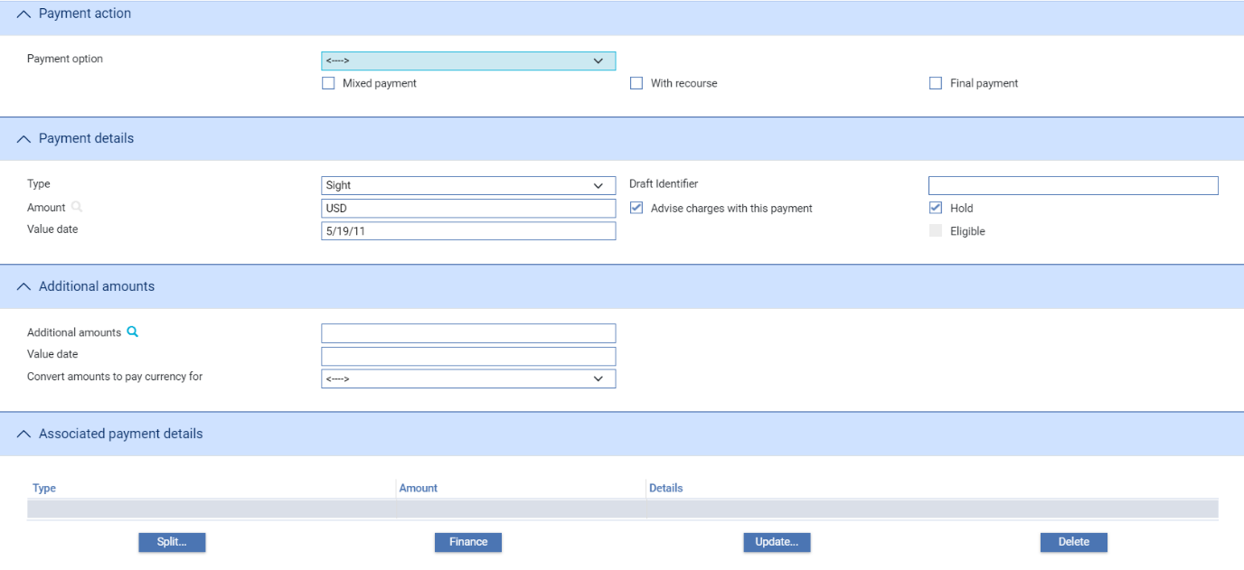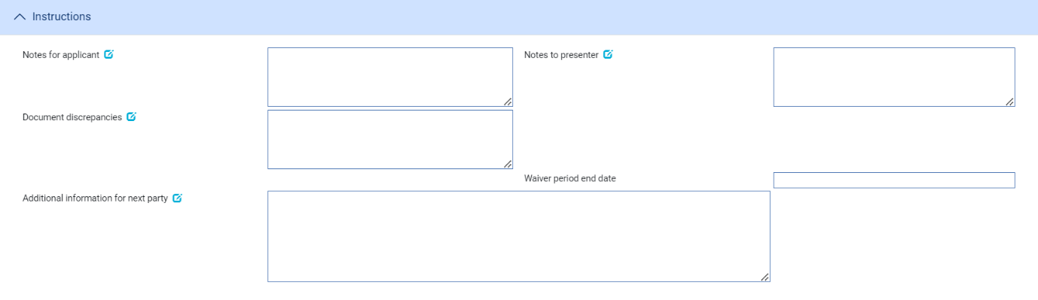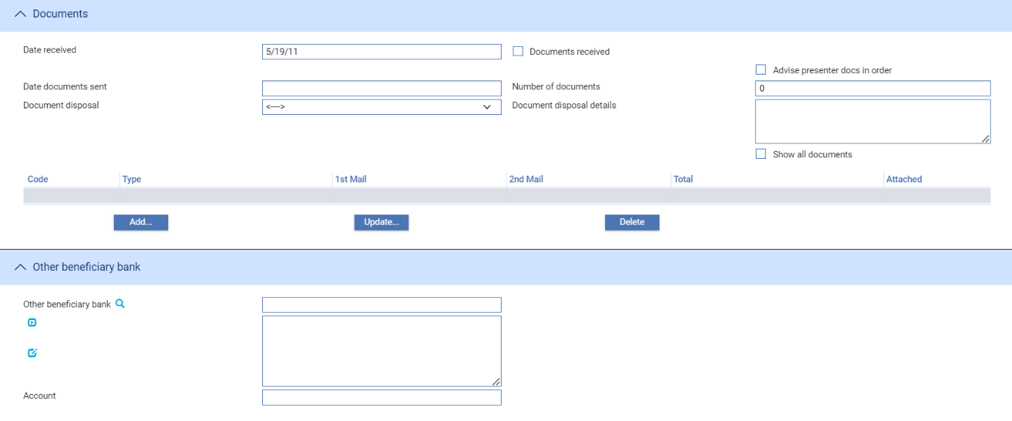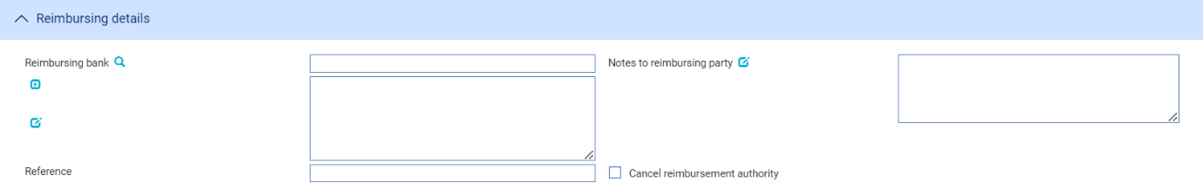

The window used during an Input step has the following panes:

* The Claim Type Pane (see page 59)
* The Import ILC Details Pane (see page 60)
* The Main Claim Details Pane (see page 60)
* The Payment Action Pane (see page 60)
* The Payment Details Pane (see page 62)
* The Additional Amounts Pane (see page 64)
* The Associated Payment Details Pane (see page 64)
* The Instructions Pane (see page 64)
* The Documents/Notes Pane (see page 65)
* The Other Beneficiary Bank Pane (see page 66)
* The Reimbursing Details Pane (see page 66)

For instructions on using the Documents/Notes pane and the Import Letter of Credit Detail pane to enter details of documents refer Common Facilities User Guide – Trade Innovation. If your system is configured to support purchase orders, the Purchase Orders button is displayed in the Main Claim Details pane, and accesses a window used to enter purchase order details (see page 43).

#### The Claim Type Pane



The Claim Type pane is present for transferable letters of credit.

Unless you wish to pay a transfer letter of credit set the Claim Type field to 'Standard'. For instructions on paying transfer letters of credit refer Transfer Letters of Credit User Guide – Trade Innovation.

#### The Import Letter of Credit Details Pane

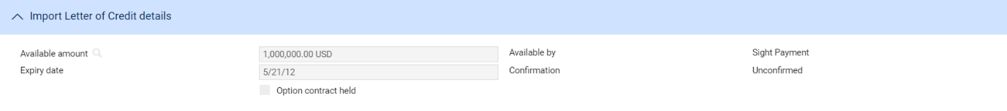

This provides some of the key details relevant to payment of the letter of credit – read only.

#### The Main Claim Details Pane

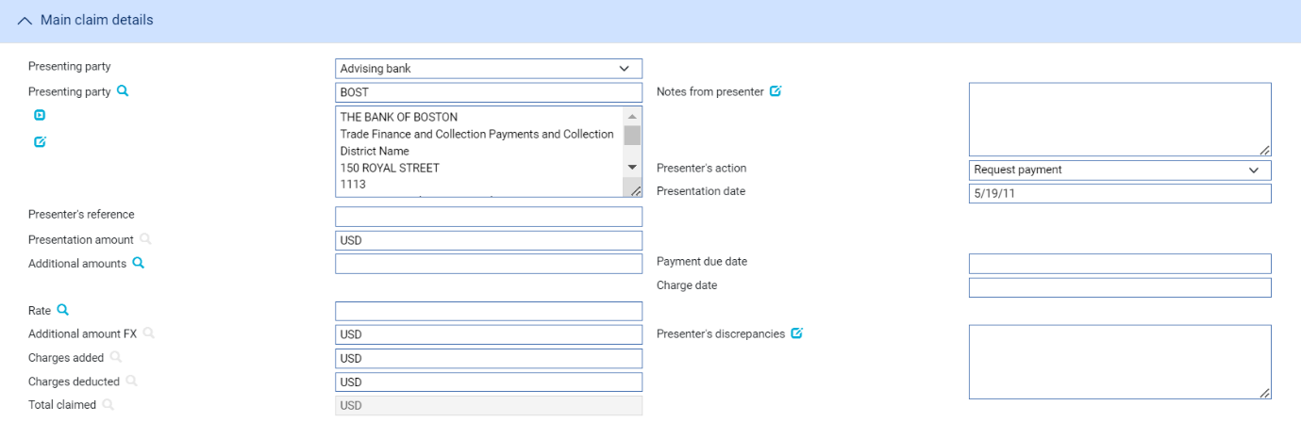

If your bank has the purchase orders functionality implemented, the Purchase Orders button is displayed, and permits you to record payment against individual purchase orders associated with the transaction.

The following table explains what to enter into the fields in the Main Claim Details pane:

|  |  |  |
| --- | --- | --- |
|  | Field | What to Enter |
|  | Presenting Party | The presenting party. You can use the first field to select a party already identified for the transaction using their party role, in which case their details are retrieved and displayed in the remaining fields in this pane.  Alternatively, if the presenting party has not been assigned a party role within the transaction, select 'Other presenting party' in the first field, then use the remaining fields to enter their details in the usual way.  The system uses the advising bank as the default, or the beneficiary, if the transaction was advised direct. |
|  | Notes from Presenter | Any notes received from the presenting party. |
|  | Presenter's Action | Choose one of the following values from the drop-down list to indicate what action the paying bank has taken with regard to the claim:   * Request Authorisation to Pay * Pay and Claim Reimbursement * Request Payment * Request Acceptance * Sender has Debited our Account * Documents Sent On Approval * Other |
|  | Presentation Date | The date the documents were presented at the bank from whom you received the claim. |
|  | Presenter's Reference | The presenting party's reference for the claim. |
|  | Presentation Amount | The system displays either the available amount of the transaction or the presentation amount, if entered during a Log step. |
|  | Additional Amounts | Any additional amounts being claimed. |
|  | Rate | If the amount in the Additional Amount field is in a currency different from that of the transaction, enter the exchange rate to be used to convert the additional amount to the currency of the letter of credit. |
|  | Additional Amount FX | The additional amounts expressed in the currency of the transaction. |
|  | Charges Added | Any charges that the sender has informed you have been added to the payment amount. For complete reconciliation check that this amount is equal to the charges due to the presenting party. |
|  | Charges Deducted | Any charges that the sender has informed you have been deducted from the payment amount. For complete reconciliation check that this amount is equal to the charges due from the presenting party. |
|  | Total Claimed | The system calculates the total amount being claimed and then displays it in this field. |
|  | Payment Due Date | The date payment is due, or the value date used to debit your account with the presenting bank. |
|  | Charge Date | The value date for any charges taken separately. |
|  | Presenter's Discrepancies | If the action involves a request for authorisation to pay, use this field to enter details of any discrepancies advised by the presenting bank. |

#### The Payment Action Pane



Refer the Appendix section for a list of payment actions.

The Payment Action pane allows you to process the claim by selecting a payment action and then entering details of the payment.

The actions included in the Payment Option drop-down list vary depending on whether the letter of credit was a direct presentation by the beneficiary and on the presenter's actions. For example, whether they are requesting authorisation to pay or whether instead they have paid and are requesting reimbursement.

For a single payment, details of the actual payment are entered into the Payment Details pane. If payment is mixed, to involve two or more part payments, check the Mixed Payment field. The system displays a Payments pane, which you can use to enter details of each of the part payments in turn.

Check the With Recourse box if the payment is with recourse; and the Final Payment box if the payment includes the final payment under the reimbursement authority.

If your payment action is 'Reject and Claim Refund' then enter the date of the refund into the Refund Date field.

The payment action you select applies to all part payments. However, where the action is 'Pay' the individual status of a payment can be changed using the Pay Status field in the Payment Details window.

Note that:

* If you enter any part payment details, the value of all part payments must not exceed the value of the letter of credit, and must reconcile with the claimed amount
* Where the payment action for an individual part payment is 'Pay at Maturity' or 'Accept', the system creates a diary event which will cause an Outstanding Claim or Outstanding Presentation event to be generated automatically at the appropriate time to allow that part payment to be matured
* If the payment action is 'Pay' for an acceptance or deferred payment, the system generates the postings and funds movements for the future date, and no separate future Outstanding Claim or Outstanding Presentation event takes place. The forward-dated postings are held by the system until the value date is reached, then posted during batch processing

1. The system is delivered with a standard set of ‘Presenter’s actions’ and ‘Payment actions’ which will typically *cover the required processing for claims and documentary presentations. However, depending on your* bank’s internal processes and requirements, it may be necessary to create additional Presenter’s and Payment actions that are more appropriate to your workflow.

Where this is required, your bank can use System Tailoring to define its own Parameter set based Presenter's actions and Payment actions for Import letters of credit and additionally, create Transfer presenter's actions and Response actions as required. A code and description can be entered for each of these actions together with the associated underlying payment ‘behaviour’ type, such as *General request, Pay, Reject, or Pay at maturity* which then determines the subsequent processing of the payment when the action is selected.

Refer *System Tailoring Guide* – Trade Innovationfor instructions on defining additional payment actions.

#### The Payment Details Pane

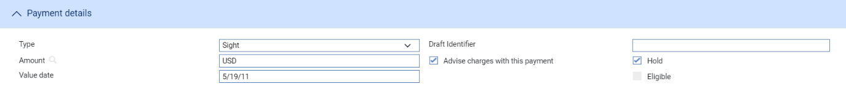

The Payment Details pane allows you to enter details of the payment you are making.

For mixed payment, check the Mixed Payment field in the Payment Action pane. A new pane - the Payments pane - is displayed in place of the Payment Details pane.

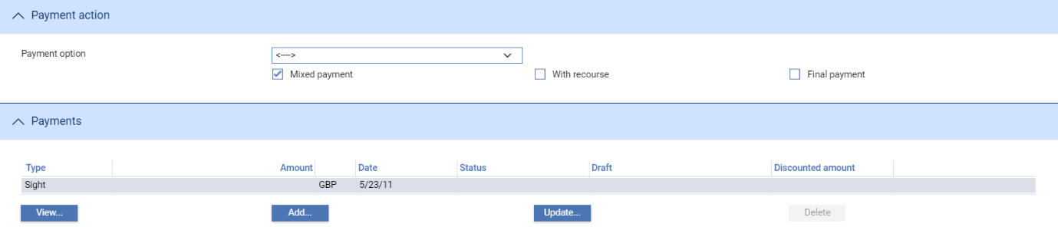

Select the payment listed in this window and click **Update**. In the window that appears, define the first part payment.

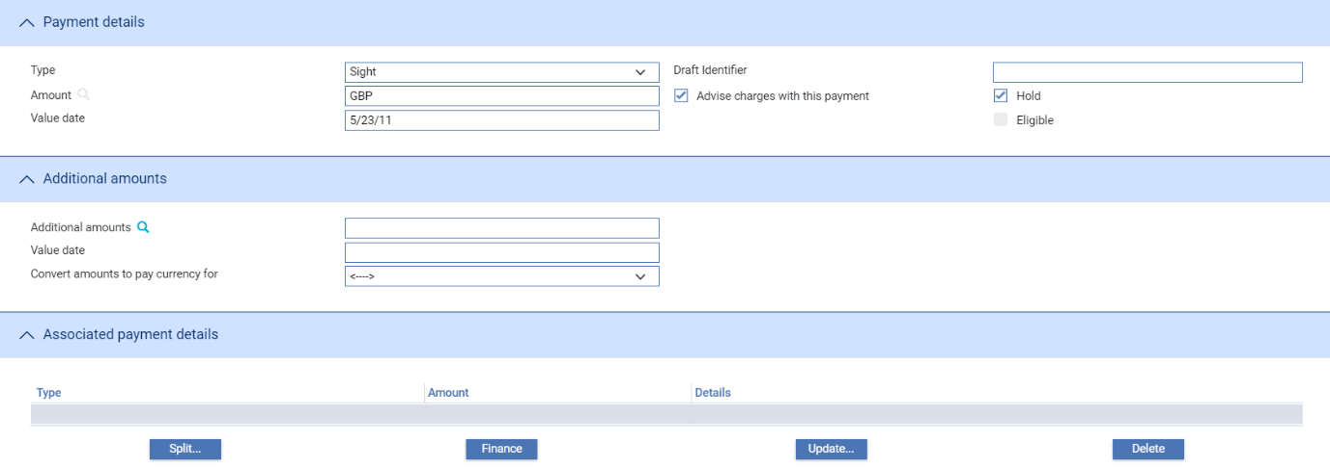

The fields are same as those used in the Payment Details pane to define a single payment. When you close the window, the details of the part payment are listed in the Payments pane, from where you can select them and amend or delete them. Use the Add button to reopen the window to enter details of the next part payment.

Once you have entered details of a payment, or part payment, it is listed in the Payments pane.

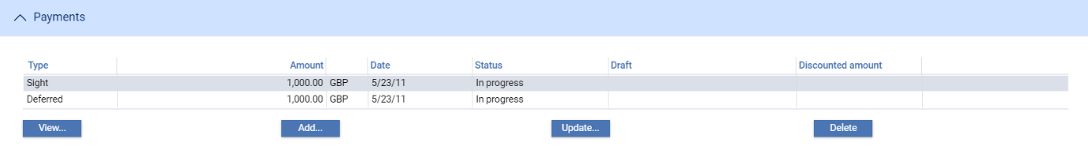

Note that the system creates a first part payment for the full amount of the payment event. If you add more part payments, remember to amend the amount of this first part payment accordingly.

The following table explains what to enter to define a payment or part payment:

|  |  |
| --- | --- |
| Field | What to Enter |
| Payment Action | This field is displayed only for mixed payments, and it initially reflects the payment action selected for the claim in the main Input window. If the payment action involves refusal or leaves the claim outstanding, then you will not be able to alter the value in this field.  If the payment action involves paying the claim, then you can use this field to select a status for each individual part payment.  Select from the available options. |
| Type | Select the type of payment - Sight, Acceptance or Deferred. The fields displayed in the rest of the window vary, depending on what you enter here. |
| Amount | The amount being claimed. |
| Advise Charge with This Payment | Check this box if charges taken or claimed are to be advised with this payment. |
| Value Date | For sight payments, enter the value date of the payment.  For acceptance and deferred payment the value date of the payment is calculated using the value in the Period field.  The system issues a warning if this date does not leave enough time for any pre-debit notification required. |
| Start Date/Period/From/ After | For acceptance and deferred payments, the start date of the payment period.  Use the Period field to define the period (as, for example, 1 month or 10 days), then use the From/After field to indicate whether the period will be calculated from or after the base date. |
| Draft Identifier | If you know the draft identifier, enter it here. |
| Hold | This field is displayed for sight and acceptance payments. Check it if drafts are being held, and uncheck it if they are being returned to the claimant.  You can discount a draft only if this and the Eligible box are checked. |
| Eligible | This box must be checked for you to be able to discount a part payment. For sight and acceptance payments, the Hold box must also be checked. |
| Margin Amount For | Enter the amount and currency of the margin amount to be used against the payment. |

#### The Additional Amounts Pane

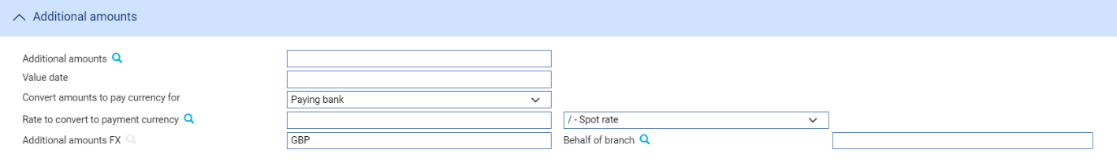

The following table explains what to enter into the Additional Amounts pane:

|  |  |
| --- | --- |
| Field | What to Enter |
| Additional Amounts | Any additional amount. |
| Value Date | The value date of any additional amount. |
| Convert Amounts to Pay Currency For | The payment amount may need to be converted to a different currency for the paying bank and or the presenting party. If so, select the appropriate value - Presenting Party, Both Parties or Paying Bank - here. |
| Rate to Convert to Payment Currency | If the payment amount needs to be converted to a different currency select or enter the rate to be used to make the conversion. |
| Additional Amounts FX | The additional amount, expressed in the currency of the reimbursement authorisation. |
| Behalf of Branch | Where relevant, the branch that owns the foreign exchange deal. |

#### The Associated Payment Details Pane

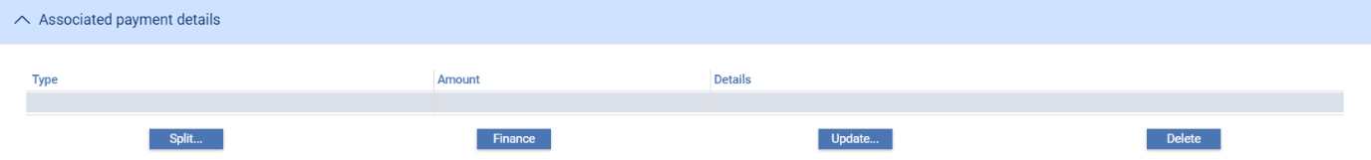

The Associated Payment Details pane allows you to apply further processing against the payment or part payments being made. As payments are defined they are listed in this pane. You can select them individually and enter details of a loan or discount or license drawdown (see page 76).

#### The Instructions Pane

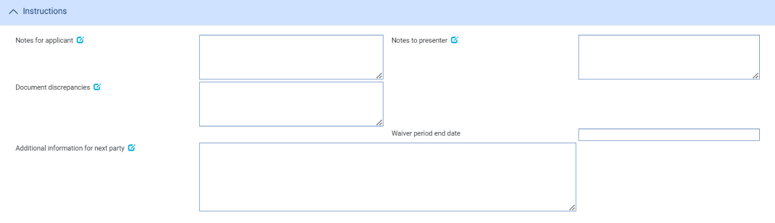

The Instructions pane allows you to enter notes for the issuer and the presenter.

Depending on the setting of the system option DiscrepancyFieldAlwaysVisible the Document Discrepancies field may be displayed here, even if the payment action would not normally require it to be populated. When the system option is switched on the field allows you to enter minor discrepancies for your bank's own audit purposes, where the payment action does not normally involve reporting discrepancies. Payment Narrative field is displayed when payment action is set to Pay, Pay at maturity, Pay with Financing, Accept and Approve Authorisation Request.

### The Documents Pane

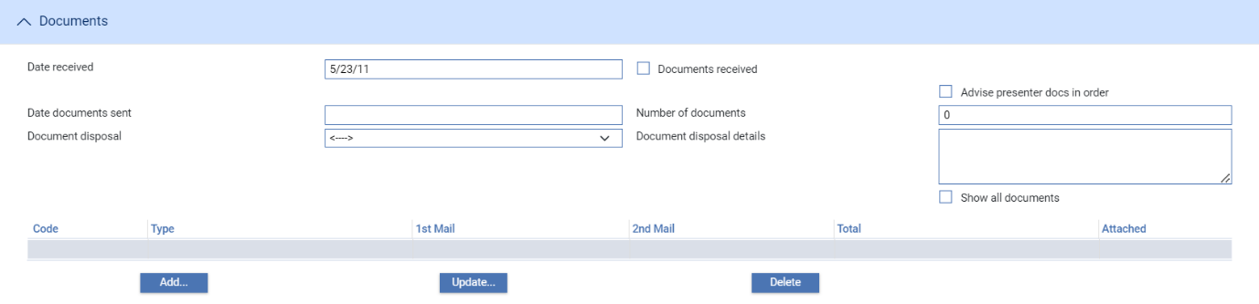

The following table explains what to enter into the fields in the Documents/Notes pane. Refer Common Facilities User Guide – Trade Innovation for instructions on adding, amending, deleting and viewing details of the actual documents involved:

|  |  |  |  |
| --- | --- | --- | --- |
|  | Field | What to Enter | |
|  | Date Received | The date the documents were received. | |
|  | Documents Received | Tick this if documents have been received for this claim. | |
|  | Date Documents Sent | The date the documents were sent, as stated on the claim. | |
|  | Number of Documents | The number of documents received here. Use the Add button to identify each of the documents received in turn. | |
|  | Document Disposal | Use this dropdown to indicate the disposal action for the documents: | |
|  |  | Hold | Select this field if you intend to hold documents received. |
|  |  | Notify | Choose Notify if you intend to forward them to the applicant. |
|  |  | Previous instructions | Acting in accordance with instructions previously received from the presenter. |
|  |  | Return | Select this field if documents are to be returned to the sender. |
|  | Document Disposal Details | . Use this field to update document disposal details. | |
|  | Advise Presenter Documents In Order | Check this box if the presenter is to be advised that that any documents received are in order. | |

If your bank has chosen to record an audit trail of all changes to attached documents then the Show All Documents check box allows you to see an audit trail of all changes for a document type.

#### The Other Beneficiary Bank Pane

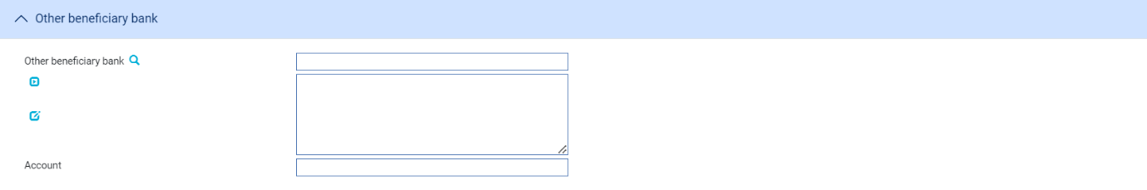

The following table explains what to enter into the fields in the Other Beneficiary Bank pane:

|  |  |
| --- | --- |
| Field | What to Enter |
| Other Beneficiary Bank | The party the presenter of the letter of credit wants you to pay (if other than the presenter). |
| Account | The number of the account to be credited with the bank identified in the Other Beneficiary Bank field. |

#### The Reimbursing Details Pane

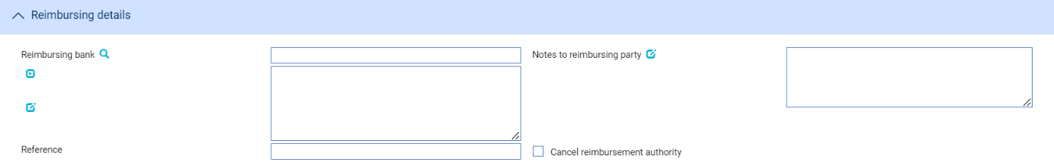

The following table explains what to enter into the fields in the Reimbursing Details pane:

|  |  |
| --- | --- |
| Field | What to Enter |
| Reimbursing Bank | The reimbursing bank. |
| Notes to Reimbursing Party | Any notes to the reimbursing bank. |
| Reference | The reimbursing bank’s reference, if known. |
| Cancel Reimbursement Authority | For letters of credit which have an associated reimbursement authorisation, where the payment leaves an outstanding balance you can use this box to cancel the reimbursement authorisation. If you check this box, the system generates an MT747 Amendment to Authorisation to Reimburse message for the reimbursing bank instructing it to cancel the reimbursement authorisation.  If you cancel a reimbursement authorisation in this way, you must include the CANC codeword in the Notes to Reimbursing Bank fields. |

## Purchase Order Details and Payment Events

During the Claim Received event, if a letter of credit has one or more purchase orders recorded against it, a Purchase Orders button is present in the Main Claim Details pane. On clicking this button, the system lists all the purchase orders recorded against the letter of credit.

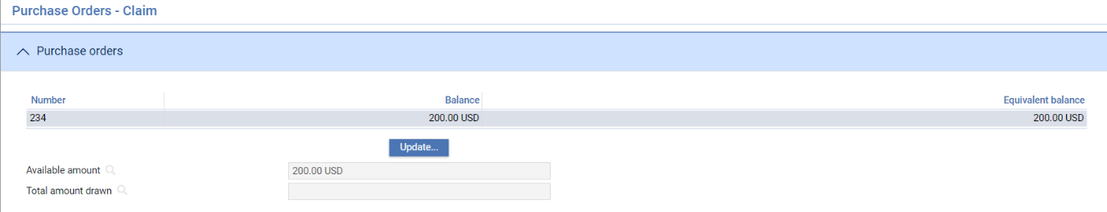

For each purchase order listed, the pane shows:

* The purchase order number
* The amount of the purchase order not yet covered by a drawdown, in the currency of the purchase order
* The equivalent amount in the currency of the letter of credit

The window also displays the total amount available under all the purchase orders listed, and the total that has already been drawn down.

### Allocating Funds to Purchase Orders

When you select a purchase order and click **Update**, the system displays details of the purchase order.

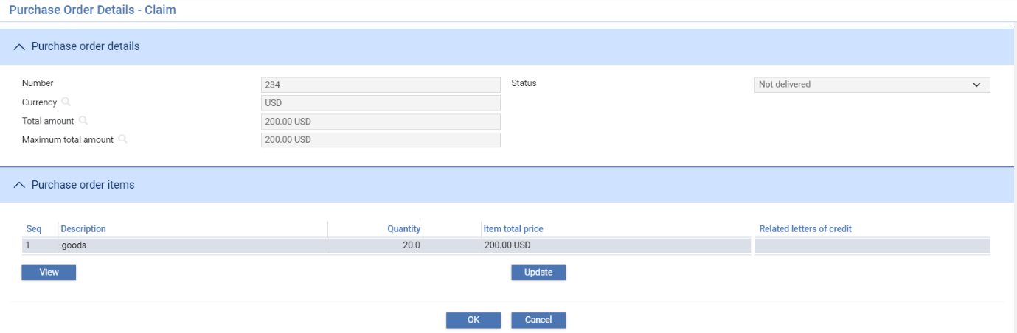

Select the item and click **Update**.

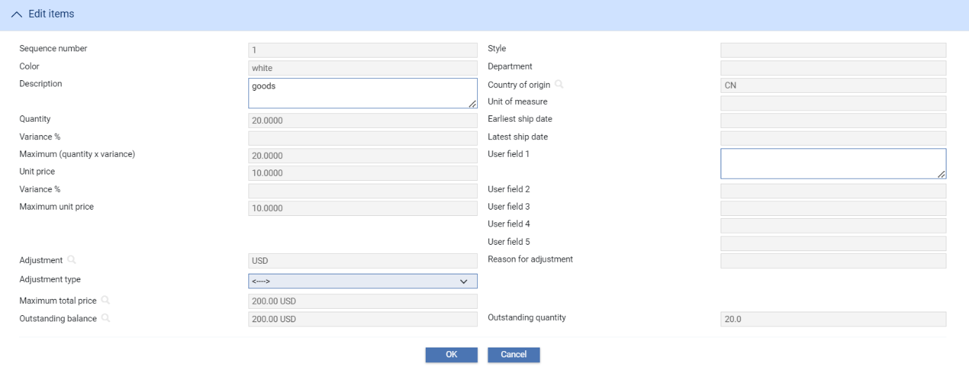

The purchase order items listed within the Purchase Order details window help you to identify the purchase order in which you are interested. For this reason it shows the original quantity and amount rather than the outstanding quantity and amount. It does, however, take amendments into account. As the original quantity is amended here, the new amended quantity is shown. You can enter details of new purchase order items in this window using the Add button.

The Status field shows the status of the purchase order, which may be one of the following:

* Not Delivered
* Partially Delivered
* Fully Delivered

The Purchase Order Items pane lists all the items recorded against the purchase order for this letter of credit. If an item is covered by the drawdown, to identify it as such first select it in this pane. The system displays details of the selected item in the fields in the Edit Items pane.

To identify the quantity of goods or services covered by the drawdown, select 'Drawdown' in the Adjustment Type field. Additional fields are displayed.

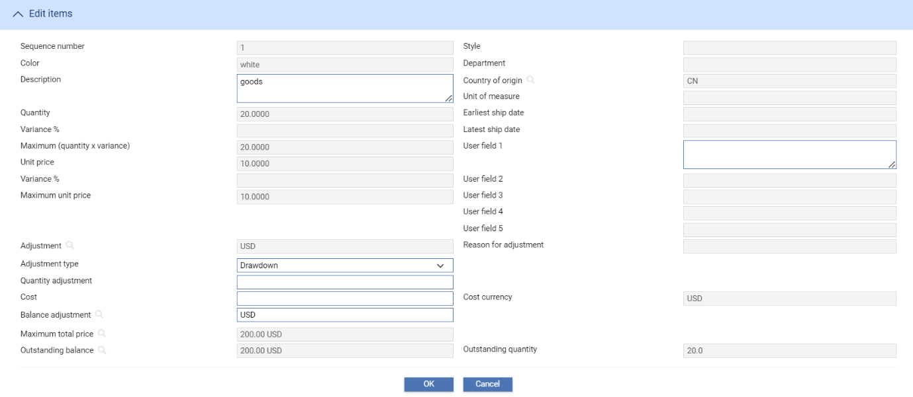

Use the Quantity Adjustment field to enter the change in the quantity covered by the drawdown. The system automatically displays the maximum cost per zone in the Cost field. You can amend the cost figure if you need to, for example to replace it with the actual cost.

The system amends the Outstanding Quantity and Outstanding Balance values accordingly and calculates and displays the value of the adjustment in the Bal Adjustment field. You can overwrite this figure to allow for any price changes or discounts the applicant has negotiated.

If the POEnterItemTotalAmount system option is set to Yes on your system, you can also enter a value in the Max. Total Price field.

1. The system will permit you to reduce the outstanding quantity and outstanding balance values to zero, but will prevent you from saving input which results in a negative value in either of these fields.

As you identify items as covered by the purchase order, the system change the status of the purchase order to 'Partially Delivered' or 'Fully Delivered', as appropriate, and updates the total amount and equivalent amount (if present) of the purchase order.

When you click **OK** to save the payment event, the system checks the drawdown details and payment details and produces warnings:

* If you have entered drawdown details but the payment action leaves the claim outstanding or to be paid at a later date
* If a payment is being made against the letter of credit but no drawdown details have been entered against purchase orders recorded against it
* If the amount of the drawdown is different from the amount of the reduction being made to the available amount as a result of the payment
* If the currency of any purchase order differs from the currency of the letter of credit
* If any balance adjustment has been made

## Continuing a Claim

If you select a payment action during the Claim Received event which involves postponing payment (for example until you have received approval from the applicant) the Outstanding Claim event allows you to continue the claim.

To continue the claim, in the Master Summary window select 'Outstanding Claim' from the Create New Event drop-down list and click **Create**. The system opens the event at either a Log step (see page 69) or Input step (see page 72), depending on how the Workflow orchestration controlling the event is configured. Refer *Workflow Tailoring User Guide* – Trade Innovation for details.

### Selecting the Claim to Continue

If there is only one outstanding claim, the system retrieves it and displays its details. If there is more than one outstanding claim, use the Select button to select the one to continue. When you click this button the system displays the Select Payment Event window.

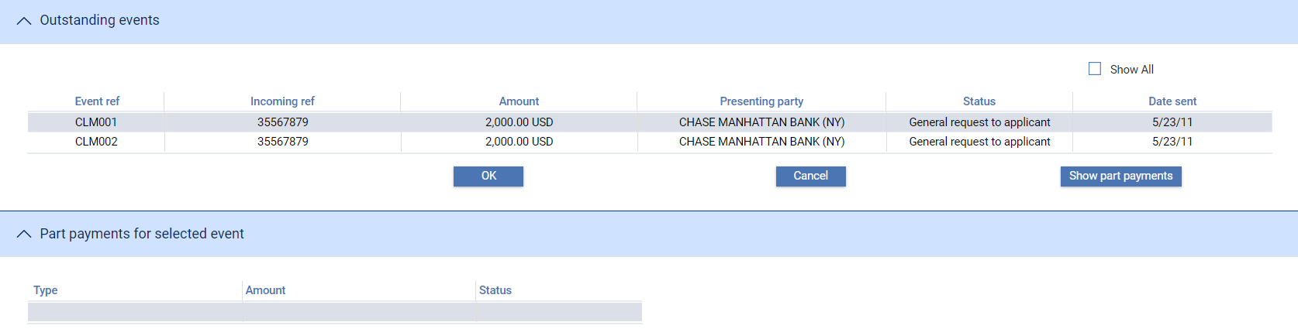

This window lists all completed Claim Received events that have not been paid. The window does not show any claims currently in progress. If you check the Show All box, the system also includes in the list all completed Claim Received and Outstanding Claim events that have been paid in full or been rejected.

If you check the Show All box, the system also includes in the list all completed payment events that are paid in full or are rejected. You can initiate an outstanding claim event against a completed claim event in order to issue general correspondence or to reject a previously-paid claim.

When you select an event and click **OK**, the system closes the window and displays information taken from that event.

### Logging the Response

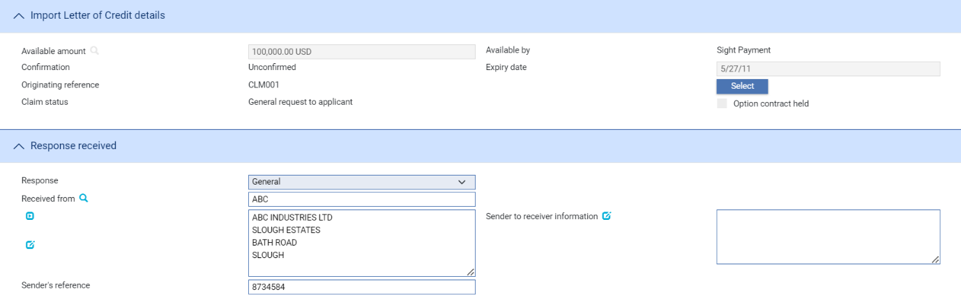

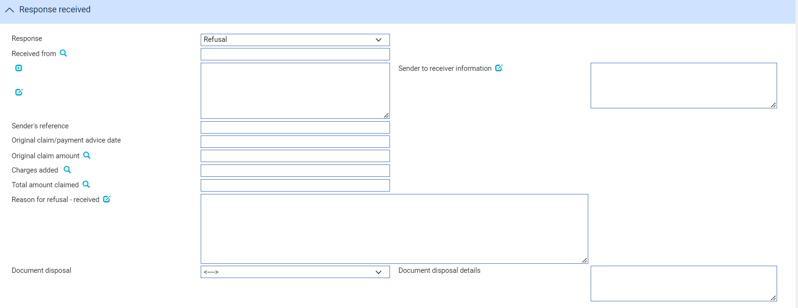

If there is only one outstanding claim, the system retrieves it and displays its details. If there is more than one outstanding claim, use the Select button (see page 69) to select the one to continue.

The table below explains what each of the fields displayed in a Log window shows:

|  |  |
| --- | --- |
| Field | What it Holds |
| Available Amount | The current available amount. |
| Available By | This field is used to set the tenor of the payment. Refer Common Facilities User Guide – Fusion Trade Innovation for instructions. |
| Confirmation | One of the of the following values:   * Confirmed * Unconfirmed * May Add |
| Expiry Date | The letter of credit’s expiry date. |
| Originating Reference | The reference of the event that is being continued. |
| Presenting Party | The presenting party details. |
| Claim Status | The status of the claim. |
| Option Contract Held | Use this field to specify whether or not an option contract is held. |
| Response | The type of response. You can select from the following:  •General (see page 64)  •Documents Received (see page 64)  •Refusal (see page 64)  •Authorisation to Pay (see page 65)  •Advice of Payment (see page 65)  •Invoices Received (see page 64) for transfer letters of credit  •Maturity (see page 66) (if the event has been generated automatically from a diary action)  •Reverse Payment (see page 67) |
| Received From | The party from whom you received the reply. |
| Sender’s Reference | The reference used by the sender for the reply. |
| Original Claim/Payment Advice Date | Use this field to update the Original claim/Payment Advice date if the response is Advice of payment, Authorisation to pay or Refusal |
| Original Claim Amount | Use this field to update the Original claim amount if the response is Advice of payment, Authorisation to pay or Refusal |
| Charges Deducted | Any charges being deducted by the sender.  For complete reconciliation check this amount using the Charges Summary window.  Refer *Common Facilities User Guide – Fusion Trade Innovation for instructions.* |
| Net Amount Paid | The net amount being paid. |
| Authorisation Instructions | Select from one of the following:  • Accept  • Debit Selves  • Pay and Claim Reimbursement  • See Details  • Negotiate |
| Instructions received | The terms of the authorisation. |
| Presenting Party | The presenting party details. |
| Presenter’s Reference | The presenter’s reference for the original claim. |
| Notes From Presenter | Any notes received from the presenting party. |
| Presenter’s Action | Choose one of the following values from the drop-down list to indicate what action the  paying bank has taken with regard to the claim:  • Request Authorisation to Pay  • Pay and Claim Reimbursement  • Request Payment  • Request Acceptance  • Sender has Debited our Account  • Documents Sent On Approval  • Other |
| Presentation Date | The date the documents were presented at the bank from whom you received the claim. |
| Presentation Amount | The amount of the claim in the original Claim Received event, and the payment type. |
| Additional Amount | Any additional amounts being claimed. |
| Payment Due Date | The date payment is due, or the value date used to debit your account with the presenting bank. |
| Charge Date | The value date for any charges taken separately. |
| Rate | If the amount in the Additional Amount field is in a currency different from that of the transaction, enter the exchange rate to be used to convert the additional amount to the currency of the letter of credit. |
| Additional Amounts FX | The additional amounts expressed in the currency of the transaction. |
| Presenter’s Discrepancies | If the action involves a request for authorisation to pay, use this field to enter details of any discrepancies advised by the presenting bank. |
| Charges Added | Any charges that the sender has informed you have been added to the payment amount. For complete reconciliation check that this amount is equal to the charges due to the presenting party. |
| Charges Deducted | Any charges that the sender has informed you have been deducted from the payment amount. For complete reconciliation check that this amount is equal to the charges due from the presenting party. |
| Total Claimed | The system calculates the total amount being claimed and then displays it in this field. |

### Entering Full Details of the Response

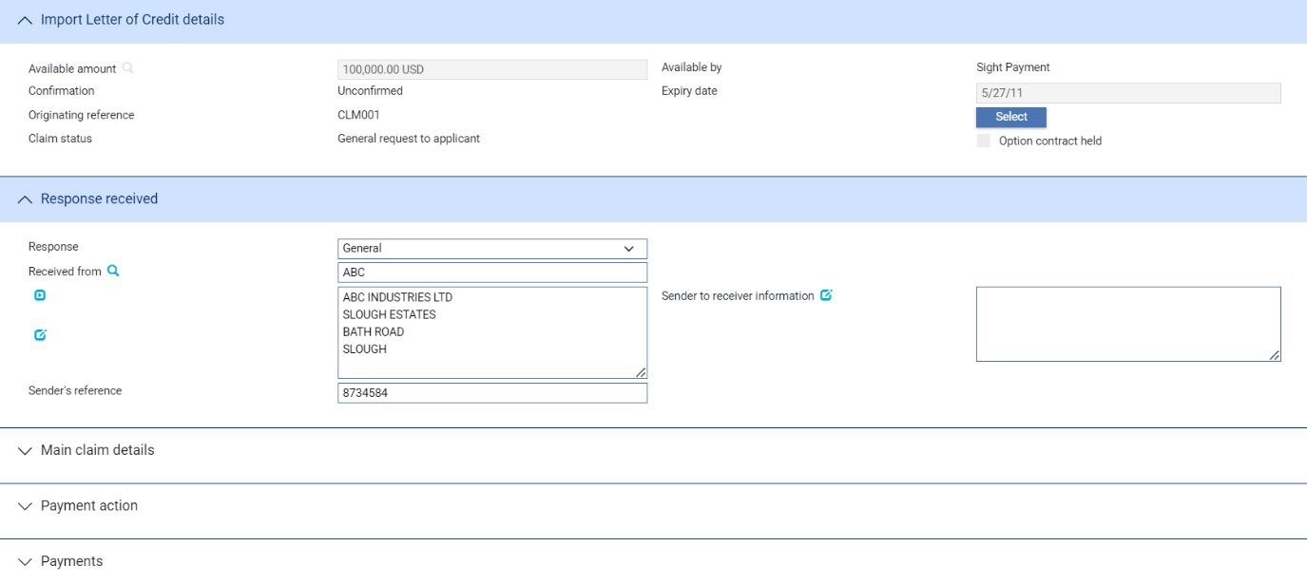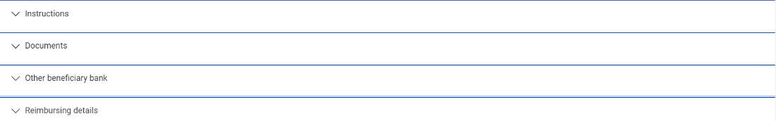

If there is only one outstanding claim, the system retrieves it and displays its details. If there is more than one outstanding claim, use the Select button (see page 69) to select the one to continue.

Use the Received From fields to identify the party from whom you received the response, and enter their reference for the response into the Sender’s Reference field.

The Response field allows you to identify the type of response received. You can select from the following values:

* General (see page 72)
* Documents Received (see page 72)
* Refusal (see page 73)
* Authorisation to Pay (see page 74)
* Advice of Payment (see page 75)
* Invoices Received (see page 72) for transfer letters of credit
* Maturity (see page 75), if the event has been generated automatically from a diary action.
* Reverse Payment (see page 76)

The fields shown in the window vary, depending on what response type you select.

#### General/Documents Received/Invoices Received

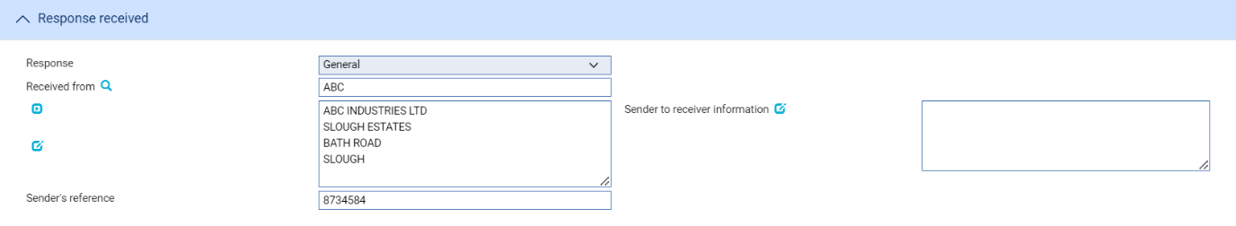

Use the Sender to Receiver Information field to enter any narrative from the sender and the Sender’s Reference field to enter the sender’s reference for the event. If you select ‘Documents Received’, you should also enter details of the documents received.

#### Refusal

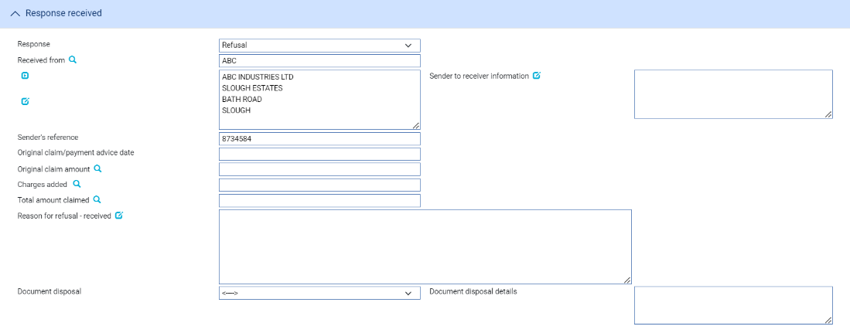

The following table explains what to enter into the fields used to record refusal:

|  |  |  |
| --- | --- | --- |
| Field | What to Enter | |
| Response | The type of response. You can select from the following:  • General  • Documents Received  • Refusal  • Authorisation to Pay  • Advice of Payment  • Invoices Received for transfer letters of credit  • Maturity (if the event has been generated automatically from a  diary action)  • Reverse Payment | |
| Received From | The party from whom you received the reply Click on  to update the Structured Name and Address. | |
| Sender’s Reference | The reference used by the sender for the reply. | |
| Sender to Receiver Information | Any narrative from the sender, which can be the applicant or the applicant’s bank. | |
| Disposal of Documents | Use this dropdown to indicate the disposal action for the documents: | |
|  | Hold | Select this field if you intend to hold documents received. |
|  | Notify | Choose Notify if you intend to forward them to the applicant. |
|  | Previous instructions | Acting in accordance with instructions previously received from the presenter. |
|  | Return | Select this field if documents are to be returned to the sender. |
| Document Disposal Details | Use this field to update document disposal details | |
| Original Claim/ Payment Advice Date | The date the original payment advice was sent. | |
| Original Claim Amount | The amount claimed on the original payment advice. | |
| Charges Added | Any charges (with currency) being claimed by the sender as the result of refusing the claim. These represent other bank’s charges due from the seller. | |
| Total Amount Claimed | The total amount (with currency) being claimed for refund. This is the total of the original amount plus any charges added. | |
| Reason for Refusal-Received | Narrative giving the reason for the refusal as received from the sender/presenter. | |

#### Authorisation to Pay

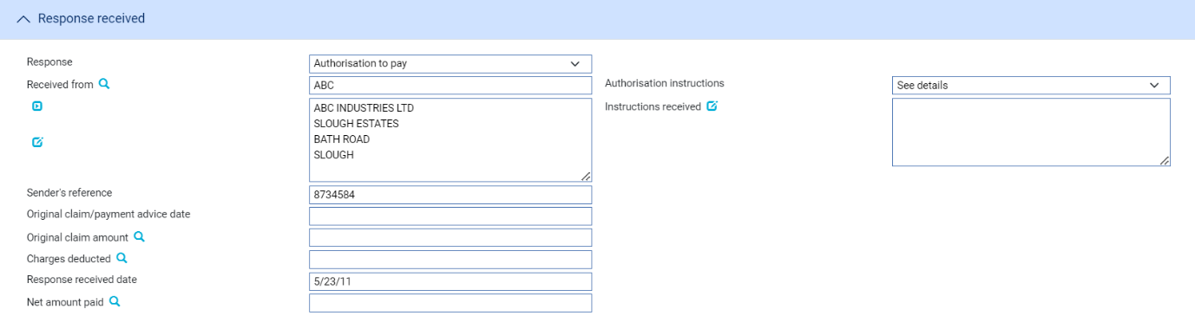

The following table explains what you should enter into the fields used to record authorisation to pay:

|  |  |
| --- | --- |
| Field | What to Enter |
| Response | The type of response. You can select from the following:  • General  • Documents Received  • Refusal  • Authorisation to Pay  • Advice of Payment  • Invoices Received for transfer letters of credit  • Maturity (if the event has been generated automatically from a  diary action)  • Reverse Payment |
| Received From | The party from whom you received the reply. Click on  to update or view the Structured Name and Address. |
| Sender’s Reference | The reference used by the sender for the reply. |
| Authorisation Instructions | Select from one of the following:   * Accept * Debit Selves * Pay and Claim Reimbursement * See Details * Negotiate |
| Instructions Received | The terms of the authorisation. |
| Original Claim/ Payment Advice Date | The date of the original payment advice. |
| Original Claim Amount | The amount claimed on the original payment advice. |
| Charges Deducted | Any charges being deducted by the sender.  For complete reconciliation check this amount using the Charges Summary window. Refer Common Facilities User Guide – Trade Innovation for instructions. |
| Net Amount Paid | The net amount being paid. |

#### Advice of Payment

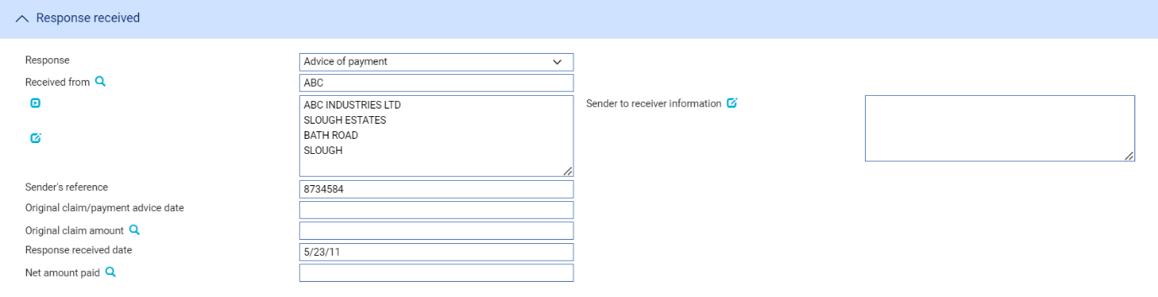

The following table explains what to enter into the fields displayed when you select Advice of Payment:

|  |  |
| --- | --- |
| Field | What to Enter |
| Sender to Receiver Information | Any narrative from the sender. |
| Original Claim/ Payment Advice Date | The date of the original payment advice. |
| Original Claim Amount | The amount claimed on the original payment advice. |
| Response Received Date | The date on which you received the response. |
| Net Amount Paid | The total amount being paid by the sender of the message. |

#### Adjust Maturity

The Adjust Maturity payment action enables you to change the value date of a future-dated payment that was specified during the payment event that you are continuing – referred here as the source event. This may be necessary if, for example, the advising bank requests you to change the date of a future payment.

This action is available only if the AllowAdjustMaturity system option is set on and only in the following circumstances:

* In an Outstanding Claim event or an Outstanding Presentation event
* When the payment action selected in the event that you are continuing was ‘Pay’
* The payment date is in the future

Unlike the other payment actions, this action is not available during a Claim Received or Documents Presented event.

You can change the following value dates, provided they are in the future:

* For the payment, in the Value Date field
* For any additional amounts
* For associated charges, using the Settlement Details window (refer Common Facilities User Guide – Trade Innovation)

When you change such a value date the system identifies charges in the source event that were due for a future value date that has not yet been reached, supersedes them in the source event and includes them in the current event set to ‘Take’. Their value date can be changed using the Settlements window.

The system also identifies postings projected in the source event with a value date that has not yet been reached and stops the original projections being posted and generates replacement projections with the revised value date.

Any SWIFT payment messages that are yet not released are stopped and new messages generated, as appropriate, from the current event. However, if messages from the source event have already been released:

* For funds movement messages (such as MT202), the equivalent messages in the new event are automatically suppressed
* For event document messages (such as MT756), you should set up rules to prevent the issue of such duplicate messages

Any charges or additional amounts that had no value date entered for them will be automatically assigned the new value date for the payment.

Value dates that have passed cannot be changed. For example, if the original claim included part payments and the value date for one of those has now passed, you cannot change the value date for that part payment.

You can enter explanations for or comments on the change in the Notes to Applicant and Notes for Presenter fields.

#### Reverse Payment

The Reverse Payment action allows a payment to be refunded where, for example, a claim is initially paid but is subsequently found to be discrepant. The payment action is available only when a transaction is flagged as having multiple payments, with a single part payment that has already been paid.

When this payment action is selected, the part payment that is already paid is set to ‘Paid/Reversed’.

Your bank will need to define postings to reverse the part payment. This might involve the reinstatement of any liability, if appropriate.

## Processing Associated Payment Details

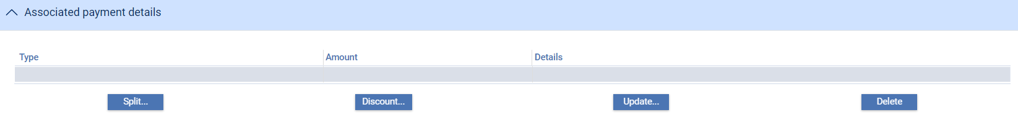

The Associated Payment Details pane allows you to apply further processing against the payment or part payments being made. As payments are defined they are listed in this pane. You can select them individually and enter details of:

* An assignment to a third party (see page 77)
* A loan (see page 77) – select the Finance line and click **Update**
* A discount (see page 78) – click **Discount**
* A license – click **Licenses**. Refer Licenses User Guide – Trade Innovation for further instructions

### Assigning Proceeds to a Third Party

Click **Split** that appears in the Associated Payment Details pane.

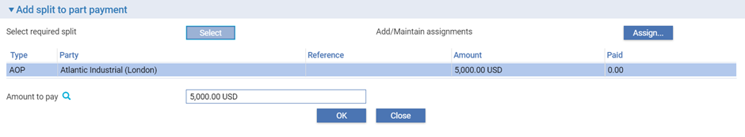

In the window that appears the system lists all assignments of proceeds (AOP), transfer letters of credit (TRF) and back-to-back letters of credit (BTB) created against the parent transaction, showing for each:

* The name of the beneficiary or assignee
* The original amount allocated
* The amount paid to date

Select the third party to whom you wish to assign proceeds and click **Select**.

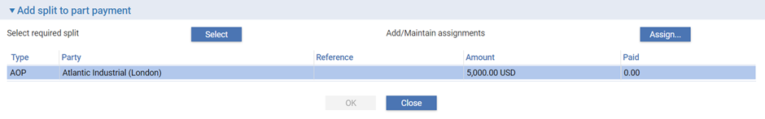

The system displays the amount to be assigned, which you can overtype. Click **Assign** to assign the amount to the selected third party.

### Entering Details of a Loan

1. The functionality described in this section is used to enter loans for systems where the financing module is not implemented. If your system has the financing module implemented refer Financing User Guide – Trade Innovation for information on processing loans.

For payments where you have selected Pay with Financing or Issue Trust Receipt Loan, a Finance line is included as part of the payment details.

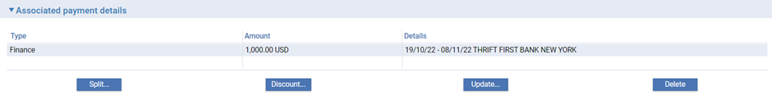

This is used to record information if the applicant needs to borrow funds in order to defer payment to a later date. Typically repayment is made from the applicant’s own funds at a future date, for example after an onward sale of goods has been arranged. When you double click on this line or select it and click **Update**, the system displays a window which allows you to enter details of a loan being made against a payment.

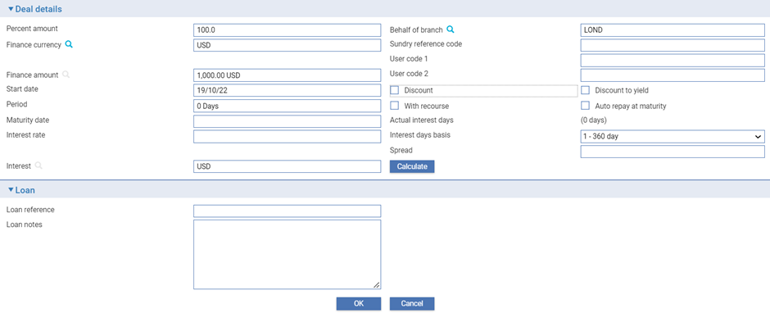

The following table explains what to enter into the field in this window to record details of any such loan.

When you complete input and close this window, the Finance line displays the amount and currency of the loan, its start date and maturity date, the interest rate, and the interest/discount amount:

### Discounting Payments

1. The functionality described in this section is available only if you do not have the financing module implemented.

For payments where you have checked both the Eligible box and the Hold box, the Discount button in the Associated Payment Details pane is enabled.

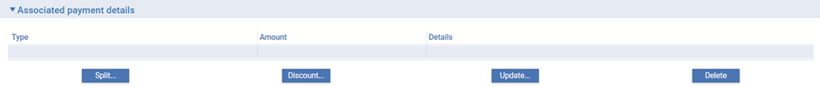

This allows you to record details of a payment to be made to the presenter before the date due under the terms of the master record.

When you click **Discount** the system opens a window for you to enter details of the discount.

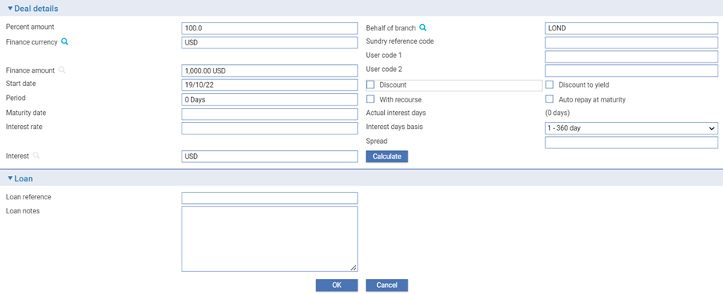

|  |  |
| --- | --- |
| Field | What to Enter |
| Percent Amount | The amount of the part payment to be financed, as a percentage. |
| Discount/ Discount to Yield | Indicate when interest is to be paid. Check the Discount box if interest is to be paid at inception, or leave the box blank if interest is to be paid at maturity.  Check the Discount to Yield box if the discount to yield formula is to be used to calculate the discount instead of the standard discount formula.  If you click on either the Discount box or the Discount to Yield box the system displays extra fields. |
|  | Once you enter a value into the Rate field the system calculates and displays the discount amount and displays it using the Discount Interest field. Alternatively, you can enter the discount amount into the Discount Interest field, and the system will calculate the interest rate and display it using the Rate field. In either case the system calculates and displays the net amount due using the Net Amount field.  Use the Discount Paid By field to define who will pay the discount interest amount on the loan. The debit party is the applicant and the credit party is the presenter. The system uses the credit party as the default. |
| Finance Currency | The currency of the loan, if different from the currency of the transaction.  If you enter a currency here that is different from the transaction currency, the system displays an Exchange Rate field for you to identify the exchange rate to be used to convert the loan amount from the transaction currency.  When you have selected an exchange rate the system calculates and displays the converted amount in the Finance Amount field. |
| With Recourse | Use this field to indicate whether or not the loan is with recourse. By default, the box is unchecked and the loan is without recourse. |
| Start Date | The start date of the loan. The system uses the part payment value date as the default. |
| Period/ Maturity Date | The maturity date for the loan. Either enter the maturity date; or use the Period fields to identify the number of days, weeks, months, quarters or years after its start date the loan will mature. If you select the latter option, the system calculates the maturity date and displays it in the Maturity Date field.  The Maturity Date field may be left open for loans with interest payable at maturity. This allows the maturity date to be entered as the loan is repaid. |
| Interest Rate | The overall rate at which interest or discount is to will be required to record details of the repayment manually.  This field can be checked only if the Maturity Date field is not blank. |
| Spread | The spread rate that has been added to the interest rate. This is used for reporting purposes only. Your bank will have devised its own system for using this field.  The values entered here will appear on the deal generated for the loan. |
| Behalf of Branch | The branch that owns the loan. |
| Sundry Reference Code/User Code 1/User Code 2 | You may use these fields to enter values for analysis purposes. Your bank will have devised its own system for using these fields. |
| Auto Repay at Maturity | Triggers the auto repay event on the Finance maturity date. |
| Actual Interest Days | Detail of the actual number of days applied for interest calculation. |
| Interest Days Basis | Interest calculation basis either 360 or 365 |
| Discount Paid By | Select which party is to pay the discount – the credit party or the debit party. |

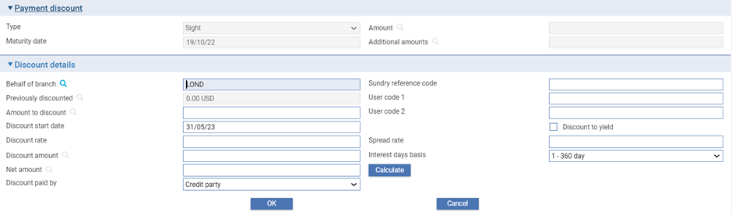

Details of the payment or part payment being discounted are displayed at the top of the window. The table below explains what to enter into the field in this window. Clicking the Calculate button updates the fields, using the values you have entered:

|  |  |  |
| --- | --- | --- |
|  | Field | What to Enter |
|  | Previously Discounted | If a discount has already been given against the transaction, the amount against which the discount was given. |
|  | Amount to Discount | The amount of the discounted payment for which the early payment is to be made. This may be up to the amount due under the part payment, including additional amounts. |
|  | Discount Date | The date the discounted payment is to be made. The system uses today’s date as a default. |
|  | Spread Rate | The spread rate that has been added to the interest rate. This is used for reporting purposes only. |
|  | Days Basis | The days basis to be used to calculate the interest. A list of valid values is given in the Common Facilities User Guide – Trade Innovation. |
|  | Discount to Yield | Click once on the Discount to Yield box so that it is checked if the discount to yield formula is to be used to calculate the discount instead of the standard discount formula. |
|  | Discount Amount | The amount of the discount. If you enter the interest rate into the Discount Rate field, the system calculates the discount and displays it in this field, where you can overwrite it. Alternatively, you can enter the discount value directly into this field and the rate will be automatically recalculated. |
|  | Discount Rate | The interest rate to be used to calculate the discount interest amount. Enter the overall rate at which discount is to be calculated (including the spread).  Alternatively, you can enter the discount as an amount in the Discount Amount field. |
|  | Net Amount | The total value of the early payment, taking into account any discount due. |
|  | Discount Paid By | Indicate which party is to pay the discount on the early payment. |
|  | Branch | The branch that owns the discount deal. |

# Repaying a Loan

Loans can be repaid in part or in full using the Repay Finance event. In the Master Summary window select ‘Repay Finance’ from the Create New Event drop-down list. The system opens the event at either a Log step or Input step, depending on how the Workflow orchestration controlling the event is configured. Refer *Workflow Tailoring User Guide* – Trade Innovation for details.

1. This functionality described in this chapter is used to repay loans against an import letter of credit for systems where the financing module is not implemented. It is also used to repay loans entered on your system prior to the implementation of the financing module. If your system has the financing module implemented refer Financing User Guide – Trade Innovation for information on repaying loans against an import letter of credit.

### Logging the Loan Repayment

As the event is opened the system retrieves details of all loans associated with the transaction and lists them.

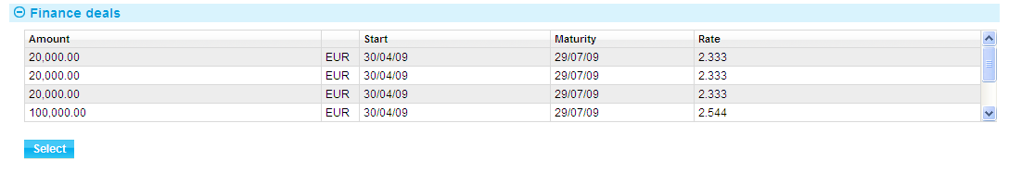

Highlight the one that is to be repaid, then click **Select**. The system retrieves details of that loan and displays them. You can subsequently use the Select button during an Input step to select a different loan, if necessary.

### Entering Full Details of the Loan Repayment

One set of fields is used if the loan has interest paid at inception.

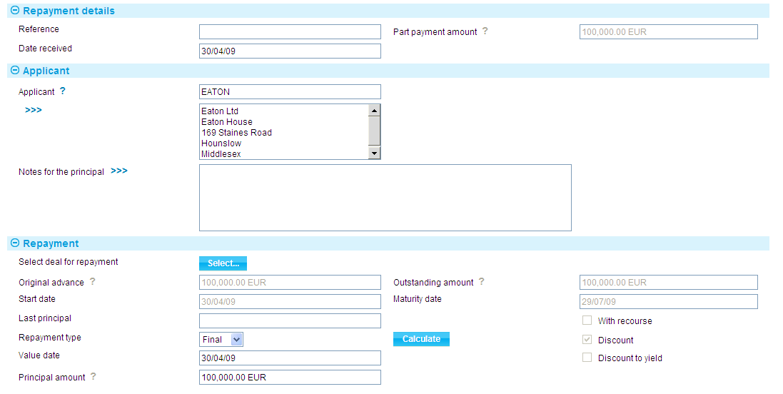

Another set of fields is used if interest on the loan is due at maturity.

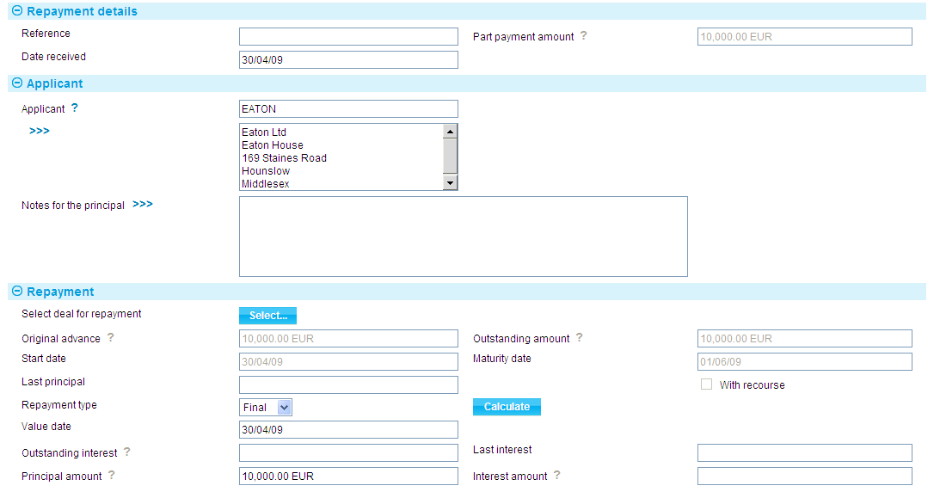

The following table explains what you should enter into the fields in this window. You can use them to repay the loan in full or in part:

If you use the Repayment field to indicate that this is a final payment, the system displays the balance of the interest still outstanding in this field, and you will not be able to alter it. If, however, you have used the Repayment field to indicate that this is a partial repayment, then enter the amount of interest being paid with this part payment, together with the relevant the amount entered for the value date, and interest will be posted for the loan for the value date entered.

#### Repaying the loan in full

To repay the loan in full, select ‘Final’ in the Repayment Type field. The system displays the full amount of the loan outstanding in the Principal Amount field, and for non-discount loans the full amount of any interest due in the Interest Amount field. You cannot overtype these figures. The system repays the outstanding amount using the value date entered for the loan repayment.

#### Making partial repayments

To enter a partial repayment, select ‘Partial’ in the Repayment Type field, then enter the amount of the principal being repaid in the Principal Amount field and for non-discount loans any interest being repaid in the Interest Amount field. The balance of the loan will be reduced by the amount entered for the value date, and interest will be posted for the loan for the value date entered.

|  |  |
| --- | --- |
| Field | What it Shows |
| Reference | The applicant’s reference for the loan repayment. |
| Date Received | The date on which you received the repayment. The system uses today’s date as the default. |
| Part Payment Amount | The amount of the part payment against which the loan was made. |
| Applicant | Displays the applicant’s details. |
| Notes for Applicant | Any notes for the applicant regarding the repayment. |
| Original Advance | Displays the amount and currency of the original loan, excluding any repayments that may have been made. |
| Outstanding Amount | Displays the amount of the loan still outstanding, and the code of the currency of the amount. This is the original amount minus any principal repayments that have been made. |
| Start Date | Displays the start date of the loan. |
| Maturity Date | Displays the date on which the loan is due to be repaid in full. |
| With Recourse | Displays whether the original advance was with recourse or not. |
| Discount | For a discounted loan, this box is checked to indicate that interest on the loan was paid at inception. |
| Discount to Yield | For a discounted loan, this box is checked if the discount to yield formula was used to calculate the discount instead of the standard discount formula. |
| Outstanding Interest | For non-discount loans, this field shows any outstanding interest (with the relevant currency code). If the repayment is against a discounted loan, then the system will not display the interest amount field as interest will have been taken at inception. |
| Last Interest | For non-discount loans, this field shows the value date of the most recent payment of interest against the loan. |
| Last Principal | Displays the value date of the most recent repayment of principal against the loan. |
| Repayment | Indicate whether the repayment is a partial payment or a final repayment of the balance of the loan. |
| Value Date | The date on which the repayment is to be made. The value date cannot be before the last processing date if interest is being paid. If principal only is being paid, the value date cannot be before the last interest payment date. |
| Principal Amount | Displays the amount of the loan outstanding, with the code of its currency. If you use the Repayment field to indicate that this is the final payment against the loan, then you cannot alter the amount shown here. However, if you use the repayment field to indicate that this is a partial payment, then you can enter the amount of the loan being repaid into this field. |
| Interest Amount | If you have used the Repayment field to indicate that this is a final payment, the system displays the balance of the interest still outstanding in this field, and you will not be able to alter it. If, however, you have used the Repayment field to indicate that this is a partial repayment, then enter the amount of interest being paid with this part payment, together with the relevant currency code. |

# Discounting a Payment

1. This functionality is used by systems where the financing module is not implemented. If your system has the financing module implemented refer *Financing User Guide* – Trade Innovation for information on discounting payments.

The system permits you to discount acceptance and deferred payments that have not yet been paid as a separate event, for example payments with a status of ‘Pay at Maturity’ or ‘Accept’.

To discount a payment, in the Master Summary window select ‘Discount Payment’ from the Create New Event drop-down list. The system opens the event either at a Log step or Input step, depending on how the Workflow orchestration controlling the event is configured. Refer *Workflow Tailoring User Guide* – Trade Innovation for details. By default the log steps includes the same panes and fields as the input steps. Depending on how your system is configured, panes and fields available in log steps can be tailored for each data capture step. Refer *SDK – Screen Tailoring* Guide – Trade Innovation for details.

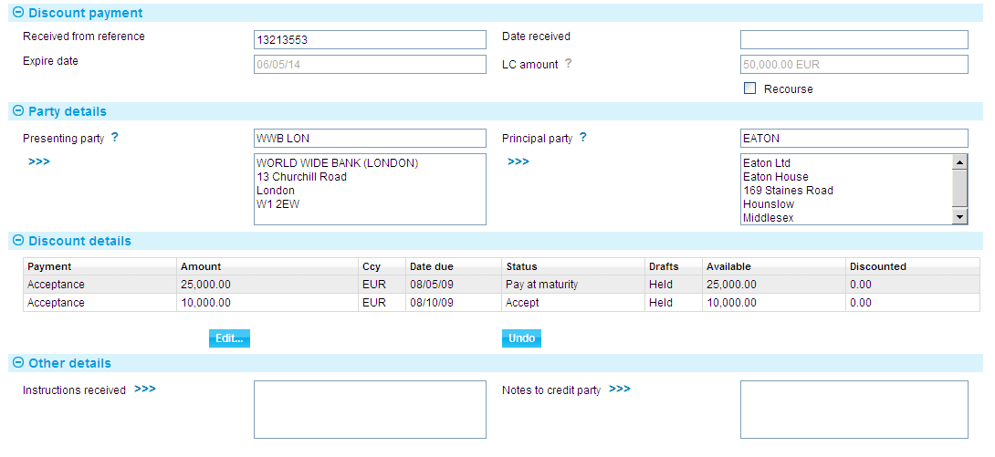

In the window displayed, the Discount Details pane lists all the payments associated with the letter of credit. Information for each payment is shown under the following headings:

|  |  |
| --- | --- |
| Heading | What it Shows |
| Payment | The type of payment – Sight, Acceptance or Deferred. |
| Amount/Ccy | The amount and currency of the payment. |
| Date Due | The date the payment is due to be made. |
| Status | The status of the payment. |
| Drafts | Indicates whether the drafts are being held by your bank or not. You can only discount a payment if drafts are being held. |
| Available | The amount of the payment available for discounting. |
| Discounted | The amount of the part payment that has been discounted, including any earlier discounting. |

The following table explains what to enter into the fields in this window:

|  |  |
| --- | --- |
| Field | What to Enter |
| Received From Reference | The reference used for the discount by the party from whom you received the request for discount. |
| Date Received | The date the request was received. |
| Expiry Date | The letter of credit’s expiry date. |
| LC Amount | The amount and currency of the letter of credit. |
| Recourse | Indicate whether or not the discount is with recourse. By default, the box is unchecked and the discount is without recourse. |
| Presenting Party | The presenting party. |
| Principal Party | The principal party. The system will debit this party, where discount is not payable by the presenting party. |
| Instructions Received | Any instructions received with the request. |
| Notes to Presenting Party | Any notes for the presenting party. |

Select the payment to be discounted, then click **Edit**. The system displays a window which you can use to enter details of the discount.

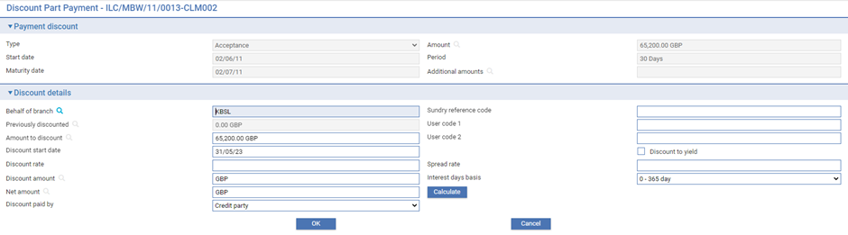

When you complete input, the details shown for that payment in the main Input window reflect the discount entered.

The Undo button removes any discount details you have entered.

# Revolve Events and Notifications

## Revolving Credits

When you first enter details of a revolving credit onto your system the system permits you to define how many times the credit will revolve, at what interval, and whether the revised amount is to be cumulative or non-cumulative. You can also specify whether a notification is to be sent in advance of the revolve date for an import letter of credit, and whether a credit is to revolve only when notification is received for an export letter of credit.

The system uses these details to create diary events for the letter of credit. It generates a diary entry for the Revolve event (see page 87), which will revolve the credit automatically on the next date, as specified in the letter of credit’s schedule. As one Revolve event is completed, the system automatically generates a diary entry for the next.

For import letters of credit, if a notification advice is to be sent, a Revolve Notice event (see page 86) is added to the diary the required number of days in advance of the next revolve date.

For export letters of credit a Revolve Notice event is created manually following the receipt of a revolve notification from the issuing bank.

Both the Revolve Notice event and the Revolve event can be configured to be generated and released automatically, requiring no manual intervention. Alternatively, they can be configured to require manual intervention at an Input, Review or Final Review step before they can be released. If this is the case, the system will generate a Revolve event during overnight processing and list it, at the appropriate step, in the Work in Progress pane in the Summary window. You must manually intervene by opening the event and performing the required steps before it can complete and be released.

If your bank has implemented credit limit checking, the system will also generate a Revolve event in the Work in Progress pane for a Revolve event configured to be processed automatically, if credit checking during overnight batch processing results in an overline condition being reported. The event will be generated at the Limit check step.

### Licenses

If there is a license attached to a revolving letter of credit, the license amount must be sufficient to cover the maximum amount available under the letter of credit – that is, the letter of credit amount plus the maximum tolerance – multiplied by the number of revolving cycles.

Refer Licenses User Guide – Trade Innovation for details of licenses.

## Revolve Notifications

The following window is used for a Revolve Notice:

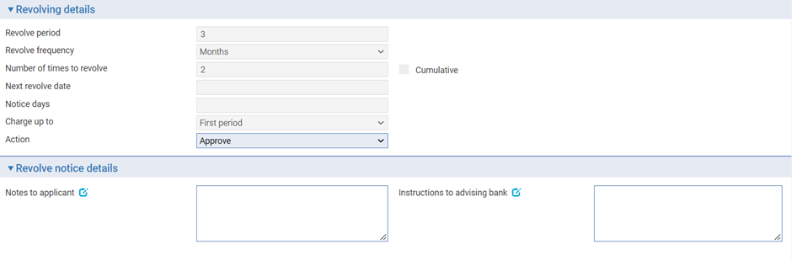

The window displays the terms under which the letter of credit revolves. Where the letter of credit has already revolved, the To Date field is present and shows how many times the letter of credit has revolved.

During an Input step you can enter notes for the applicant and the advising bank. These will appear on notifications sent to each of these parties respectively.

The Action field allows you to indicate whether the next Revolve event is to take place or not. If you select ‘Approve’, the Revolve Notice event generates a notification of revolution for the next advising bank, and the next Revolve event takes place in the usual way at the appropriate time. If you select ‘Reject’ instead, no notification is sent and the Revolve event is removed from the diary. However, future Revolve events will continue to be generated in the usual way.

## Revolving the Letter of Credit

The following window is used for a Revolve event:

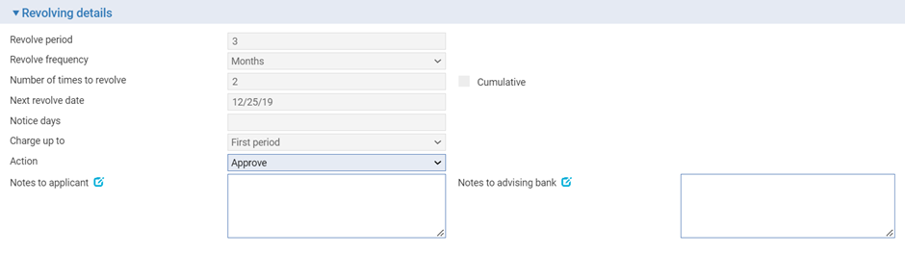

The window displays the terms under which the letter of credit revolves. Where the letter of credit has already revolved, the To Date field is present and shows how many times the letter of credit has revolved.

During an Input step you can enter notes for the applicant and the advising bank.

The Action field allows you to indicate whether the revolution is to take place or not. If you select ‘Approve’, the revolution takes place and the system sets the date for the next Revolve event and, if required, the next Revolve Notice event in the diary. If you select ‘Reject’ instead, the Revolve event is removed from the diary. However, future Revolve events will continue to be generated in the usual way.

# Amending an Import Letter of Credit

A letter of credit can be amended using an Amend event (see page 95) at any time between the release of the Issue, Advise or Transfer event that created it and book-off.

Typically, an amendment is initiated by the issuing bank at the request of the applicant. The issuing bank then passes details of the amendment on to the next bank in the processing chain, which records the details and then inform the next advising bank or the beneficiary, as appropriate.

There are two types of amendments. Amendment requesting beneficiary approval and amendments which does not require any approval.

If beneficiary approval is not required for the amendment, then accounting entries and changes to the master record as a result of the amendment are carried out as soon as the Amend event is released.

If the beneficiary’s approval is required for the amendment, then we have further two ways of processing them.

1. Proactive amendments and
2. Non-proactive amendment.

Once Proactive amendment feature is enabled through system option ‘**AllowLCProactiveAmendMaster**’ then all the amendments irrespective of seek beneficiary approval flag will be updated in the master record once the amendment is released.

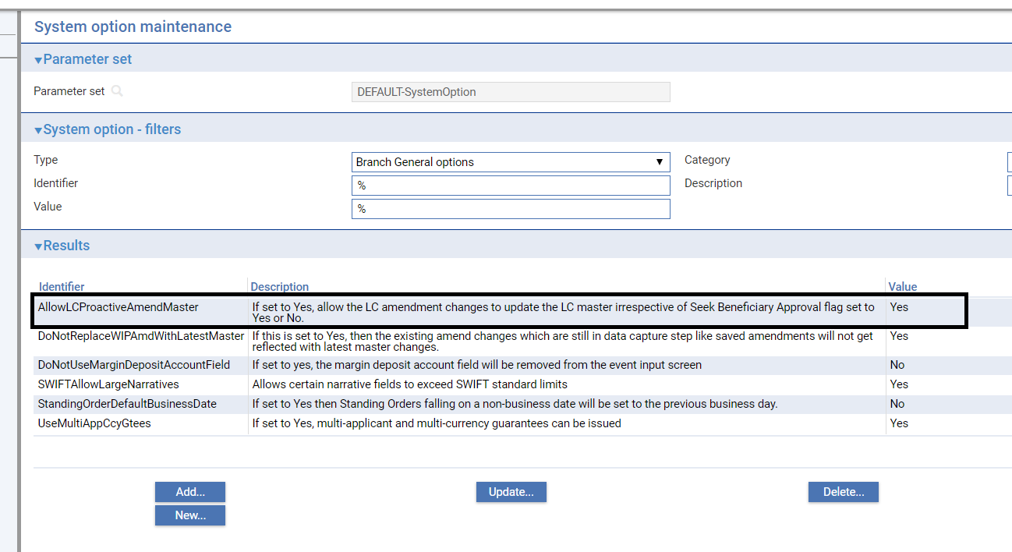

If beneficiary approval response is received, then the status of the amendment will be changed from Awaiting approval to Approved. In case beneficiary rejection response is received then the changes made will be reverted under beneficiary rejection response processing event.

Accounting entries updating will still depend on the bank’s posting rules setup. i.e. if they wish to proceed with updating accounting entries and charge collection

1. On amendment release and do the reversal booking if beneficiary rejects later or
2. They can do as and when the approval response received from beneficiary.

For non-proactive amendments, the amendment changes do not take effect until the beneficiary’s approval is obtained and recorded in the system. In this case, no accounting entries are produced for the Amend event, although any charges due can be paid, if required. Once beneficiary approval is recorded, then the appropriate accounting entries are made once the event recording beneficiary approval is released. If beneficiary approval is required, then the changes made during the amendment are not applied to the master record until beneficiary approval is obtained.

If the amendment increases the amount of a letter of credit that is already participated, a Drawdown/Revolve Commit Amt event may be created as a subsidiary event to decrease the commitment amount available on the participation deal. If the amendment decreases the amount of a letter of credit that is already participated, a Drawdown/Revolve Commit Amt event may be created as a subsidiary event to increase the commitment amount available on the participation deal, if the deal is revolving.

You can use an Amend event to change a letter of credit from inoperative to operative and to reinstate an expired or cancelled letter of credit’s master record. However, you cannot reinstate a cancelled transfer letter of credit using an Amend event.

The Amend event should not be used to participate a transaction that was previously not participated. Use a Maintain Liability event instead.

## Reversal Postings

You can use the reversal posting facilities to set up the necessary postings to handle amendments which may have an effect on any previous liability accounting, such as changes to confirmation instructions or the tenor of a payment.

## Transfer Letters of Credit

Transfer letters of credit and their parent letter of credit can be amended independent of each other, although the system warns you if:

* An amendment to the value of the parent letter of credit means that its amount falls below that allocated to transfer letters of credit, back-to-back letters of credit and assignments
* An amendment to the value of a transfer letter of credit means that it exceeds the amount of the parent letter of credit available for allocation to the transfer

It also prevents you from making an amendment to the expiry date of either the parent letter of credit or the transfer letter of credit which would result in the transfer expiring after the parent letter of credit.

Refer Transfer Letters of Credit User Guide – Trade Innovation for instructions on amending a transfer letter of credit.

## Assignments of Proceeds and Back-to-back Letters of Credit

Assignments of proceeds can be amended or removed from an import letter of credit at any time between the release of the Advise event and payment.

Back-to-back letters of credit are amended independent of their parent letter of credit, although the system issues warnings if amendments to amounts or expiry dates take the letter of credit outside the terms of the parent letter of credit.

## Licenses

If the master record is attached to a license, the License pane is available for you to view and amend any details of additional reservations or reinstatements when the amount or currency change.

There will also be some additional validation when you make an amendment to a master attached to a license. For example:

* If you make an amendment after the Valid To date on the license is passed, the system will either reject the amendment or allow a new license to be added, depending on how your system is set up
* If you change the shipment date, the new shipment date must be between the Valid From and Valid To dates on the license
* If you change the amount or currency, the new value will be validated against those on the license. The license amount may be reserved or reinstated for the amended amount
* If you change either the name of the applicant or the beneficiary on an import letter of credit, the new name must be the same as the nominated party on the import license

Note that if you are increasing the amount of a master record, then a reservation is automatically made against the license. If you are decreasing the amount, then a reinstatement is automatically made. If you change the currency, you may reinstate in the old currency and make a reservation in the new currency (assuming that the license in question allows multiple currencies).

If the master record is amended so that its status changes from Cancelled or Expired, the reinstated letter of credit value will be validated against the available amount on the license.

If the amendment requires beneficiary approval then any reservations or drawdowns required occur in the Ben Response to Amend event instead, provided that the amendment is approved.

Refer Licenses User Guide – Trade Innovation for details of licenses.

## Purchase Orders

You can make changes to purchase order details using two events – the Amend event and the Adjust event. Both events allow you to record purchase order details against an import letter of credit after the letter of credit has been created, and to change certain details of any purchase orders already entered.

Where the purchase order is in a currency different from that of the letter of credit, you can amend the exchange rate used. You can also amend the description, zone of measurement, adjustment amount and reason, and quantity of individual items within a purchase order.

If you use the customer gateway interface service, details of amendments involving purchase order details may be received electronically, in which case the amended details will be mapped automatically to the appropriate Amend event fields.

If the amendment details are transmitted to the advising bank via SWIFT, the purchase order details can be mapped to field 79 Narrative of the MT707 Amendment to a Documentary Credit message.

## Revolving Letters of Credit

For a revolving letter of credit, if you amend the details governing revolutions, then the new revolution details are then used to generate the next Revolve Notice and Revolve events upon completion of the Amend event. However, if the amendment requires beneficiary approval, any changes to the revolve details take effect once the Ben Response to Amend event recording the beneficiary’s approval is released.

## Maintaining Liability

You can change the way that liability on a transaction is shared by using the Maintain Liability event. Maintain Liability events can be used to:

* Participate a transaction
* Share customer liability on a transaction

When you click **OK** or **Pend** on the Input window of an Amend event for a participation deal, a Maintain Liability subsidiary event is automatically generated for each transaction affected by the amendment. You can use the Subsidiary Events link from the Master Summary window to view this event but it is processed and released via the participation deal Amend event.

Refer Participated Deals User Guide – Trade Innovation for the Maintain Liability event.

## Handling More than One Amendment at a Time

The system permits you to have more than one Amend event in progress at the same time. If you attempt to open an Amend event for a master record that already has an Amend event in progress, or is awaiting the beneficiary’s response to an amendment, the system will warn you of the fact, but will allow you to continue.

The saved amendments data can either be over ridden with the latest master data as an when the new changes updated in the master record or can be protected so that the changes saved will not be lost due to new master data changes. This depends on the system option ‘**DoNotReplaceWIPAmdWithLatestMaster**’. If you enable this system option, then the saved amendment data will be protected and will not be overridden with latest master changes but will show the comparison of current event data with the latest master data. Whereas if you disable the system option, then the system will show the current details held for the master when the Amend event is created or opened at an Input step.

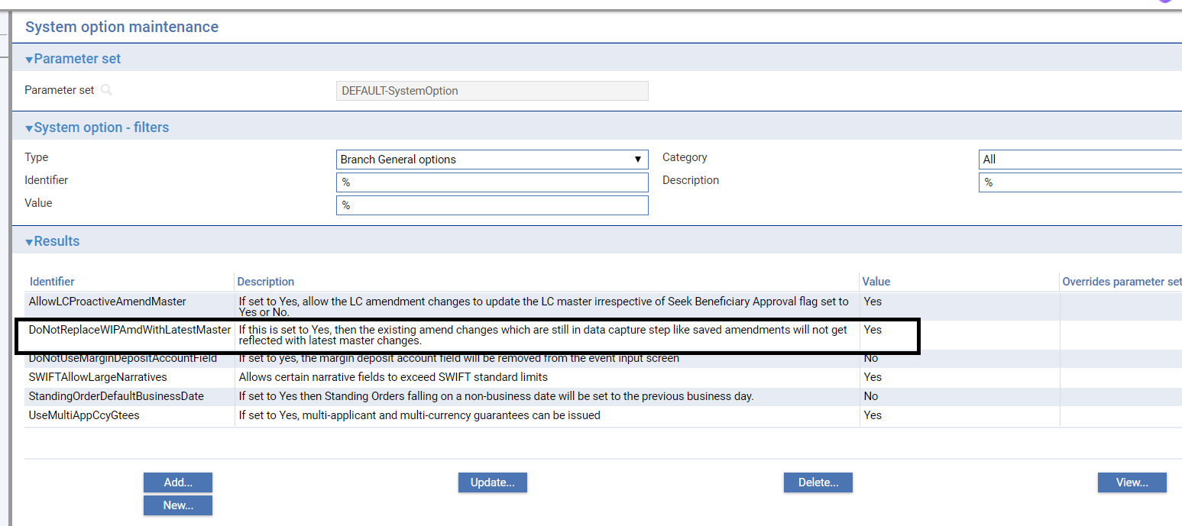

You can check whether any changes have been made to master record details between an Amend event requiring beneficiary approval being initiated and that approval being received. The Beneficiary Response to Amend event allows you to display a list of master record fields and indicates in this list any fields where the information held on the master record differs from that held in the Beneficiary Response to Amend event. Should you discover a field that has been updated since the Amend event was initiated, you can choose whether or not to overwrite the value currently held in the master record with the value held in the Beneficiary Response to Amend event.

A field - the Use Previously Amended Amounts in Advise field – present during the Amend event when a previous amendment is still awaiting beneficiary approval permits you to decide whether or not the amount shown in tag 34b of the MT707 advice should take into account the amount of the earlier amendment.

If your system is configured so that Amend events need to be reviewed before release, then during these later steps the supervisor will be advised of the existence of another Amend event that has completed while the current event has been at a Review or Final Review step. They can then decide how each Amend event should be handled to ensure that the required changes are implemented.

## Displaying Changes

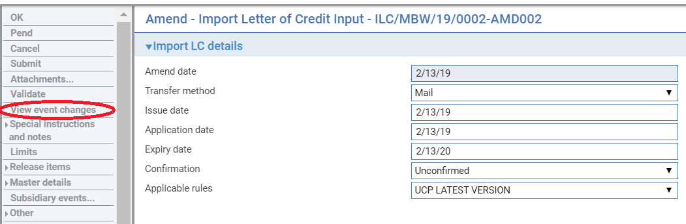

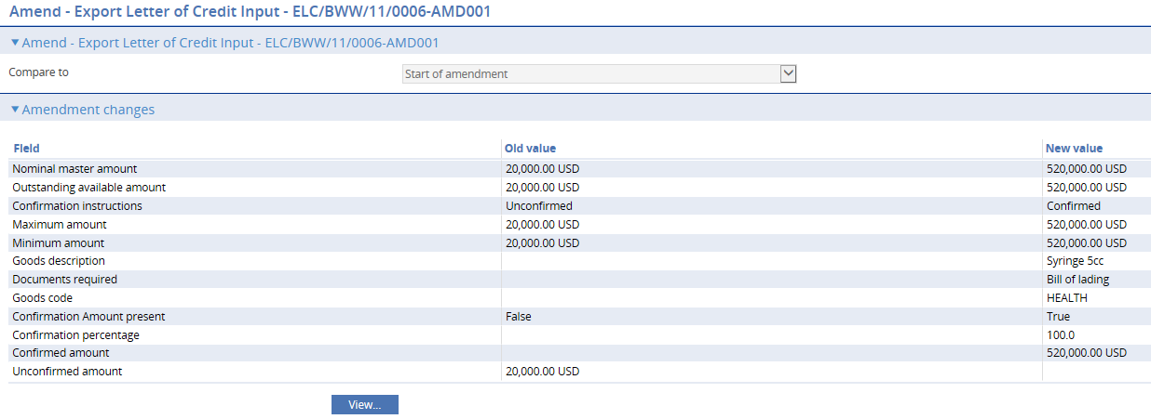

When making amendments or adjustments to a transaction the View event changes menu allows you – and reviewers – to list those fields that have changed within the event. It opens a window that lists those fields whose value has changed and shows for each the value before the current event and the new value resulting from the event.

For free-format narrative fields, your bank can configure the system so that it shows either the entire content of the field in the New Value column, or just a certain number of lines (defined by the system option ViewChangesLineCount) followed by the text:

>>> plus n more lines. ‘View’ for details.

Where n is the number of additional lines not displayed.

Selecting that entry in the list and pressing the View button displays the entire content of the field.

This window is displayed automatically when the event is opened for review or final review.

1. If you work with this window open, use the Refresh button to update the display to show any changes made since you opened the window.

Due to any other parallel amendment event or when entering the beneficiary’s response to an Amend event or a to a Transfer LC Amend event for a letter of credit, the View Event Changes menu permits you to check whether any master record details have changed since the amendment event was initiated.

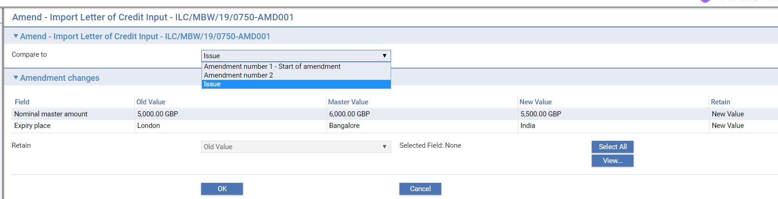

It lists those fields whose value has changed and shows for each:

* The value before the event was initiated (Old Value)
* The new value resulting from the change made in the event (New Value)
* If another event has taken place since the amendment event was initiated which has changed the value of fields held on the master record, the current value of those fields (Master Value). If this field is blank, no intervening change in value has taken place
* You can see any changes made by clicking the View button.

The window displayed allows you to see any intervening changes made by clicking the Intervening button.

By default, Retain column will display to retain New values. If you wish to replace the New value with either Old value or with Master value, then you can click any field and select retain with Old / Master / New value and then click OK to save the changes.

## Handling Delta Changes in Below 5 Narrative Fields

Below 5 narrative fields can now hold 8*100*65 character of data compared to previous 1*100*65 characters. This is due to introduction of new MT708 amendment extension messages which can have maximum of 7 extinctions.

1. Description of Goods and/or Services.
2. Documents required.
3. Additional conditions.
4. Special Payment Conditions for Beneficiary
5. Special Payment Conditions for Receiving Bank.

Due to this change it will be inefficient to pass all the 8*100*65 character of data under every amendment for small change. Hence below new instructions codes are introduced to handle delta changes:

**ADD** : Must be followed by the text to be added (a sentence, paragraph or line item)

**DELETE :** Must be followed by the text to be deleted (a sentence, paragraph or line item)

**REPALL** : Must be followed by the text that replaces all text in same field. No other code may be used.

The presence of this field implies that description of documents required is amended.

The user is able to enter one or more delta changes associated with, for an example, the Goods description field using Add or/and Delete instructions.

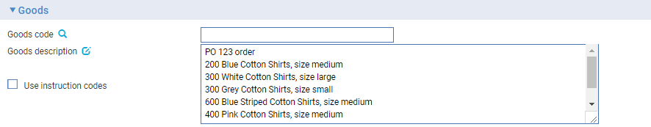

The ‘Use instruction codes’ flag controls the behavior of a given narrative field.

* If the flag is off, the narrative field is editable so that the full text can be revised.
* If the flag is on, the narrative field is non-editable and enables its associated instructions to be added, deleted or updated.

### Replace all instruction

To revise the full text, click on the edit icon  at the end of the ‘Goods description’ field label and then click **Edit**.

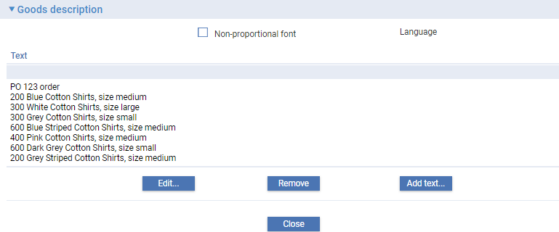

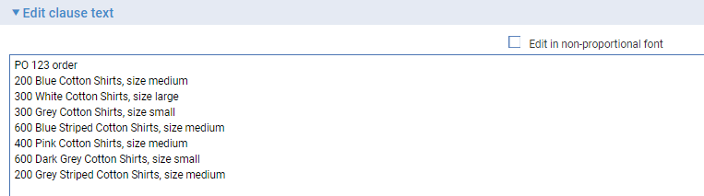

The Amendment changes page allows you to compare the current amendment versus a selected baseline of master details that represent the scope of a given LC.

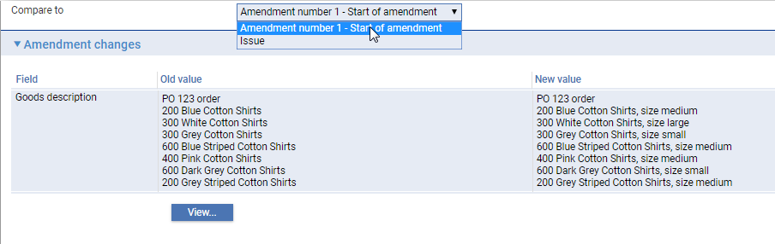

The list of possible baselines available for comparison can include the Start of the current amendment (master snapshot) and previous events such as Pre-advise, Issue/Advise, all Amendments (identified in the drop-down list with their respective amendment numbers), Adjustments (with their respective event reference numbers) and provisional events under the current Amendment.

The **View** button allows you to have a side by side compare view of the selected baseline (Old) versus the current amendment (New):

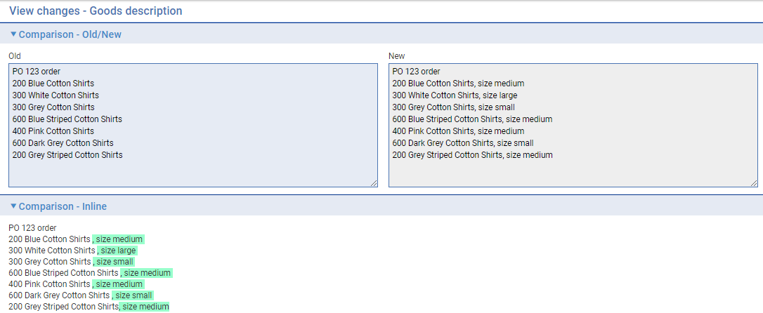

The ‘Comparison – Inline’ contents, results from the text compare that has been automatically performed to enable the user to distinguish changes.

**Outward MT707**

The Good description field is interpreted and mapped to the field 45B on MT707 as shown below:

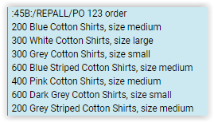

### Add or/and Delete Instructions

If the ‘Use instruction codes’ flag switched on, you can enter delta changes instructions.

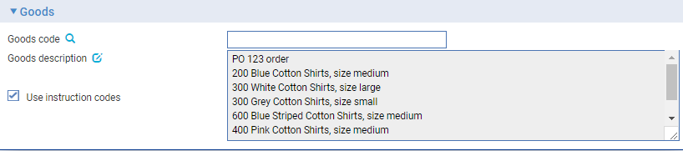

Click on edit icon  at the end of the ‘Goods description’ field label.

On the resulting page

* Enter one or more delta changes qualified as ‘add’ or ‘delete’ instructions without leaving the page.
* Select an existing instruction and update without leaving the page, which results in the description being copied to the edit field so it can be overtyped. The user has the option to submit or cancel the update.
* Select an existing instruction and delete without leaving the page.

The following screenshots illustrate a delete instruction being defined:

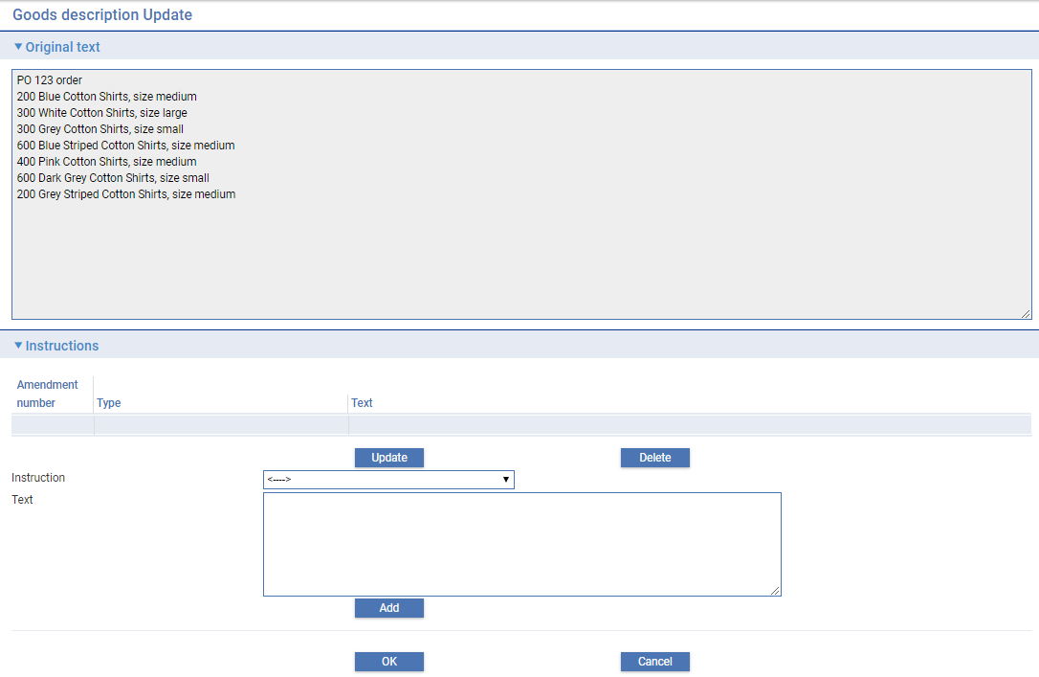

To delete a part of the existing text, select instruction type/qualification, click **Delete**

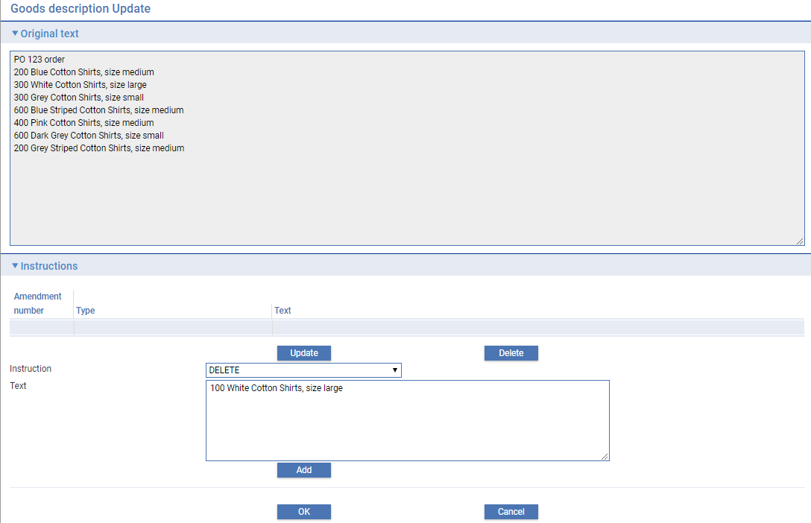

The instruction text field becomes editable and you can enter the required text directly or by copying and pasting from the original text field (displayed at the top of the page). Click the **Add** button to insert the instruction

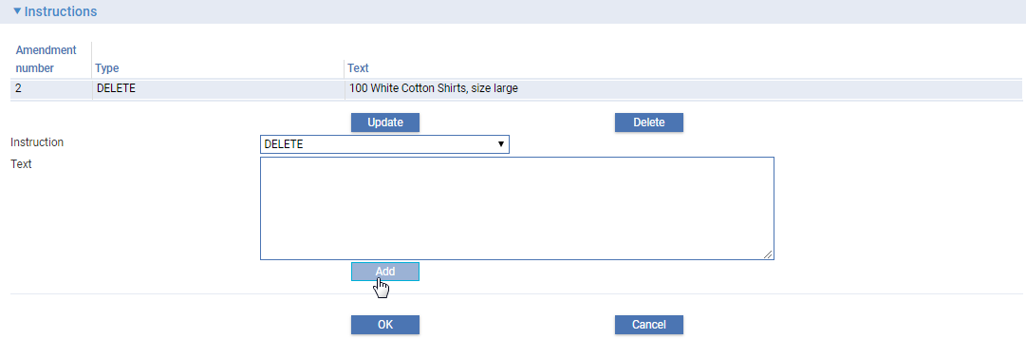

Similarly, to add new details, set the instruction type to ‘Add’ and enter the required text.

The delta changes are saved as discrete changes. But, when the details of a given narrative field are viewed on the Amendment change page, the delta instruction appear pended at the end of existing details.

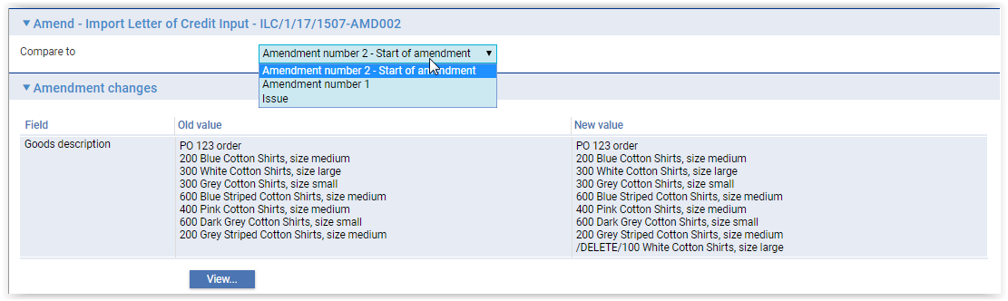

The **View** button enables the changes to be distinguished

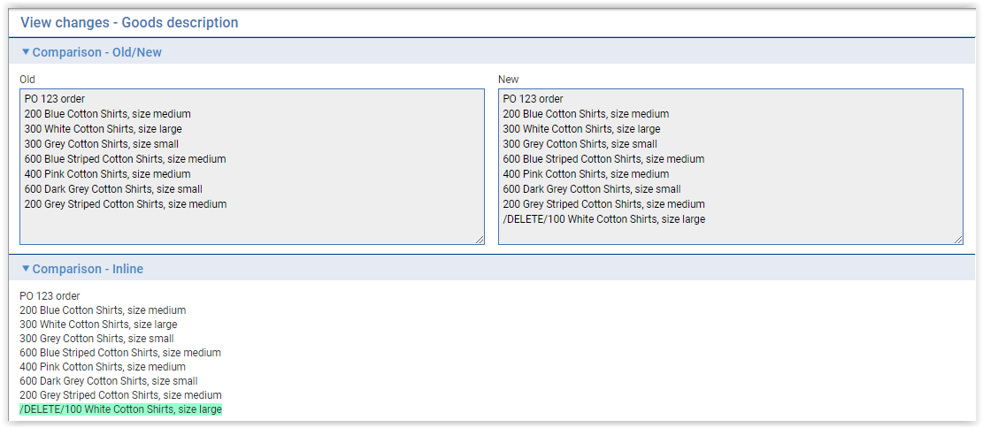

### Switching the ‘Use instruction codes’ flag on and off

The following behaviour is observed when switching between the Use instruction codes mode flag on (delta codes mode) and flag off (Replace all mode):

* Whenever a user switches mode, the system prompts with a message with a Yes/No option asking the user if they want to continue.
* If the user starts with Replace all mode and switches to Use instruction codes mode, the narrative field resets ignoring revisions made while in the editable mode.
* If the user starts with Use instruction codes and switches to Replace all mode, the previous-event delta instructions (including any added in the current event) remain available by appending in the editable narrative just in case the user needs to refer to them (especially if the flag is set off by mistake).

The system prompts an error message when code words are present in the narrative field when the event is validated. The user must remove these delta changes if they wish to proceed on a replace all basis.

### Visibility

The instruction code/text is shown for all previous amendments in the current amendment chain but the user can change only those entered in the current amendment chain.

Each instruction text is saved with the following additional details for reference purposes:

* Event ID
* Amendment number
* Narrative code
* Narrative description
* Instruction code
* Instruction text

The event fields associated with an amendment narrative field have been enhanced so that the lower level parts of event fields are available for use on documents and gateway messages.

## Amending an Import Letter of Credit

To amend a letter of credit, in the Master Summary window select ‘Amend’ from the Create New Event drop-down list and click **Create**. The system opens the event at either at a log or input step depending on how the Workflow orchestration controlling the event is configured. Refer *Workflow Tailoring User Guide* – Trade Innovation for details. By default the log steps includes the same panes and fields as the input steps. Depending on how your system is configured, panes and fields available in log steps can be tailored for each data capture step. Refer *SDK – Screen Tailoring* Guide – Trade Innovation for details. 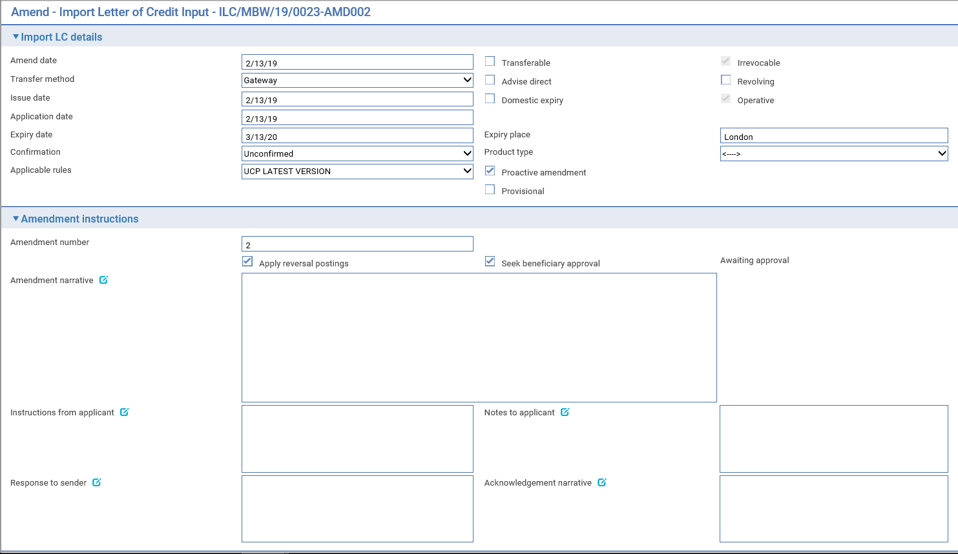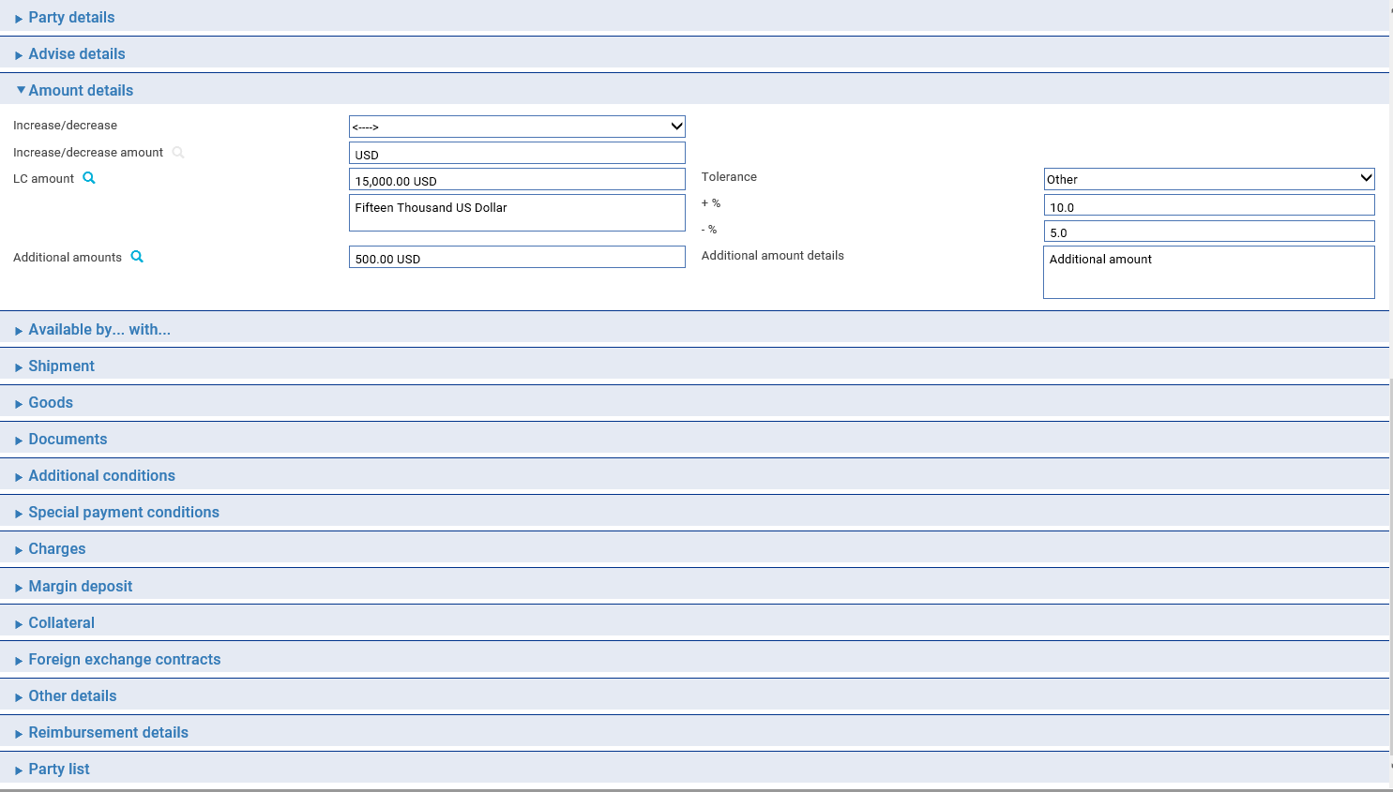

The View event changes menu (see page 92) allows you to display any changes made during the event. The Purchase Orders button in the Goods pane is displayed if your system has the purchase orders functionality implemented. It allows you to enter or amend details of purchase orders relating to the transaction.

Depending on how your system is configured, the Amendment Narrative field may be positioned on its own in an Amendment Narrative pane. (This is controlled by the AmendAdjustEventScreenlayout system option.)

The window displays a sub-set of the information already input for the transaction, which you can overtype. Your bank can configure the event so that you cannot amend the content of the Goods Description, Documents Required and Additional Conditions fields. (This is controlled by the ProtectFieldsGoodsCondDocsOnAmend system option.)

The following additional fields are present:

|  |  |
| --- | --- |
| Field | What to Enter |
| Amend Date | The date of the amendment. |
| Apply Reversal Postings | Shown only if the DoNotApplyReversalPostings system option is set to ‘No’. Leave it checked if your bank has set up reversal postings for the letter of credit Amend event and wishes to apply them when the event is released. |
| Seek Beneficiary Approval | Check this box if beneficiary approval is required for the amendment.   1. **Seek Beneficiary Approval** flag is checked by default. Uncheck the field if beneficiary approval is not required.   Set Branch general system option ‘DoNotSeekBeneficiaryApproval’ to ‘Yes’ to change the default value of this field to unchecked. The system option only changes the default state of the field but the field can still be updated within the transaction. |
| Amendment Narrative | Information about the amendment. |
| Response to Sender | Any information for the party from which you received the amendment or amendment request. |
| Proactive amendment | This flag is available only if the system option ‘AllowLCProactiveAmendMaster’ is enabled. This will provide a control on current amendment transaction if it should be processed as proactive amendment or not. |

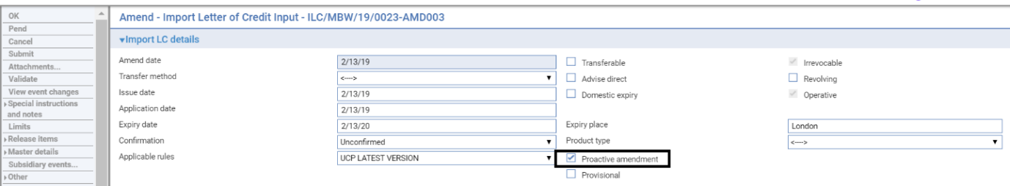

You can enter a new amount in one of two ways:

* Use the Increase/Decrease field to indicate whether the amendment involves an increase or a decrease, then enter the amount by which the letter of credit is to be increased or decreased into the Increase/Decrease Amount field
* Overtype the existing value in the LC Amount field

### Amending Purchase Order Details

Purchase order details are accessed using the Purchase Orders button in the Shipment pane. When you click this button the system displays a window that allows you to add, amend or delete purchase order details.

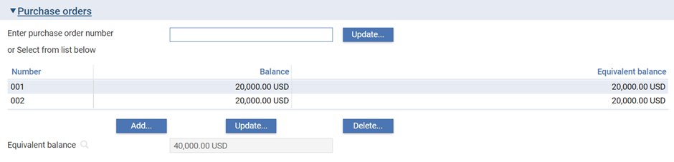

This window lists any purchase orders currently recorded against the letter of credit. For each purchase order listed, it shows:

* The purchase order number
* The amount of the purchase order not yet covered by a drawdown, in the currency of the purchase order
* The equivalent amount in the currency of the letter of credit

You can view and delete purchase order details in the usual way using the Add, Update and Delete buttons. You can also add new purchase orders. The window used to add the details is the same as that used in the Pre Advice and Issue events (see page 43).

### Recording the Beneficiary’s Response to an Amendment

If, when amending a letter of credit, you check the Seek Beneficiary Approval flag, based on proactive amendment system option settings (‘AllowLCProactiveAmendMaster’) either the amendment changes will be applied to master or will not take effect until the beneficiary’s approval is obtained and recorded in the system. In either case the status of the transaction will still be awaiting approval.

1. **Seek Beneficiary Approval** flag is checked by default. Uncheck the field if beneficiary approval is not required. Set Branch general system option ‘DoNotSeekBeneficiaryApproval’ to change the default value of this field to unchecked.

To enter details of the beneficiary’s response for an import letter of credit, in the Master Summary window select ‘Beneficiary Response to Amend’ from the Create New Event drop-down list and click **Create**. The system opens the event either at a Log or at Input step depending on how the Workflow orchestration controlling the event is configured. Refer *Workflow Tailoring User Guide* – Trade Innovation for details. By default the Log steps include the same panes and fields as the input steps. Depending on how your system is configured, panes and fields available in log steps can be tailored for each data capture step. Refer *SDK – Screen Tailoring* Guide – Trade Innovation for details.

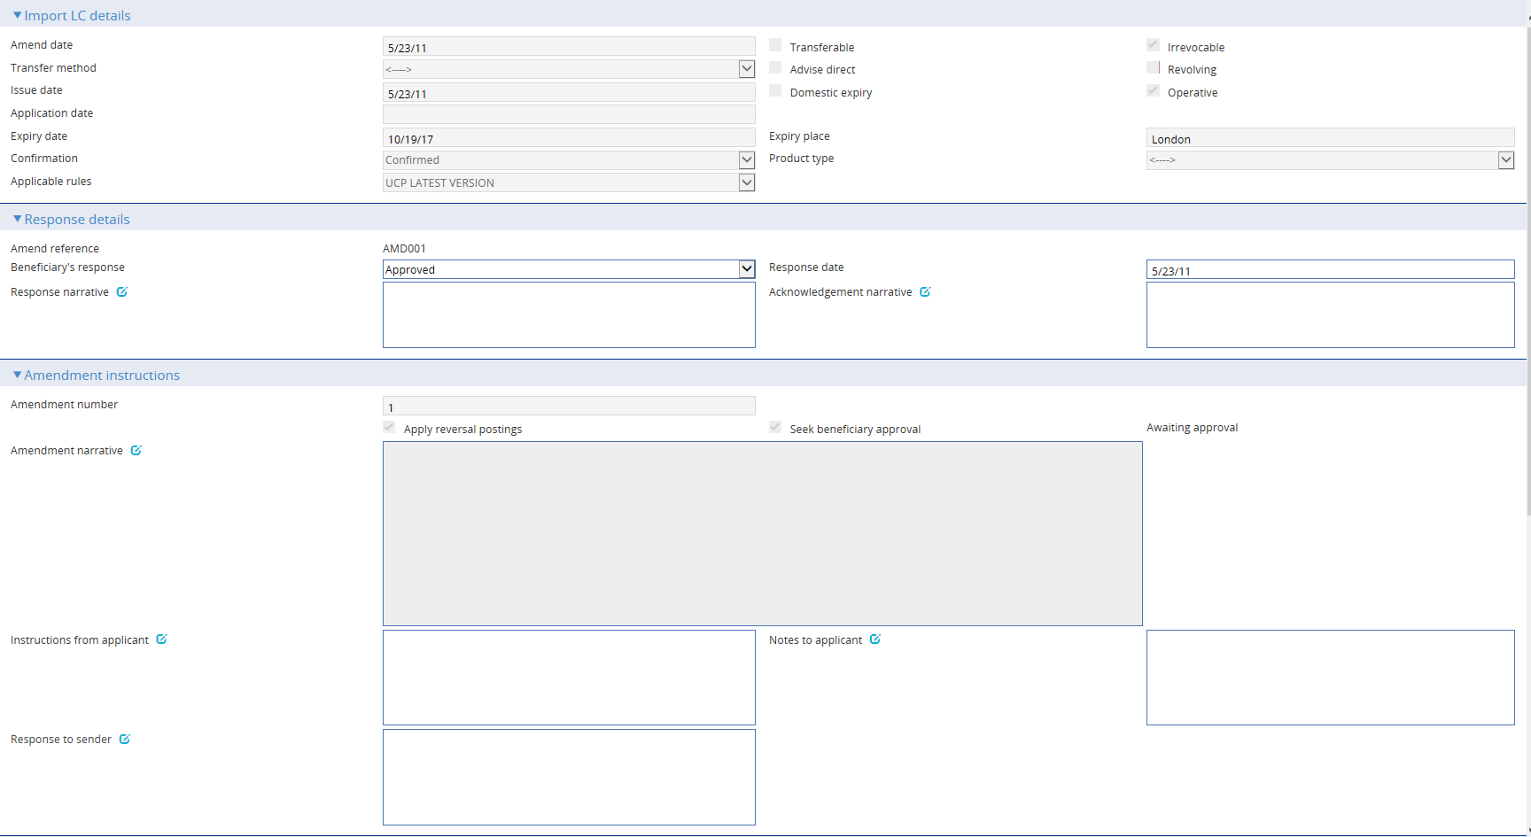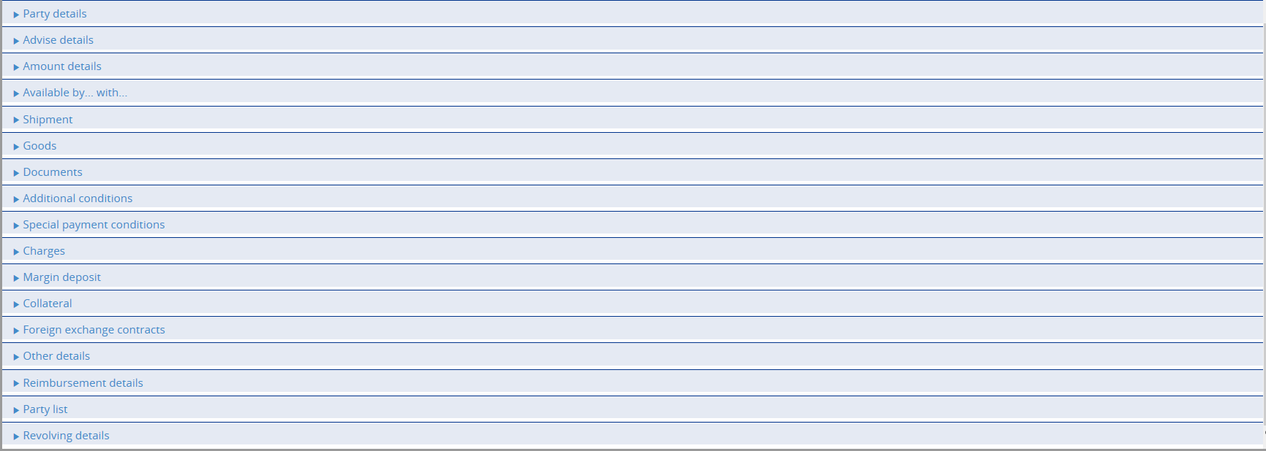

As with the Amend event your system may be configured so that the Amendment Narrative field is positioned on its own in an Amendment Narrative pane. (This is controlled by the AmendAdjustEventScreenLayout system option.)

Your bank can configure the event so that you cannot amend the content of the Goods Description, Documents Required and Additional Conditions fields. (This is controlled by the ProtectFieldsGoodsCondDocsOnAmend system option.)

If there is only one Amend event awaiting a beneficiary response, the system retrieves it and displays its reference. If the letter of credit has more than one Amend event awaiting beneficiary response, then the Select button permits you to select the one to which the beneficiary’s response relates.

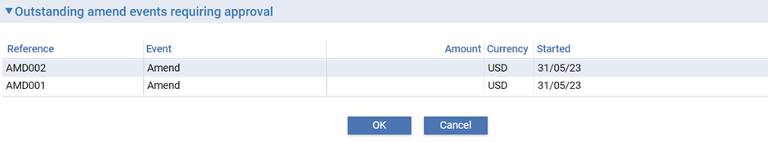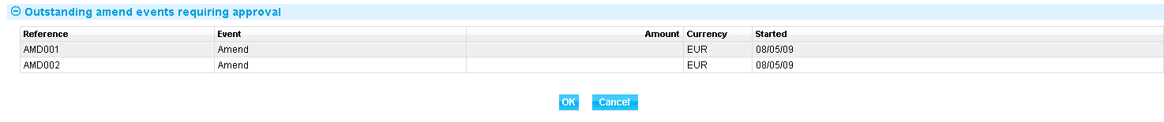

The View event changes menu (see page 92) allows you to display any changes made during the event.

Enter the date when your bank received the beneficiary’s response using the Response Date field.

Use the Beneficiary’s Response field to select whether the beneficiary has approved or rejected the amendment. Use the Response Narrative and Acknowledgement Narrative field to enter any additional information included with response, such as the reasons for a rejection.

In case the amendment is processed as proactive amendment then on processing beneficiary rejection response the system will auto suggest the reverted values on the screen. All the fields on the screen will be allowed to edit if user is not satisfied with the reverted value suggested.

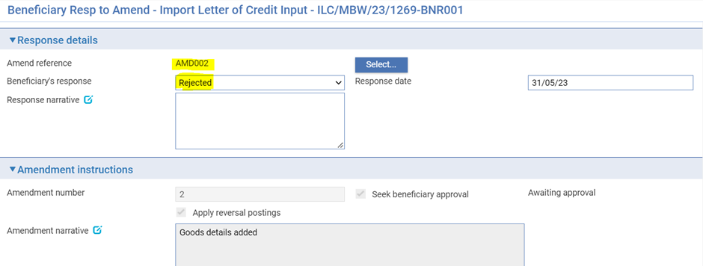

### Auto Revert Functionality

This is used to enable system to revert the amendment changes while processing beneficiary rejection response. This is applicable only for proactive amendments.

All the amendment fields can be categorized in to below 4 types of data and each type has a different logic to revert the changes.

**Type 1:** Values that can be replaced with another value. Example: Place of expiry

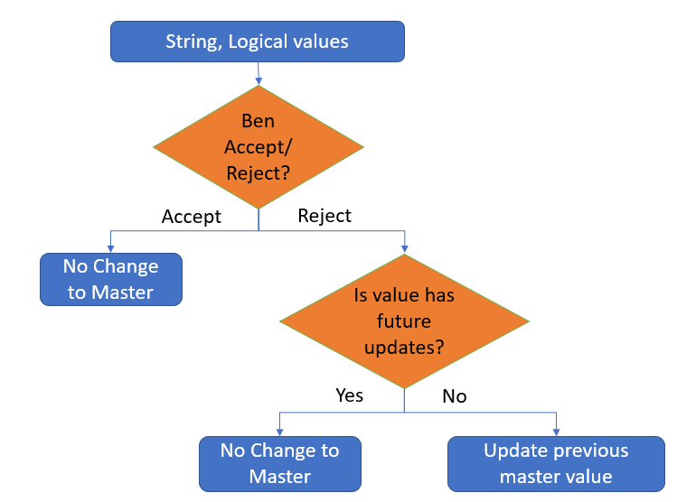

**Type 2:** Derived values. Example: Amount

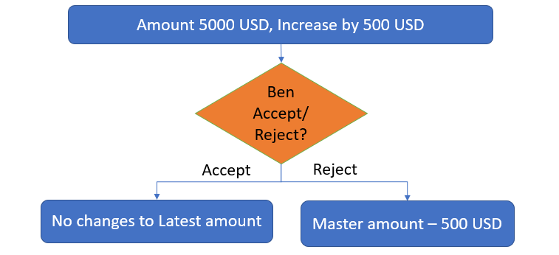

**Type 3:** Large narrative fields where delta changes are handled by ADD, DELETE, REPALL key words.

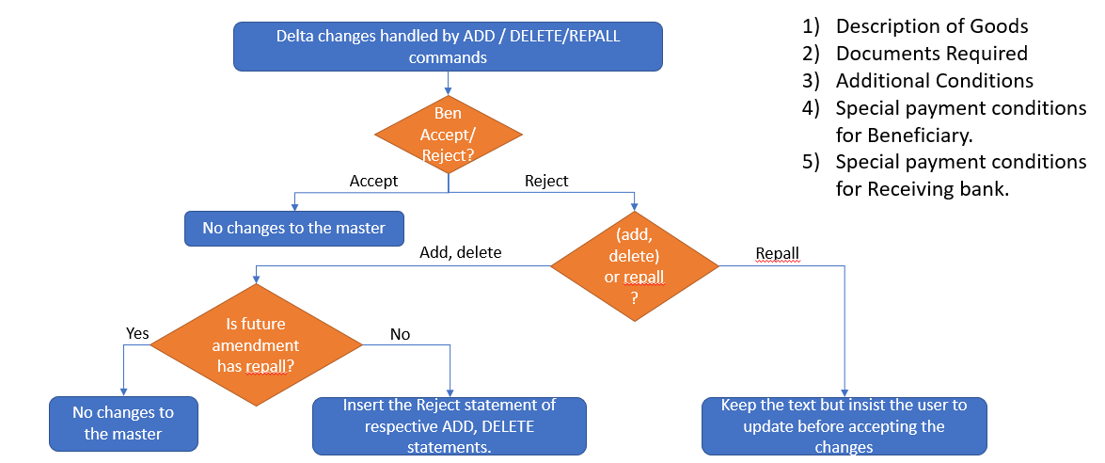

**Type 4:** Combination of multiple fields concatenating in to one field data. This is applicable only if the amendment is sent via SWIFT channel i.e., using MT707/708

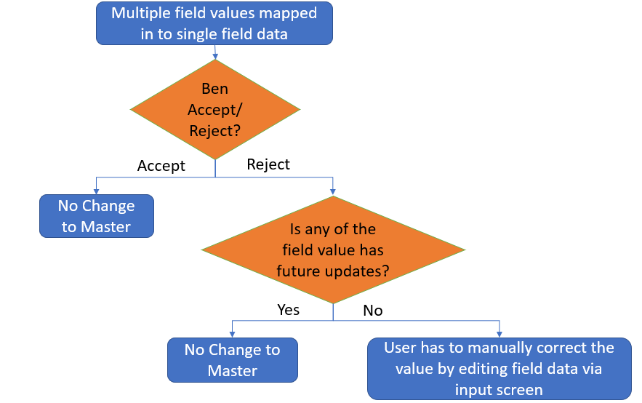

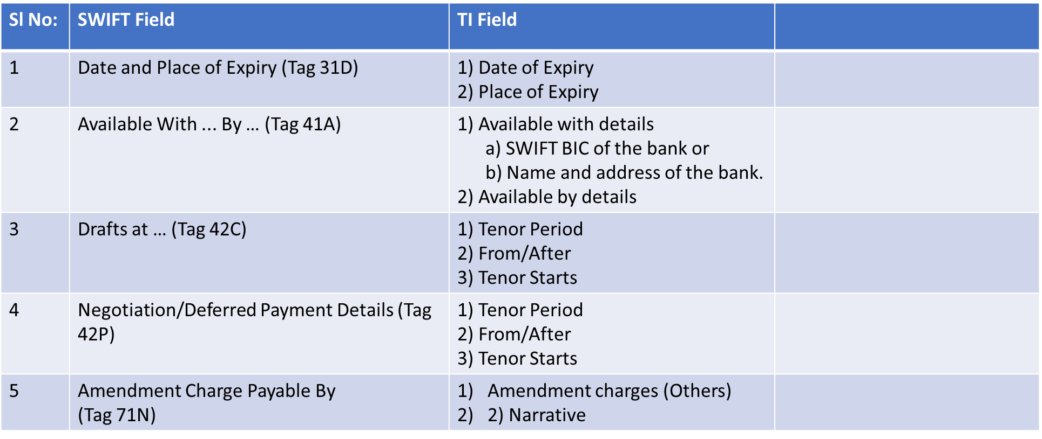



1. If user is making any additional changes apart from the original amendment changes while processing beneficiary rejection response then below waring message is shown on the screen:   
   “**Additional changes exist with is not part of the original amendment**”.

## Making Adjustments to the Master Record

The functionality of the Amend event (see page 95) allows you to make all the changes that are likely to be required in the normal course of business at the request of the applicant, and which may require beneficiary approval. The system includes an Adjust event (see page 105), which contains additional functionality to allow you to make changes to all the information recorded for a transaction, except your bank’s reference number for the transaction, and the status of a transaction’s master record.

The Adjust event is designed to allow you to make changes where you need to alter details but do not need to notify other parties.

1. Once you have initiated an Adjust event, the system will prevent you from opening any other event for the transaction until the Adjust event has completed. If you attempt to open an Adjust event while another event for the master is in progress, the system will warn you of the fact and prompt you to abort the Adjust event. Unless you are attempting to make an adjustment to allow the pre-existing event to complete, you should abort the Adjust event and wait until the pre-existing event has completed before attempting the Adjust event again. If you continue with the Adjust event, then the system will prevent any further work on the pre-existing event until the Adjust event has completed.

This functionally is intended to allow you to correct mistakes, and should be used cautiously. If you make any changes using this functionality, you should ensure that the proper reconciliations are carried out.

### Adjusting an Import Letter of Credit

With the appropriate master record open, in the Master Summary window select ‘Adjust’ from the Create New Event drop-down list and click **Create**. The system opens the event at either at a Log or Input step depending on how the Workflow orchestration controlling the event is configured. Refer *Workflow Tailoring User Guide* – Trade Innovation for details. By default the log steps include the same panes and fields as the input steps. Depending on how your system is configured, panes and fields available in log steps can be tailored for each data capture step. Refer *SDK – Screen Tailoring* Guide – Trade Innovation for details.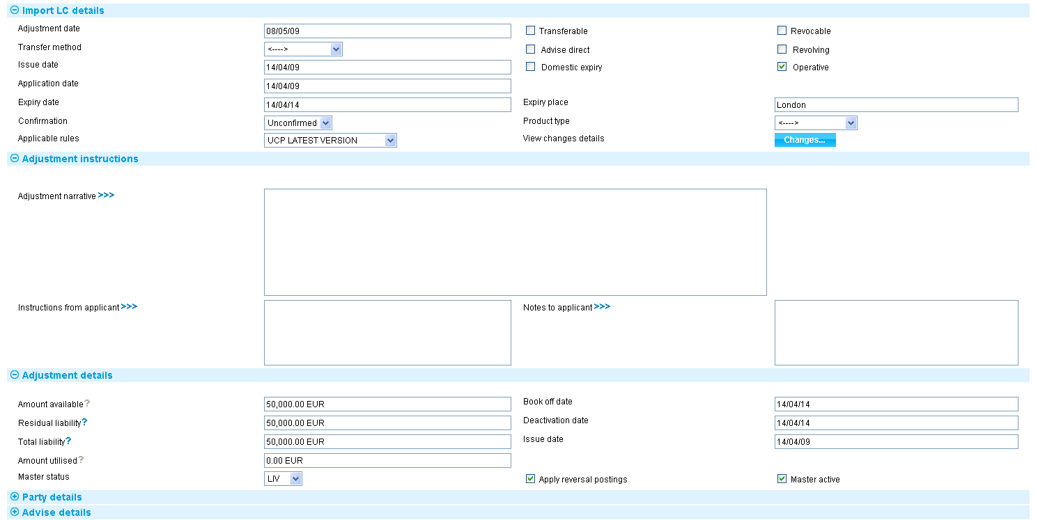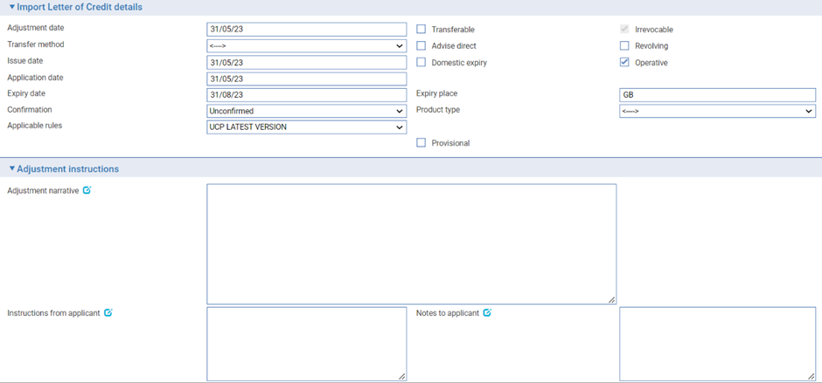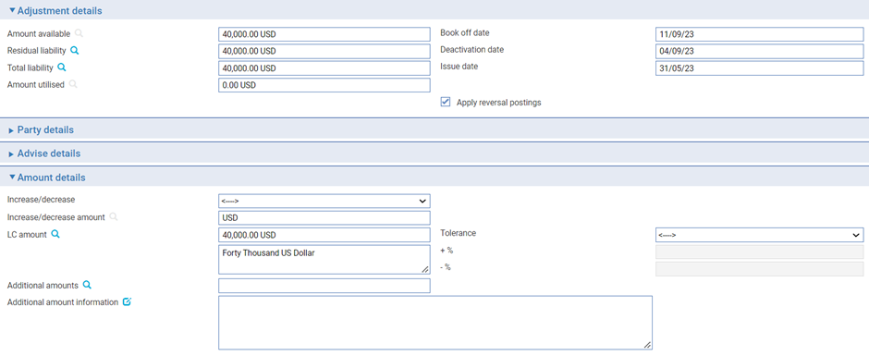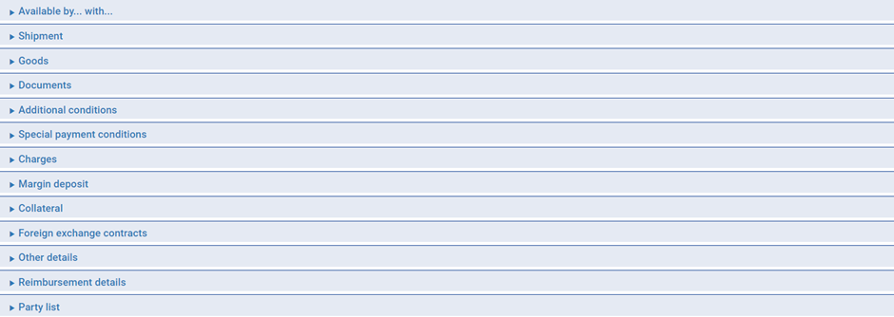

The Changes button (see page 92) allows you to display any changes made during the event.

The window displays a sub-set of the information already input for the transaction, which you can overtype.

Depending on how your system is configured, the Amendment Narrative field may be positioned on its own in an Amendment Narrative pane. (This is controlled by the AmendAdjustEventScreenlayout system option.)

During an Adjust event you can view charges and add optional charges, but cannot edit existing charges. To change charges, use a Maintain Charges event.

You can enter a new amount in one of two ways:

* Use the Increase/Decrease field to indicate whether the amendment involves an increase or a decrease, then enter the amount by which the letter of credit is to be increased or decreased into the Increase/Decrease Amount field
* Overtype the existing value in the LC Amount field

|  |  |
| --- | --- |
| Field | What to Enter |
| Adjustment Date | The date the adjustment was made. |
| Adjustment Narrative | A narrative identifying the nature of and reason for the adjustment. |
| Instructions from Applicant | Any instructions from the applicant relating to the adjustment. |
| Notes to Applicant | Your bank’s response to the applicant, if relevant. |
| Amount Available | The current available amount. |
| Residual Liability | The system displays the outstanding liability amount for the master record, excluding the amounts of any presentations. Use this field to overwrite those shown on the master summary if, for any reason, the master figures are incorrect. |
| Total Liability | The system displays the outstanding liability amount for the master record, including that of accepted drafts not yet paid. Use this field to overwrite those shown on the master summary if, for any reason, the master figures are incorrect. |
| Book Off Date | The system displays the letter of credit’s book-off date, which you can amend. The system will then book off the letter of credit when the new book-off date is reached. |
| Deactivation Date | The system displays the date on which the letter of credit will become inactive (after its expiry date and any days grace period has elapsed). You can amend this date.  Refer System Tailoring User Guide – Trade Innovation for the days grace period, which may be different for master records expiring locally and those expiring abroad. |
| Issue Date | The letter of credit’s issue date. |
| Amount Utilised | The amount of the letter of credit utilised so far. |
| Apply Reversal Postings | Leave checked if your bank has set up reversal postings for the import letter of credit Adjust event and wishes to apply them when the event is released.  If the DoNotApplyReversalPostings system option in the system administration application is set to yes, then the Apply Reversal Postings check box is not available on this event. |

# Cancelling an Import Letter of Credit

A letter of credit can be cancelled at any time after the release of the Advise event and book-off. However, you cannot cancel an import letter of credit on which there is work in progress.

Typically, cancellation will be initiated by the issuing bank at the request of the applicant. The issuing bank then passes details of the cancellation on to the next bank in the processing chain, which will record them and inform the next advising bank or the beneficiary, as appropriate.

The system provides:

* A Cancel event which allows you to record details of the cancellation. The Cancel event includes the facility to create messages to forward details of the cancellation
* A Beneficiary Response to Cancel event, which allows you to enter and forward details of a beneficiary’s response to a cancellation notification

If beneficiary approval is not required for the cancellation, then as soon as the Cancel event is released, accounting entries are produced to reduce the liability and liability outstanding to nil and the master record is given the status CAN, although it is not removed from the system.

If a margin deposit was made to cover the letter of credit then accounting entries are generated by the Cancel event to repay unutilised funds back to the customer’s account.

If a letter of credit that has a license attached is cancelled any unutilised amount reserved can be reinstated (provided that the Automatically Reinstate parameter has been set and a reservation had previously been made).

If the beneficiary’s approval is required for the cancellation, then the cancellation does not take effect until the beneficiary’s approval has been obtained and recorded using the system. If this is the case, then no accounting entries are produced for the Cancel event, although any charges due can be paid, if required. Once beneficiary approval has been recorded using a Beneficiary Response to Cancel event, then the appropriate accounting entries are made once the Beneficiary Response to Cancel event has been released. If beneficiary approval is required, and is not forthcoming, then the cancellation does not take effect.

For instructions on cancelling a transfer letter of credit Refer Transfer Letters of Credit User Guide – Trade Innovation.

1. A cancelled standby letter of credit can be reinstated using the Amend event.

## Reimbursement Authorities

Where a letter of credit has an associated reimbursement authority, the Cancel Reimbursement event permits you to cancel that reimbursement authority while leaving the letter of credit active. The event generates an MT747 message for the reimbursing bank instructing it to cancel the reimbursement authority.

Reimbursement authorities can also be cancelled from within a Claim Received or Outstanding Claim event, as described in Chapter 4.

## Cancelling an Import Letter of Credit

To cancel an import letter of credit, with the appropriate master record open, in the Master Summary window select ‘Cancel’ from the Create New Event drop-down list and click **Create**. The system opens the event at either at a log or input step depending on how the Workflow orchestration controlling the event is configured. Refer *Workflow Tailoring User Guide* – Trade Innovation for details. By default the log steps includes the same panes and fields as the input steps. Depending on how your system is configured, panes and fields available in log steps can be tailored for each data capture step. Refer *SDK – Screen Tailoring* Guide – Trade Innovation for details.

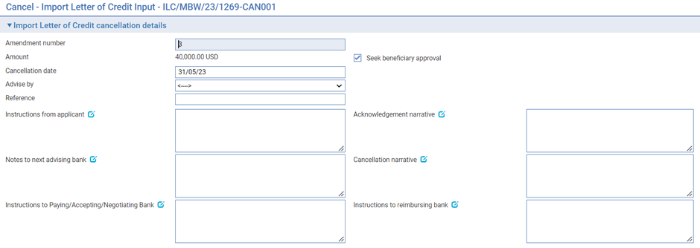

The following table explains what to enter into the fields in this window to cancel the letter of credit:

|  |  |
| --- | --- |
| Field | What to Enter |
| Amendment Number | Cancellation request is part of amendment request hence requires the amendment number. |
| Seek Beneficiary Approval | Check this box if beneficiary approval is required for the cancellation.   1. **Seek Beneficiary Approval** flag is checked by default. Uncheck the field if beneficiary approval is not required.   Set Branch general system option ‘DoNotSeekBeneficiaryApproval’ to ‘Yes’ to change the default value of this field to unchecked. The system option only changes the default state of the field but the field can still be updated within the transaction. |
| Cancellation Date | The date when the cancellation takes effect. This defaults to today’s date, but you can change it.  Any refunds to the customer are calculated with effect from the cancellation date. |
| Advise By | The method of transmission to be used to send details of the cancellation on. |
| Reference | Any reference for the cancellation request. |
| Instructions from Applicant | Any instructions from the applicant regarding the cancellation. |
| Acknowledgement Narrative | Any Acknowledgement narrative to be updated. |
| Cancellation Narrative | A description of the reasons for the cancellation that is to be sent to the advising bank (and the reimbursing bank). |
| Instructions to Advising Bank | Any instructions to the advising bank regarding the cancellation. |
| Instructions to Reimbursing Bank | Any instructions to the reimbursing bank regarding the cancellation. |
| Instructions to Paying/Accepting/Negotiating Bank | Specify instructions to Paying/Accepting/Negotiating Bank |

## Recording the Beneficiary's Response to a Cancellation

If, when cancelling a letter of credit you check the Seek Beneficiary Approval flag, then the cancellation does not take effect until the beneficiary's approval is obtained and recorded in the system.

1. **Seek Beneficiary Approval** flag is checked by default. Uncheck the field if beneficiary approval is not required. Set Branch general system option ‘DoNotSeekBeneficiaryApproval’ to change the default value of this field to unchecked.

To enter details of the beneficiary's response for an import letter of credit, in the Master Summary window select 'Beneficiary Response to Cancel' from the Create New Event drop-down list and click **Create**. The system opens the event at either at a log or input step depending on how the Workflow orchestration controlling the event is configured. Refer *Workflow Tailoring User Guide* – Trade Innovation for details.

### Logging the Response

A response log step has only the Import LC Details pane.

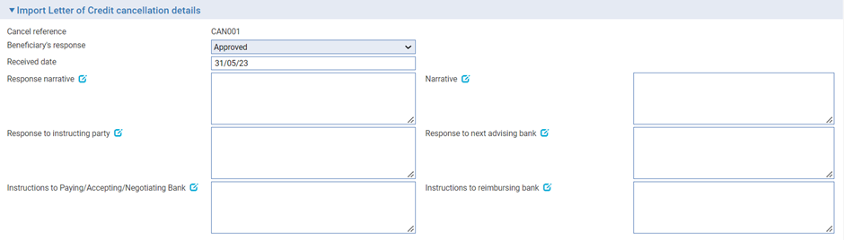

### Entering Full Details of the Response

A response Input step shows additional details of the cancellation.

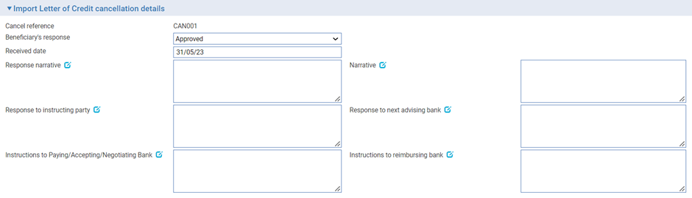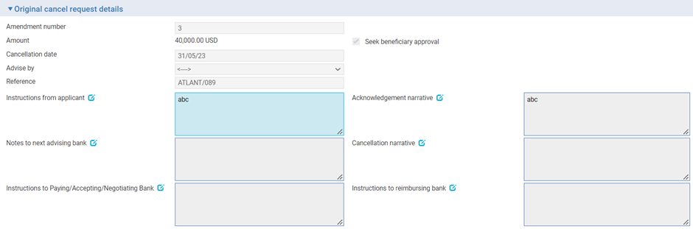

Use the Beneficiary's Response field to indicate whether the beneficiary has approved or rejected the cancellation, and the Received Date to record the date the response was received.

Use the Response to Beneficiary field to enter any additional information included with the response, such as the reasons for a rejection. Instructions fields allow you to record information from the applicant and or the advising bank and reimbursing bank. The Cancel Detail pane shows the original cancellation request details.

## Cancelling a Reimbursement Authority

Where a letter of credit has an associated reimbursement authority, the Cancel Reimbursement event permits you to cancel that reimbursement authority while leaving the letter of credit active. You can only use this event with a letter of credit that has a reimbursing bank defined.

In the Master Summary window select 'Cancel Reimbursement' from the Create New Event drop-down list and click **Create**. The system opens the event at either at a log or input step depending on how the Workflow orchestration controlling the event is configured. Refer *Workflow Tailoring User Guide* – Trade Innovation for details. By default the log steps includes the same panes and fields as the input steps. Depending on how your system is configured, panes and fields available in log steps can be tailored for each data capture step. Refer *SDK - Screen Tailoring* Guide – Trade Innovation for details.

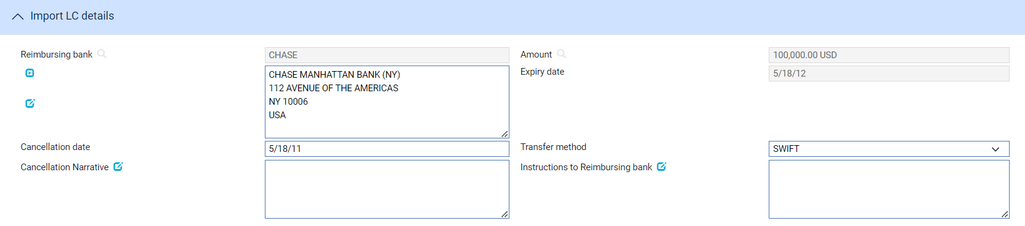

The event shows the letter of credit amount and expiry date and the reimbursing bank details. Use the Cancellation Date field to enter the date the cancellation is to become effective (the current processing date appears as the default) and the Transfer Method field to select the transfer method to be used to send the cancellation (the transfer method for the reimbursing bank is used as the default).

You can use the Narrative field to enter free-format text concerning, for example, the reasons for the cancellation; and the Instructions to Reimbursing Bank field to enter any instructions for the reimbursing bank.

# Appendix - Payment Actions and Charges

This appendix explains how the system handles the processing of charges during a payment event for letters of credit.

This appendix covers only the special processing for letters of credit. For a full account of how the system handles charges refer Common Facilities User Guide – Trade Innovation.

## Charges

When requesting payment, or asking for authorisation to pay, for an export letter of credit it is sometimes necessary for the bank to advise the issuing bank of charges that will be due from the applicant. Similarly, when documents are received on an import letter of credit, the issuing bank may need to advise the applicant of charges due, as a request for approval is sent to the applicant. The system handles this by allowing you to claim the charges.

If you select the Release Items|Charges link during a payment event, then when you have For Master selected, the system will display an additional button - the Claim All button.

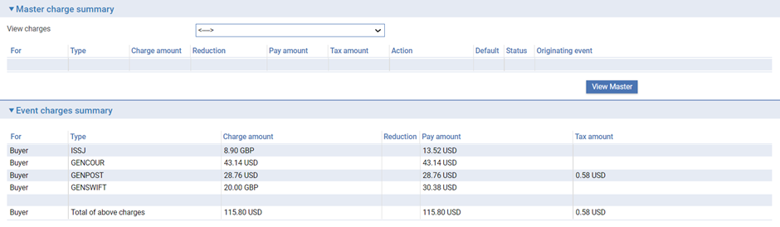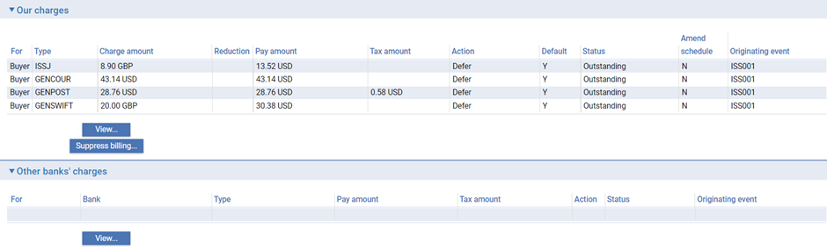

For more on the Charges Summary window refer Common Facilities User Guide – Trade Innovation.

If you click **Claim All**, the system changes the value in the Action column to 'Claim' for all charges with a status of 'Outstanding' or 'In Preparation'. When the event is completed, the status of these charges changes to 'Claimed'. This indicates that the charges have been claimed by the bank, but payment has not yet been authorised or paid. No postings are generated by the claim, since no payment has yet been made.

If the response does not authorise payment of the claim, you will need to manually take all previously-claimed charges. The system will issue a warning that these charges relate to an outstanding payment event and are being superseded. Once taken, these previously-claimed charges can be waived or edited in the usual way.

## Presenter's Actions

The following table lists all the presenter's actions supported by the system and explains when they might be used:

|  |  |
| --- | --- |
| Presenter's Action | What it Signifies |
| Request Authorisation to Pay | Discrepancies have been advised by the presenter and authorisation to pay is being requested. If this option is selected, an extra field is displayed, allowing you to enter details of discrepancies. |
| Pay and Claim Reimbursement | The sender has paid the beneficiary and has sent a claim to the reimbursing bank. |
| Request Payment | The presenter is requesting payment. |
| Request Acceptance | The presenter is requesting payment and or acceptance of drafts. |
| Sender has Debited our Account | The presenter has paid the beneficiary and has debited the receiver's account. |
| Documents Sent On Approval | Documents with discrepancies have been sent on approval. |
| Other | Used when the payment action involves more complex instructions, for example where discounting of acceptances is being requested. The Notes fields should be used to provide details. |

## Payment Actions

The Payment Action field allows you to select the appropriate action for the claim. Actions are of three types.

Payment actions indicate that the bank is paying or will pay the claim in the future. These include:

* Approve Authorisation Request
* Pay
* Pay with Financing
* Pay at Maturity
* Issue Trust Receipt Loan
* Accept
* Forward Documents
* Repay Finance

Some actions reject or refuse the claim. These include:

* Refuse Documents
* Reject
* Reject and Claim Refund
* Reject Authorisation Request

Some actions leave the claim outstanding. These include:

* Await Documents
* Request Approval from Applicant
* Issue Trust Receipt
* Issue a General Request to Applicant or Presenter

Note that in addition to the standard actions mentioned above, your bank may define other actions (which are based upon the standard actions) in order to satisfy your internal processes. These additional actions will also be available in the drop-down list.

Refer *System Tailoring Guide* – Trade Innovationfor instructions on defining additional payment actions.

### The Effect of Different Payment Actions on Charges

The following table indicates the effect of different payment action behaviours on charges for import letters of credit:

|  |  |  |  |  |  |  |
| --- | --- | --- | --- | --- | --- | --- |
| Payment Action Behaviour | What it Does | Our Charges for Buyer | Our Charges for Seller | Other Party Charges | Other Bank's Charges for Buyer | Other Bank's Charges for Seller |
| Accept | The payment will be made at maturity. The payment advices such as MT756 can be produced immediately and the payment will be automatically picked up as the maturity falls due so that it can be continued and paid.  This is available for acceptance payments only. | Claim | Claim | Claim | Claim | Claim |
| Approve Authorisation Request | This is the same as 'Pay'. The response is used to send an MT752 Authorisation to Pay message. When this option is taken an additional drop down list can be used to enter further authorisation details:   * See details * Accept * Remitted - note value date field is then shown * Debit sender's account * Negotiate * Claim reimbursement | Take | Take | Take | Take | Take |
| Await Documents | Typically no accounting will typically be done. However where the sender has debited an account in their books or claimed reimbursement then the accounting entries may be generated by using this option in conjunction with the claim details presenter's action. | Defer | Defer | Defer | Defer | Defer |
| Await Replacement Invoices | Only available where a transfer import letter of credit requires invoice substitution. This allows replacement invoices to be requested from the first beneficiary before continuing the claim. | Defer | Defer | Defer | Defer | Defer |
| Forward Documents Only | Documents are passed to the applicant when they are received. This is treated as the final action under a claim where the sender has debited the receiver's account.  This payment action is available only if the Documents Received field has been checked. | Take | Take | Take | Take | Take |
| General Request to Issuer, Presenter or Transferee | This can be used to send correspondence about the claim to the applicant, presenter or transferee, by entering details into the Notes for Debit Party or Notes For Presenter field, as relevant. | Take | Take | Take | Take | Take |
| Issue Trust Receipt | This allows a trust receipt to be sent to the applicant so that it can be signed and returned. | Take | Take | Take | Take | Take |
| Issue Trust Receipt Loan | This causes the Finance button to be made available allowing details of a deal to be entered to fund the receipt of funds from the applicant. | Take | Take | Take | Take | Take |
| Pay | The claim is to be paid and postings generated. The payment advices such as MT756 can be produced immediately. If the payment is a mixed payment each part payment is initially set to have a status of 'Pay' which can be overridden as required to one of the following pay statuses:   * Pay * Pay at maturity * Accept (if acceptance part payment only) | Take | Take | Take | Take | Take |
| Pay at Maturity | The payment will be made at maturity. The payment advices such as MT756 can be produced immediately and the payment will be automatically picked up as the maturity falls due so that it can be continued and paid. | Claim | Claim | Claim | Claim | Claim |
| Pay from Suspense | As for 'Await Replacement Invoices', but additionally would be used to pay the second beneficiary from suspense. | Defer | Defer | Defer | Defer | Defer |
| Pay with Financing | This causes the Finance button to be made available allowing details of a deal to be entered to fund the receipt of funds from the applicant. | Take | Take | Take | Take | Take |
| Refuse Documents | Documents are refused. No payment is made. What happens to the documents depends on what is selected in the Document Disposal field. If 'Return' is selected, payment status is set to 'Reject', otherwise it is set to 'In Progress'. If documents are held the presenting party may re-present further documents allowing the claim to be continued. This is typically used to generate an MT734. | Take | Claim | Take | Take | Take |
| Reject | Documents are refused. No payment is made and the event is closed The bank can either return or hold documents. | Take | Take | Take | Take | Take |
| Reject and Claim Refund | Documents are refused. The bank can either return or hold documents. The value date allows the date of refund to be specified where the sender has already debited the receivers account. This is typically used to generate an MT734. | Take | Take | Take | Take | Take |
| Reject Authorisation Request | The payment request (MT750) is refused. The payment is not made. The response is given either as an M796 Answers or an MT734 Advise of Refusal.  This is available only if the presenter's action Is 'Request Authorisation to Pay'. | Take | Take | Take | Take | Take |
| Repay Finance | Allows the user to create a Repay Finance event. | Take | Take | Take | Take | Take |
| Request Approval from Applicant | Your bank does not pay but seeks authorisation to pay from the applicant. | Claim | Defer | Claim | Claim | Defer |
| Reverse Payment | The bank reverses a part payment that has already been paid. | Take | Take | Take | Take | Take |